

HEALTH LEADS UK LTD:
COMPLETE FLOW

Paapri Cloud Technology

HEALTH LEADS UK LTD:
DESIGN TO BUILD
DOCUMENT

Paapri Cloud Technology
Design to Build Process Flow

Inventory Item
This is a record for something you stock and sell. Track the amount and value you have on hand, as well as the marginal profit you make.
Using this type of item record requires the Inventory feature.
As you buy and sell inventory, your Cost of Goods Sold (COGS), income, and asset accounts are updated. Item profits are reflected on your income statement.
Step 1: Inventory Item creation :- Navigate to Lists->Accounting->Items->New.
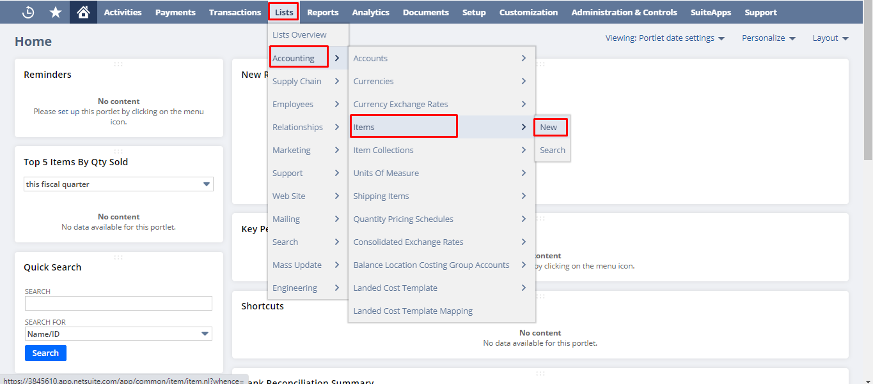

Step 2: Click on Inventory Item

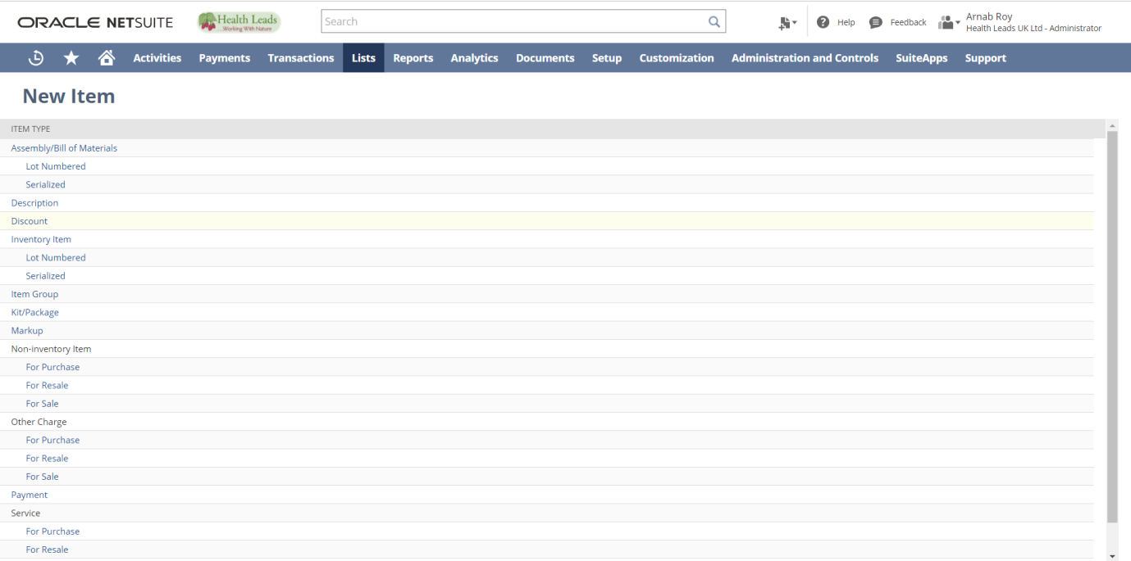

Step 3: Fill the required details for the Inventory Item. Mandatory fields -Item Name/Number, Tax Schedule under Accounting subtab. Put the other necessary details.
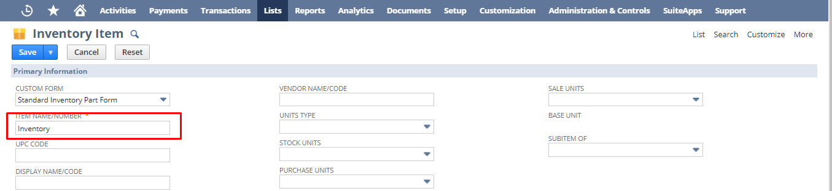

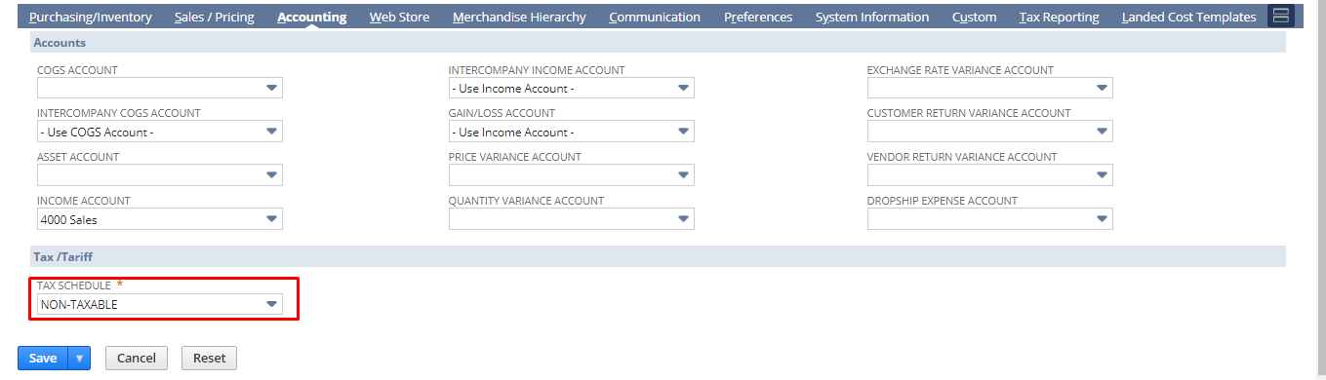

Under Purchasing tab please put the costing method, purchase description, purchase price, vendor and vendor specific purchase price.

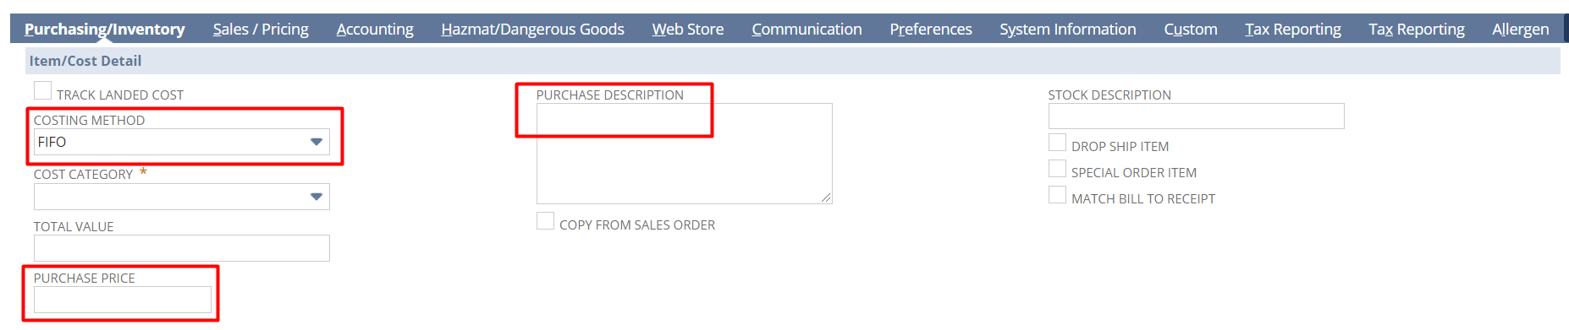
Here ,purchase price means when a vendor buy the item he would see this amount which you put in purchase price field and purchase description means when a vendor buy a item he would see this as a description of the item.
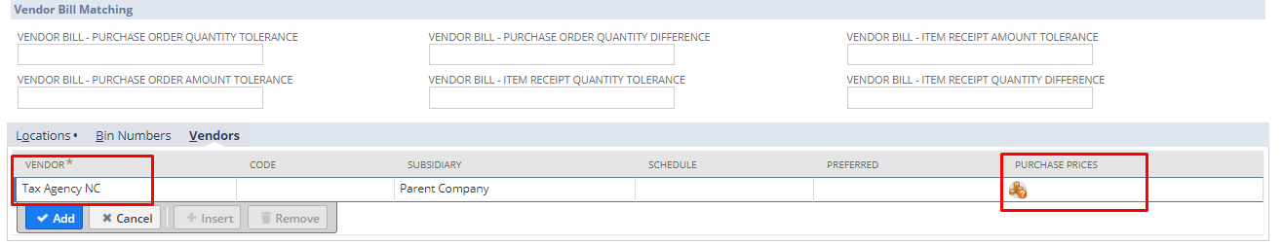
Here, you can select the purchase price against each vendor. In order to set price you have to click on the icon under purchase prices field. After clicking on that you redirect to a subtab shown below. In the subtab you can select the currency and price.
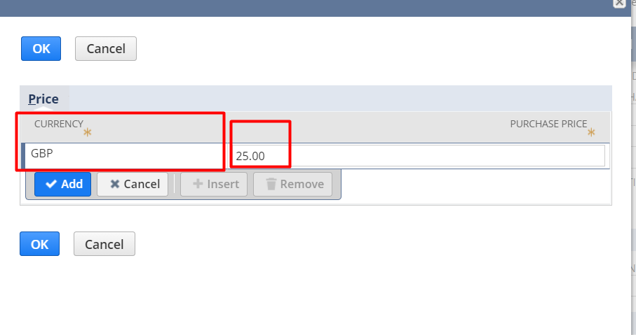

Note: Costing method field is not editable. After saving the item record, system will not allow you to change costing method.

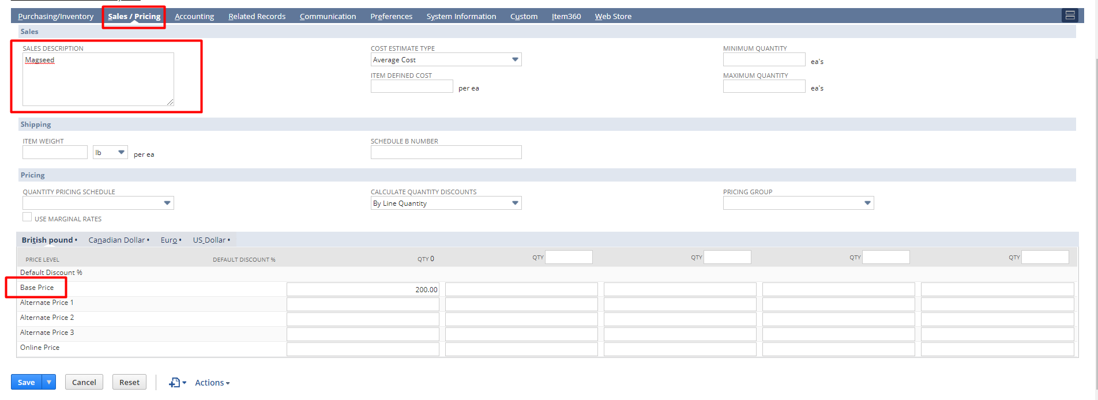
Under Accounting Tab, please put Tax Schedule & COGS, ASSET, INCOME Account
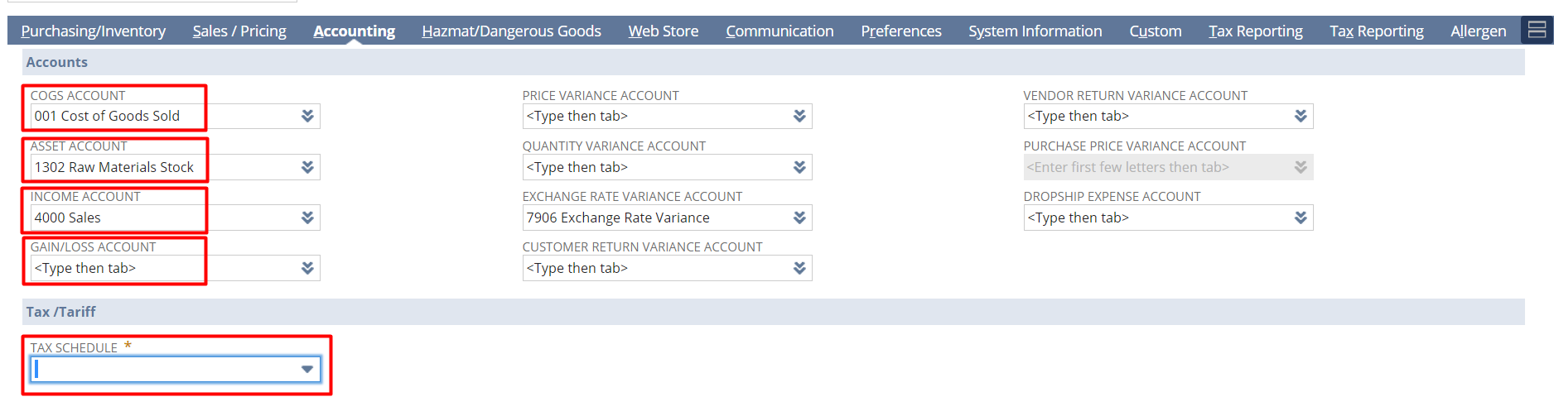
Step 4: click the “Save” button.

Serialized Inventory Item
With the help of serialized item, you can track the purchase and sale of physical inventory items by assigning a serial number to each item. At the time of receiving a serialized item you must enter a serial number for each serialized item. For example, if you enter a quantity of 2, then you must enter two serial numbers. Similarly, at the time of fulfilling the item you must select the serial number of the item to specify from which serial number you are shipping your inventory.
Step 1: Serialized Item creation: Navigate to Lists->Accounting->Items->New.


Step 2: Click on the Serialized under Inventory
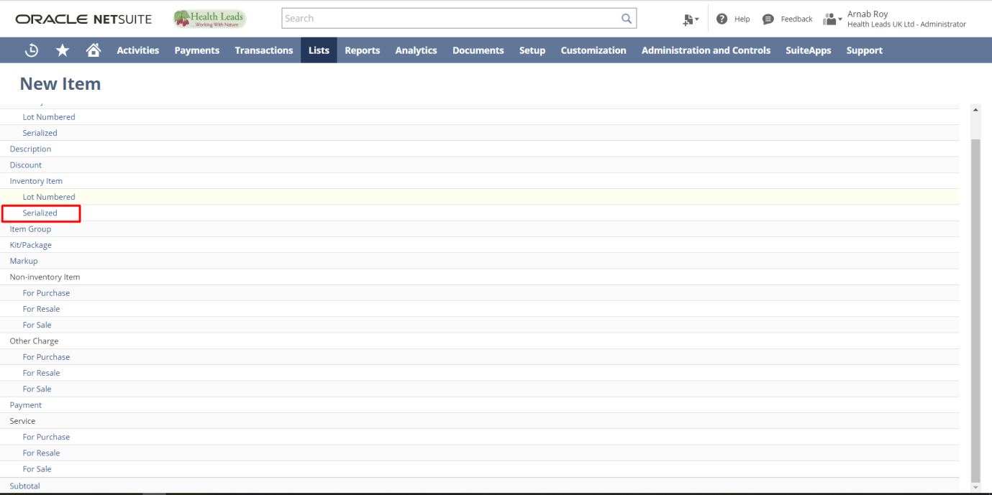

Step 3: Fill the required details for the Serialized Inventory Item. Mandatory Fields-Item Name/Number, Tax Schedule under Accounting subtab and other necessary details.

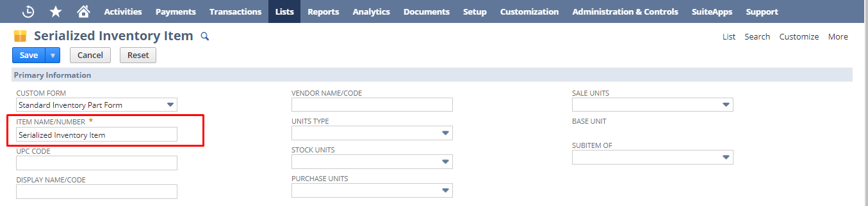
Under purchasing tab please put costing method, purchase price, purchase description.


Here ,purchase price means when a vendor buy the item he would see this amount which you put in purchase price field and purchase description means when a vendor buy a item he would known the item by this description of the item.

Here, you can select the purchase price against each vendor. In order to set price, you have to click on the icon under purchase prices field. After clicking on that you redirect to a subtab shown below. In the subtab you can select the currency and price.




Under Accounting Tab, please put Tax Schedule & COGS, ASSET, INCOME Account


Under Sales/Pricing tab you can put sales description, cost estimate type with the help of which NetSuite calculates estimated gross profit.
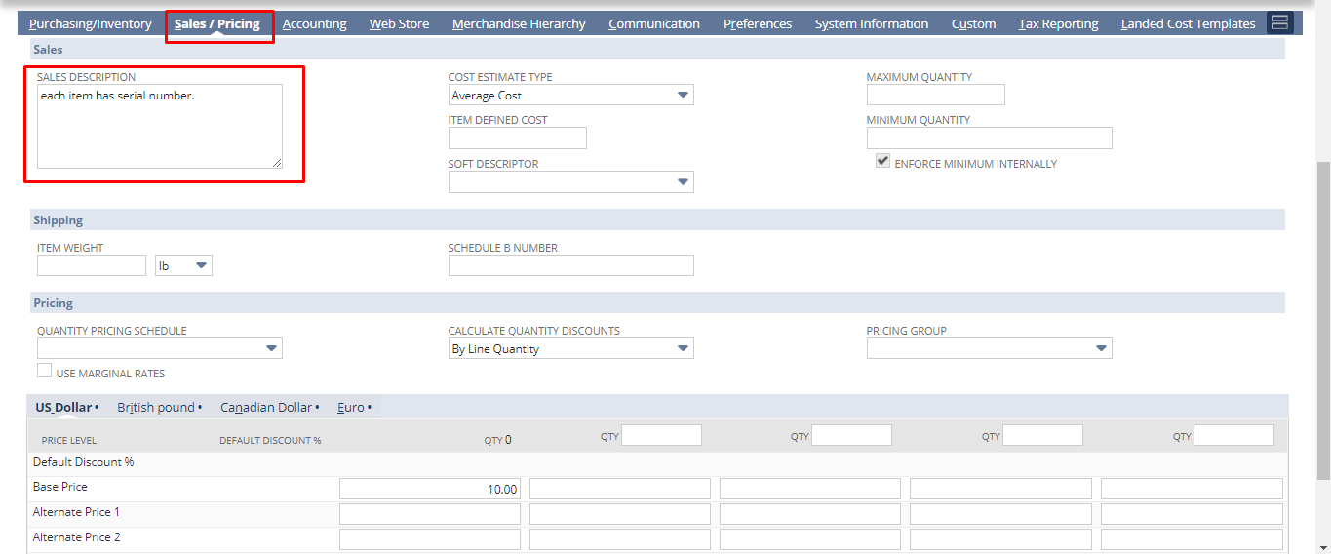
Step 4: Then click the “Save” button.
Lot Numbered Inventory Item
This is a record to track a group of inventory items by assigning a lot number to identify the group. For example, you can identify an item lot by its expiration date.
Using this type of item record requires the Lot Tracking feature.
Step 1: Lot Numbered Item creation: Navigate to Lists->Accounting->Items->New.


Step 2: Click on the Lot Numbered under Inventory
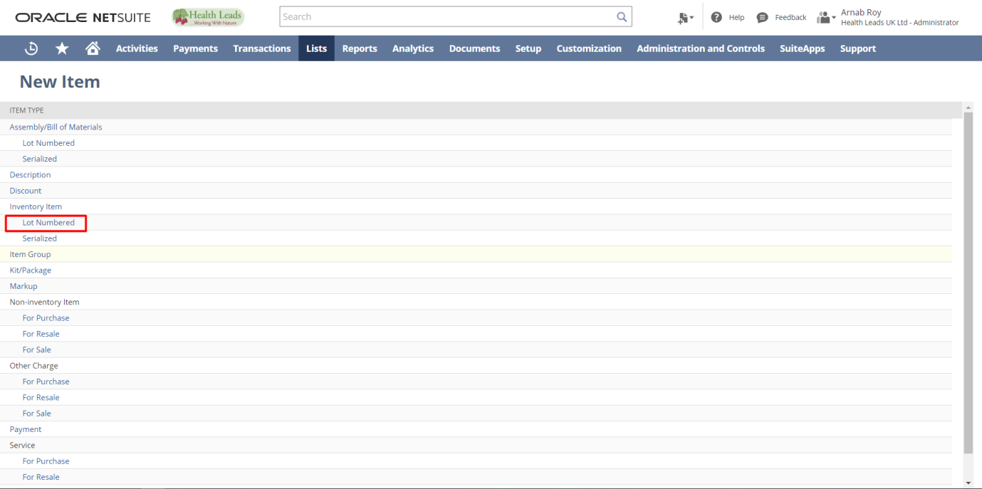

Step 3: Fill the required details for the Lot Numbered Item. Mandatory Fields-Item Name/Number, Tax Schedule under Accounting subtab and other necessary details.
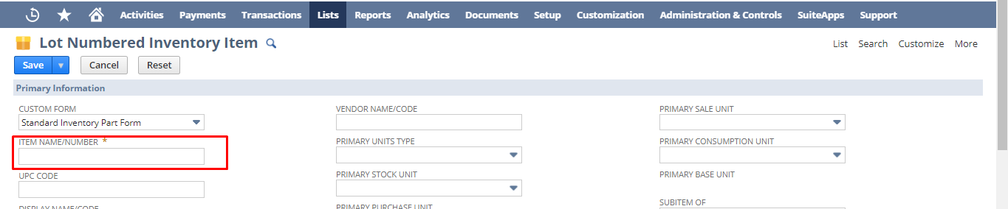

Under purchasing tab, please put costing method, purchase price, purchase description and vendor specific purchase price


Here ,purchase price means when a vendor buy the item he would see this amount which you put in purchase price field and purchase description means when a vendor buy a item he would known the item by this description of the item.

Here, you can select the purchase price against each vendor . In order to set price you have to click on the icon under purchase prices field. After clicking on that you redirect to a subtab shown below. In the subtab you can select the currency and price.




Under Accounting Tab, please put Tax Schedule & COGS, ASSET, INCOME Account


Under Sales/Pricing tab you can put sales description, cost estimate type with the help of which NetSuite calculates estimated gross profit.

Step 4: Then click the “Save” button.

Group Item
This is a record to identify several member items that are sold together as one unit. The price of the group is dependent on its components' prices.
A group can be made up of taxable and non-taxable items. If a grouped item has taxable and non-taxable components, the sales tax is calculated only on the value of the taxable components.
Step 1: Non-Inventory Item creation: Navigate to Lists->Accounting->Items->New.


Step 2: Click on Item group.
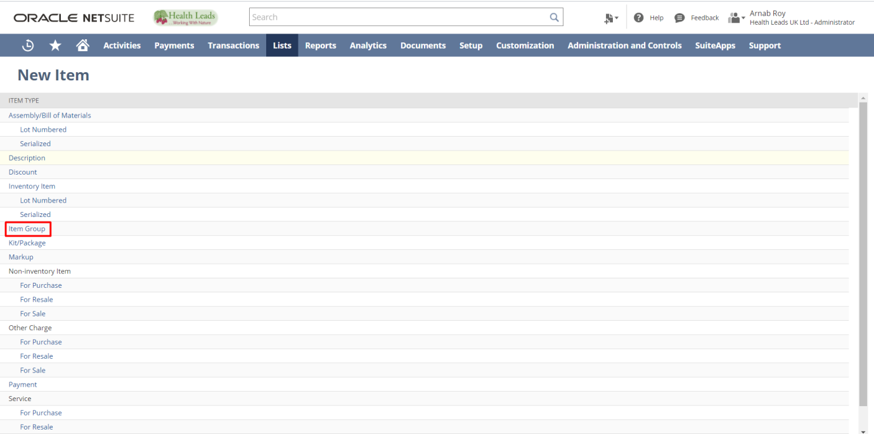
Step 3: Fill the required details for the Group Item. Mandatory Fields-Item Name/Number.
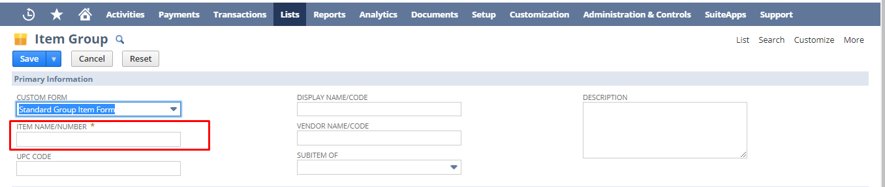

Group item means, an item consist of more than one item and the price of it depends on the items containing in it. In order to create a group item, you have to select items as well as its quantity for grouping under purchasing tab.
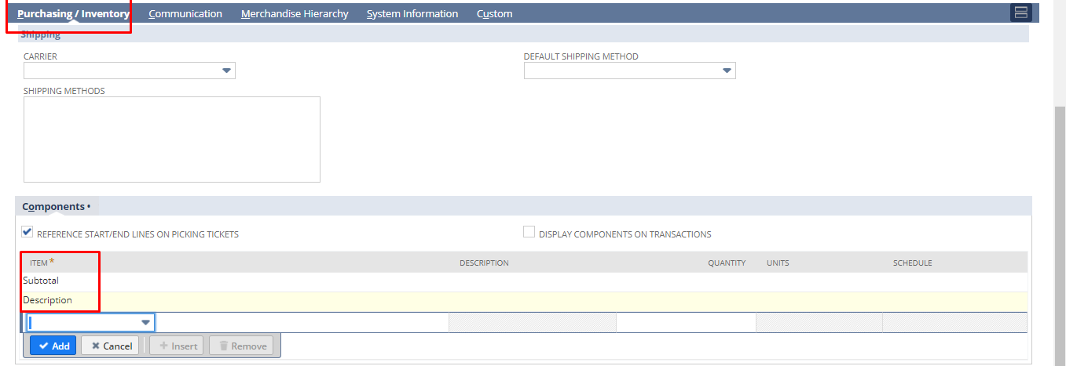

Step 4: Hit the Save button.
Kit/package Item
This is a record to identify several member items that are sold together as one unit. The price of the kit is not dependent on its components' prices and can be assigned several price levels.
Step 1: Non-Inventory Item creation: Navigate to Lists->Accounting->Items->New.

Step 2: Click on kit/package.
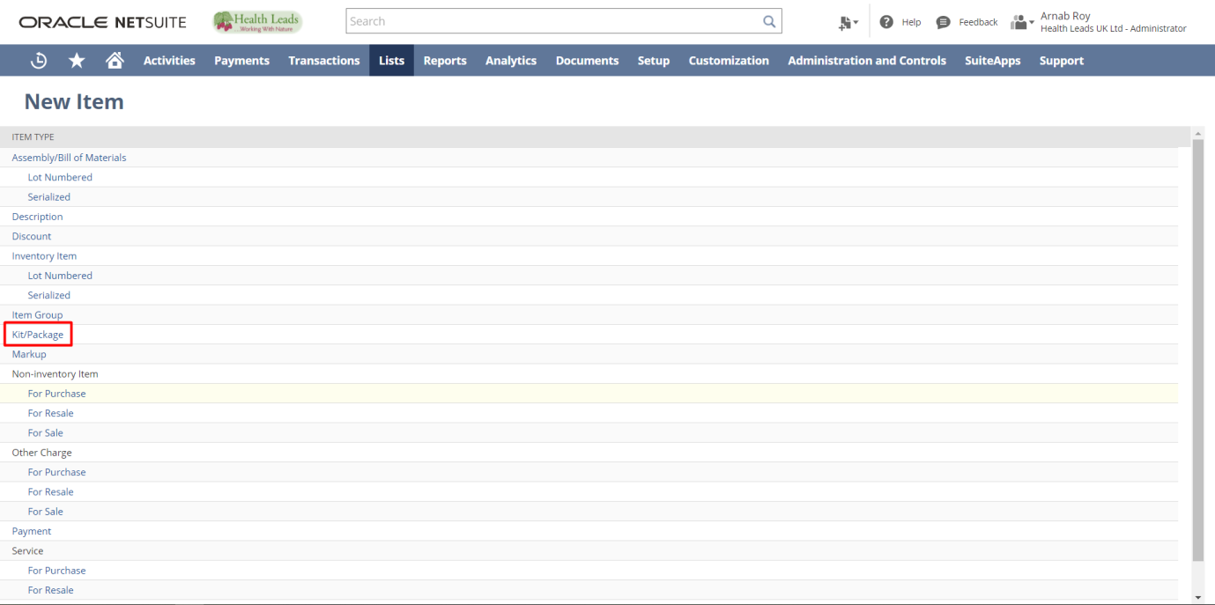

Step 3: Fill the required details for the kit/package Item. Mandatory Fields-Item Name/Number, Tax Schedule and Income account under Account subtab.

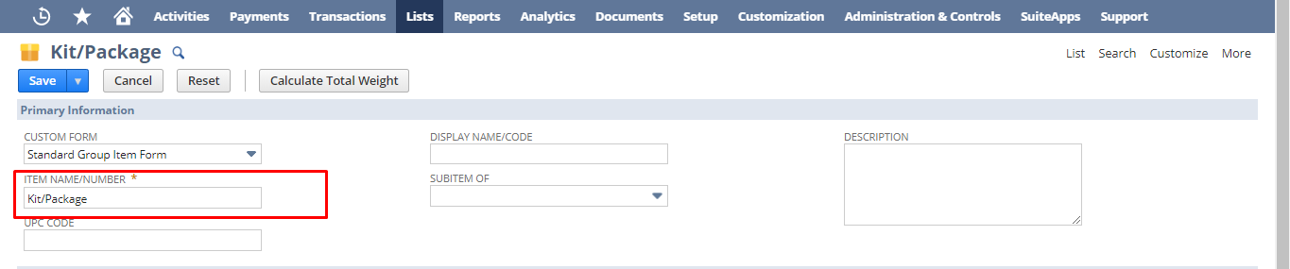

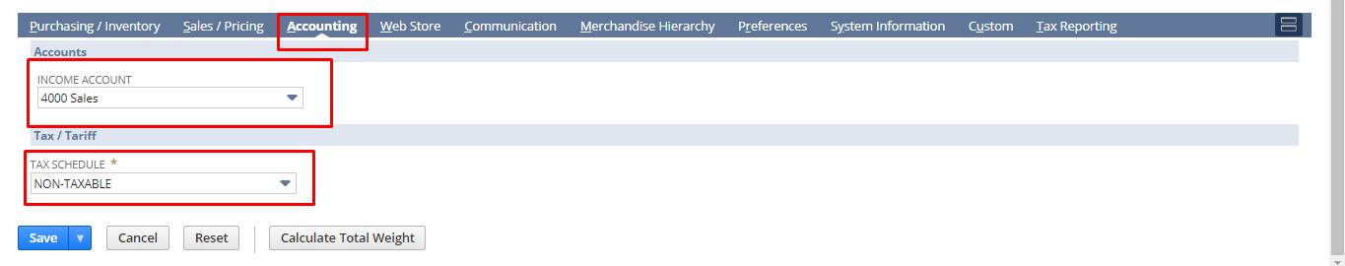

Kit/package item means, an item consist of more than one item and the price of it does not depends on the items containing in it. In order to create a Kit/package item (Example: Makeup kit) you have to select items as well as its quantity for grouping under purchasing tab .
Note: Duplicate items are not allowed in a kit item. Example, suppose in a makeup kit there are three components like one small mirror, A Moisturizer, A Face Primer. Now when we create a kit item with these three components, we cannot select any item twice. If we select any duplicate component then system will give a pop up says “Duplicate kit members are not allowed. Instead, increase the quantity of that member on a single line-item.”
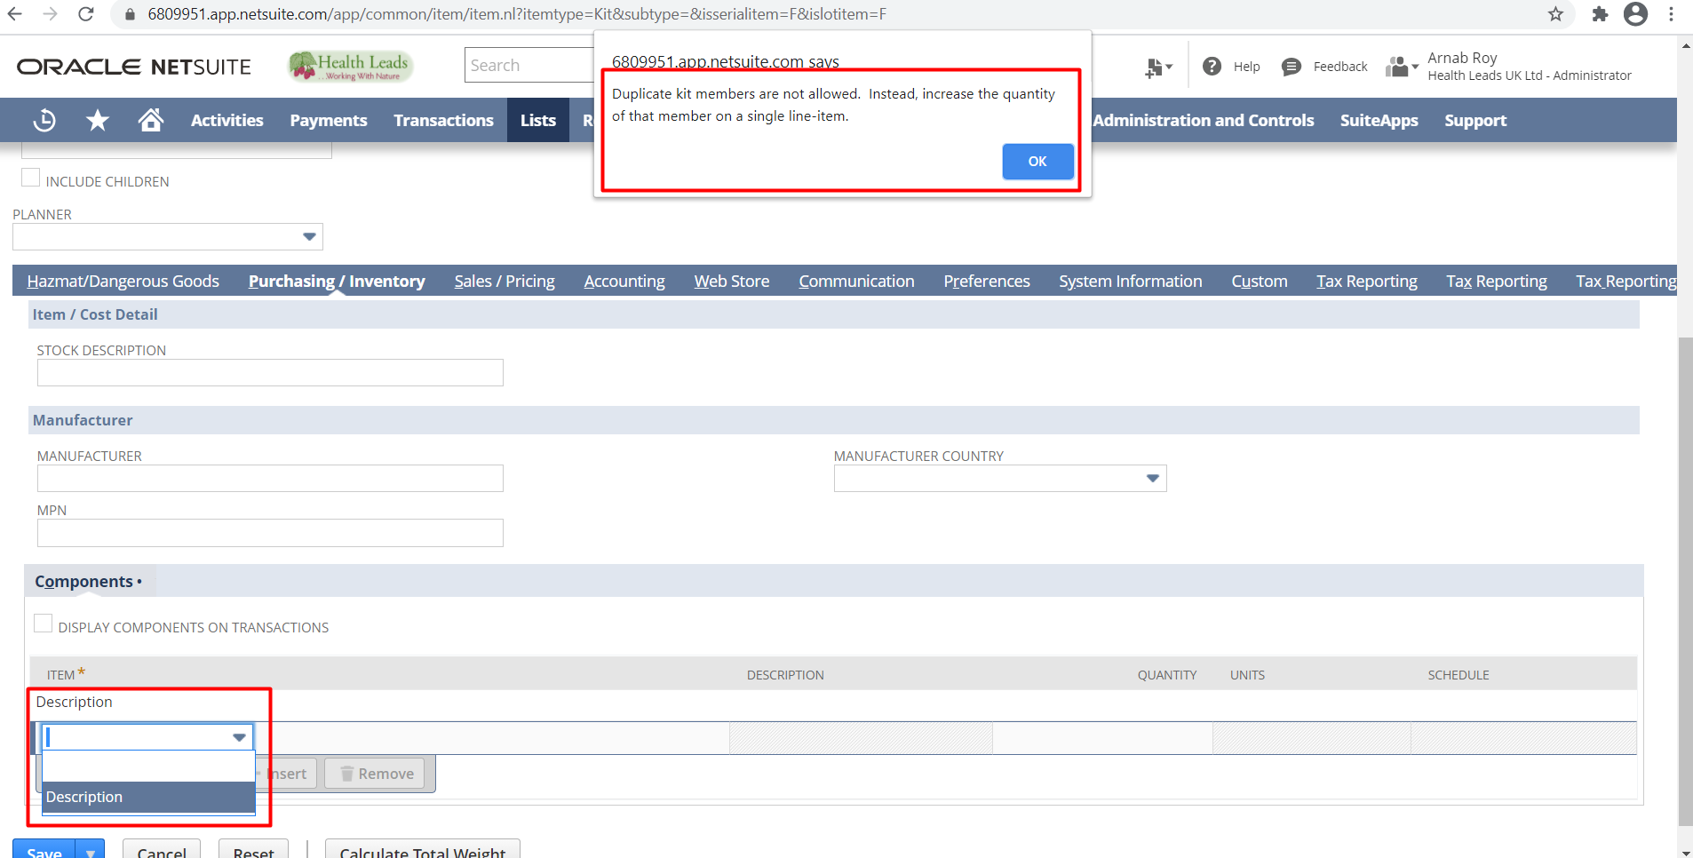

Step 4: Then hit the save button
Markup Item
You can use markup items to apply an additional charge to an order. Using markup items enables you to track markup amounts without affecting inventory valuation.
For example, you can charge a rush fee for expediting a service or delivery. You can choose to markup the amount for this charge by a flat additional fee.
Step 1: Non-Inventory Item creation: Navigate to Lists->Accounting->Items->New


Step 2: Click on Markup items.
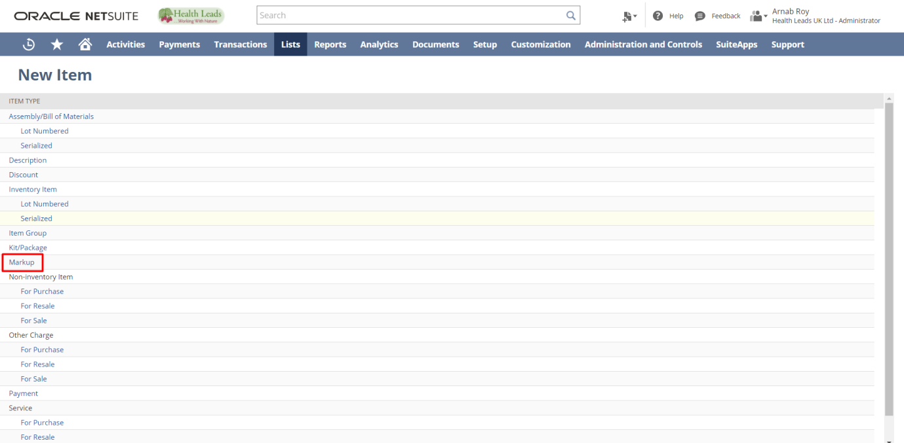

Step 3: Fill the required details for the Markup items Item. Mandatory Fields-Item Name/Number, Rate.
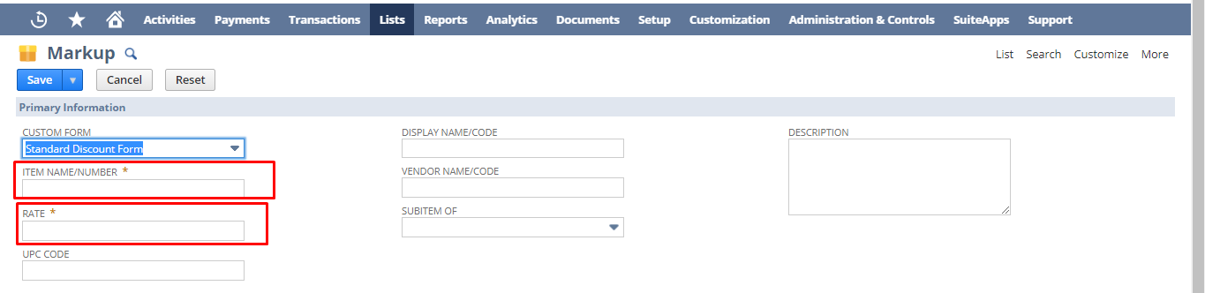
Then fill the Tax Schedule field under Accounting subtab.
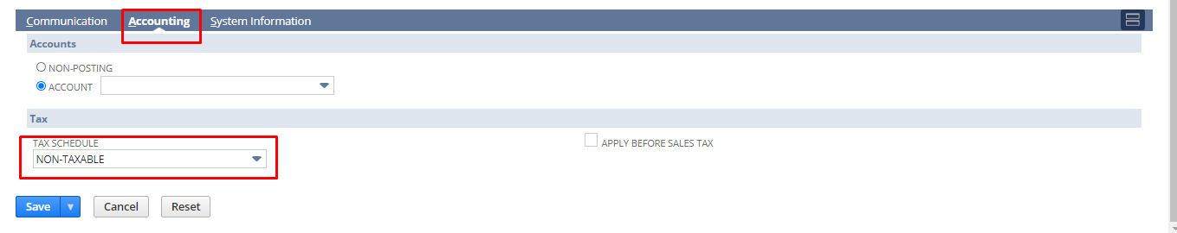
Step 4: Click on save button.

Non-Inventory Item
Items that you always drop ship or other items that you sell or purchase but do not stock can be recorded and tracked as non-inventory items.
For example, you might use non-inventory items in the following ways:
- Non-inventory for sale – to sell items you custom create for each order
- Non-inventory for purchase – office supplies you purchase but do not sell
- Non-inventory for resale – drop-ship items that you do not store but you sell directly from the vendor
Non-inventory for resale
Step 1: Non-Inventory Item creation: Navigate to Lists->Accounting->Items->New.


Step 2: Click on Sale/Purchase/Resale under Non-Inventory
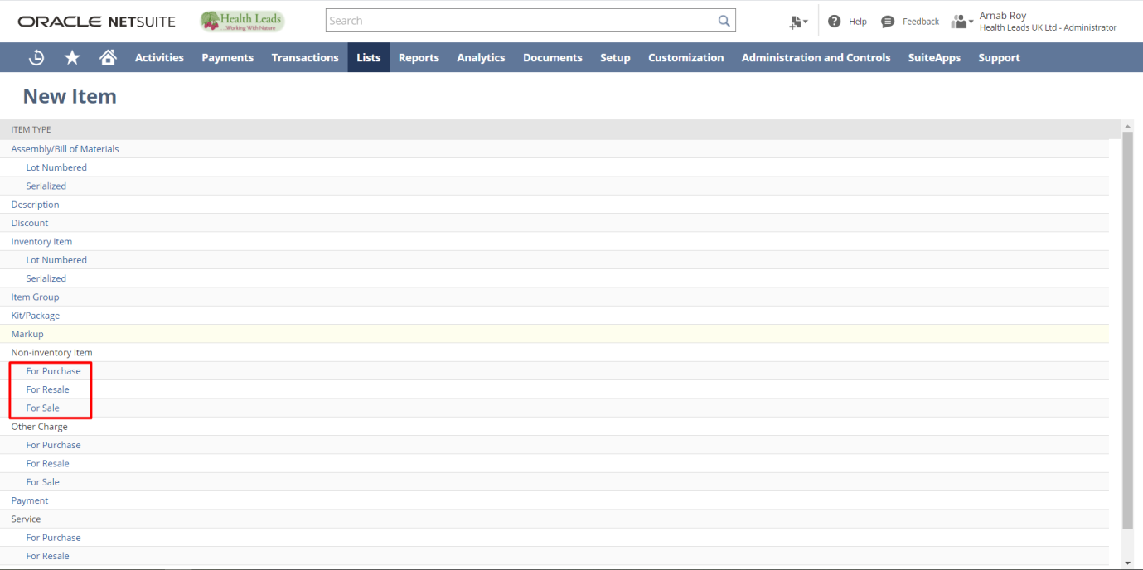
Step 3: Fill the required details for the Non-Inventory Item. Mandatory Fields-Item Name/Number, Tax Schedule, EXPENSE ACCOUNT , INCOME ACCOUNT under Accounting subtab and put other necessary details & then click the “Save” button.

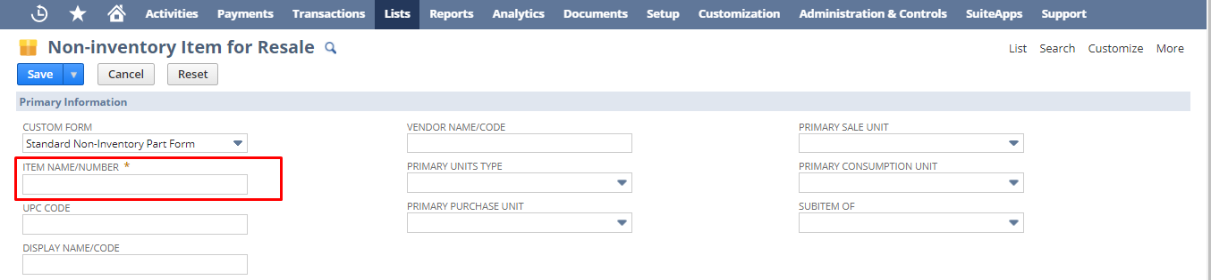

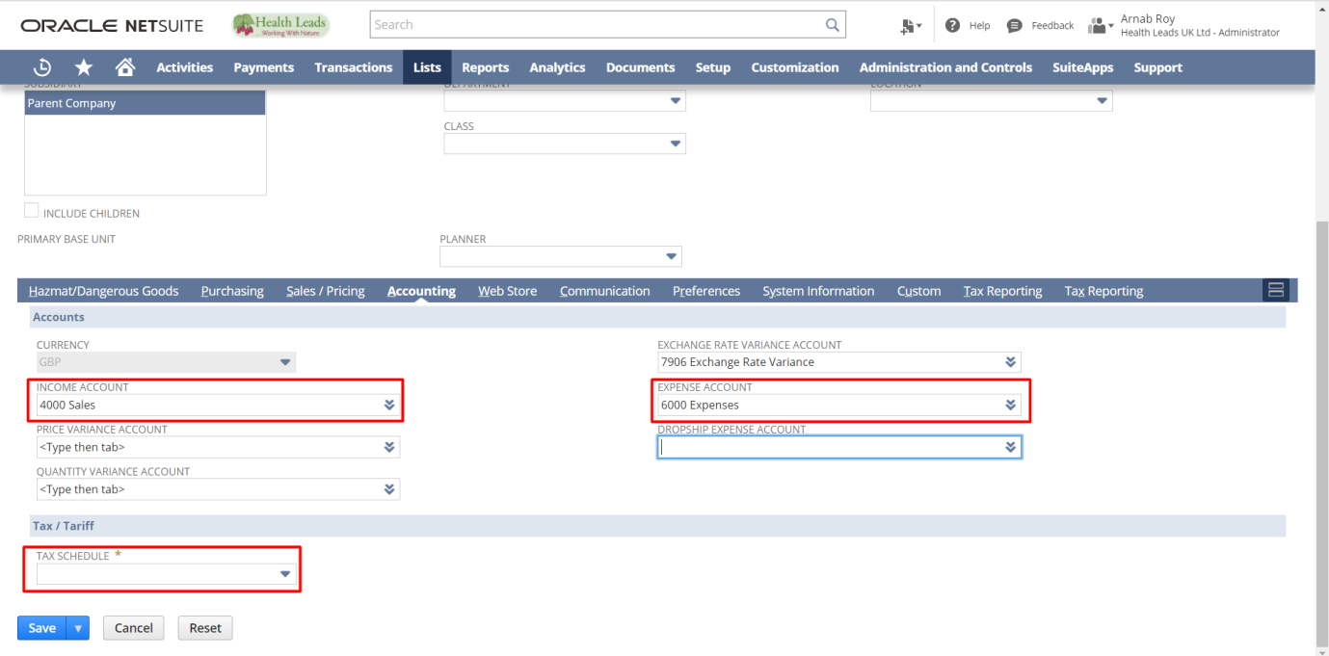

Under purchasing tab, please put vendor specific purchase price

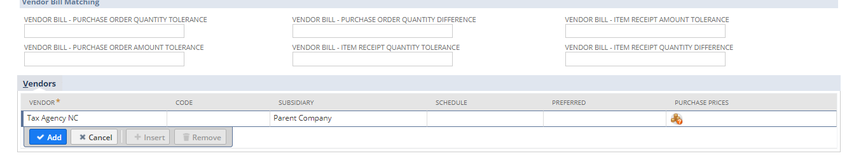
Here, you can select the purchase price against each vendor. In order to set price, you have to click on the icon under purchase prices field. After clicking on that you redirect to a subtab shown below. In the subtab you can select the currency and price.


Step 4: click on save button.
Non-inventory for sale
Step 1: Non-Inventory Item creation: Navigate to Lists->Accounting->Items->New.


Step 2: Click on Sale/Purchase/Resale under Non-Inventory


Step 3: Fill the required details for the Non-Inventory Item. Mandatory Fields-Item Name/Number, Tax Schedule, INCOME ACCOUNT under Accounting subtab and put other necessary details & then click the “Save” button.
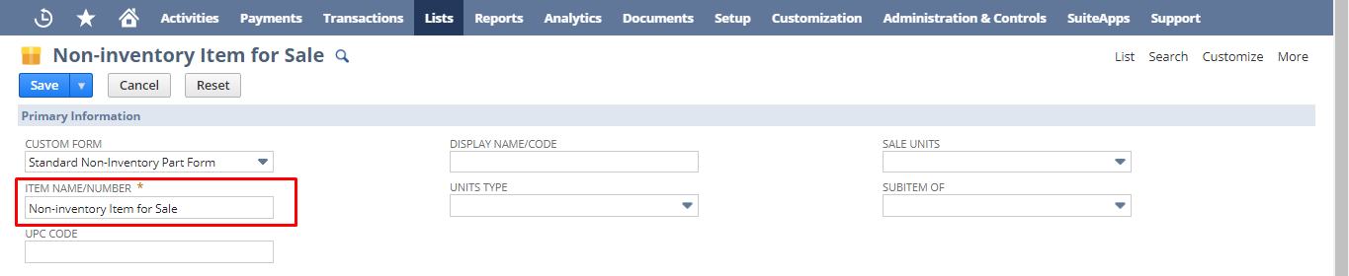

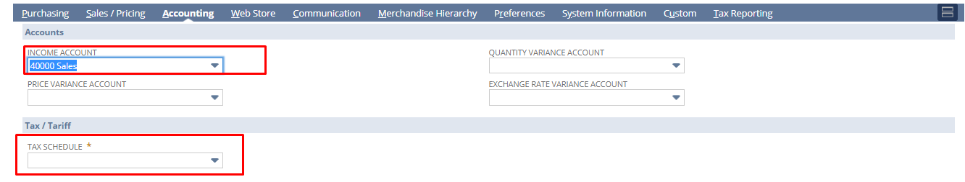

Step 4: click on save button.
Non-inventory for purchase
Step 1: Non-Inventory Item creation: Navigate to Lists->Accounting->Items->New.


Step 2: Click on Sale/Purchase/Resale under Non-Inventory.


Step 3: Fill the required details for the Non-Inventory Item. Mandatory Fields-Item Name/Number, Tax Schedule, Expense Account under Accounting subtab and put other necessary details & then click the “Save” button.
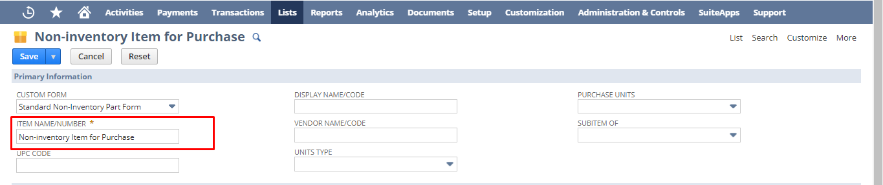

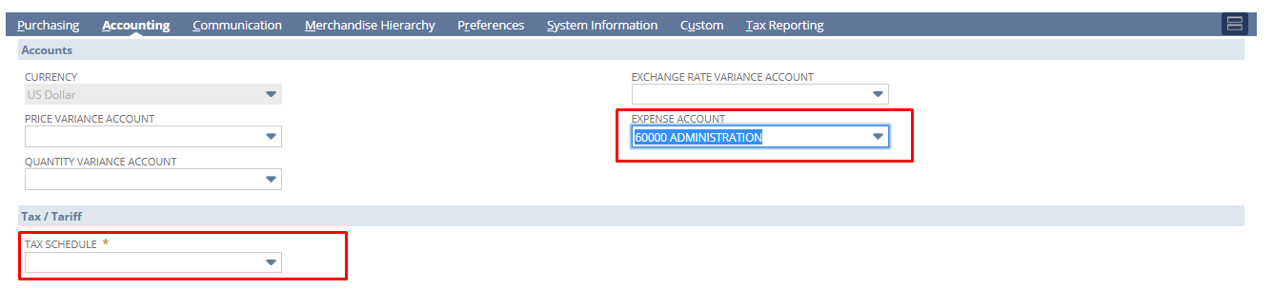

Under purchasing tab please put purchase price, purchase description and vendor specific purchase price
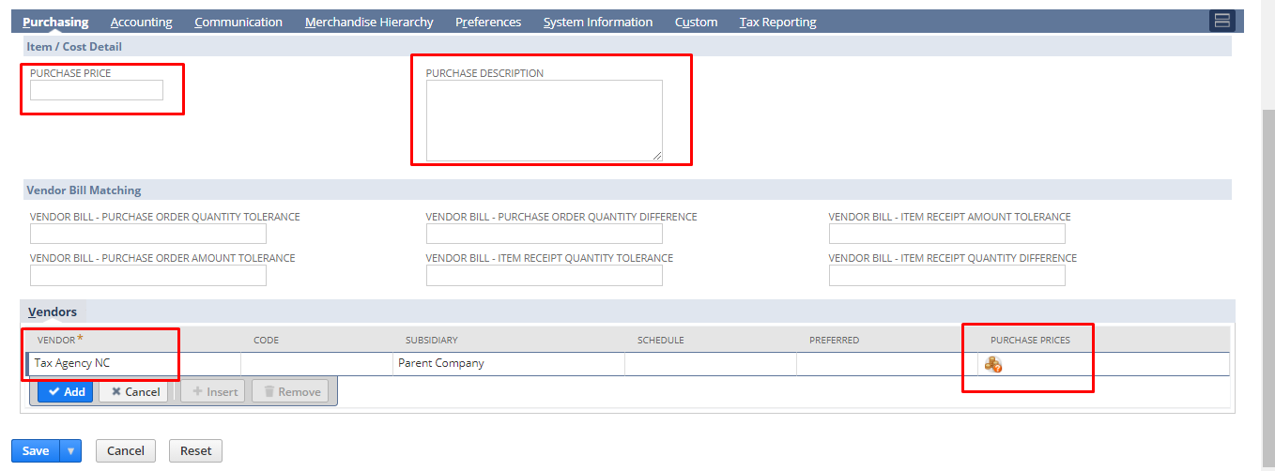

Here, purchase price means when a vendor buys the item, he would see this amount which you put in purchase price field and purchase description means when a vendor buys an item, he would know the item by this description of the item.

Here, you can select the purchase price against each vendor. In order to set price, you have to click on the icon under purchase prices field. After clicking on that you redirect to a subtab shown below. In the subtab you can select the currency and price.



Step 4: click on save button.

Other Charge Item
Step 1: Other Charge Item creation: Navigate to Lists->Accounting->Items->New.

Step 2: Click on Sale/Purchase/Resale under Other Charge Item

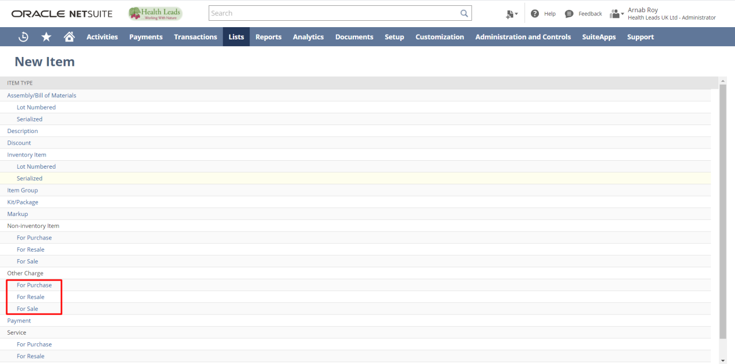
Step 3: Fill the required details for the Non-Inventory Item. Mandatory Fields-Item Name/Number, Tax Schedule under Accounting subtab and put other necessary details & then click the “Save” button.
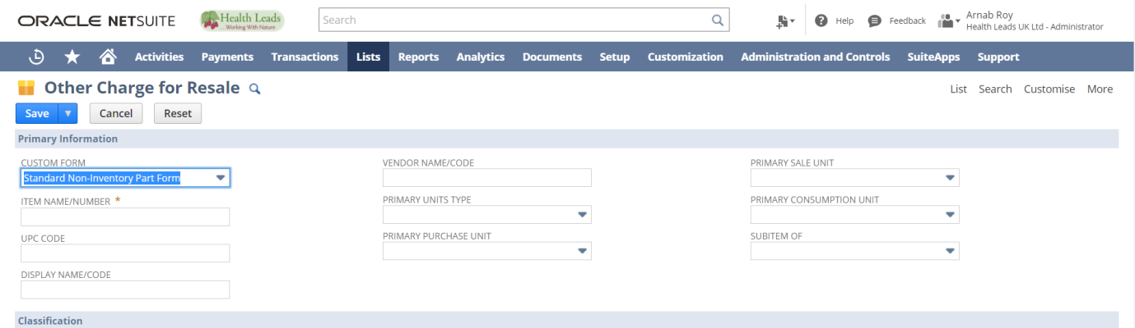
Under Accounting tab, put ‘Income’ & ‘Expense’ Account and Tax Schedule


Service Item
A service item is an item you create to track time and record billable hours.
Service items are classified as Services for Purchase, Services for Resale, or Services for Sale.
- Services for Purchase – services your business buys but doesn't sell to customers
- Services for Resale – services your business buys and then sells to customers
- Services for Sale – services your business sells but doesn't buy

For example, Wolfe Software creates a service item called Installation. Since Wolfe's employees are providing the service, this service is considered a Service for Sale. When entering time records, employees can select this item to identify the amount of time they spent installing software for a customer. Then, Wolfe Software can invoice the installation time to the appropriate customer.
1. Service for resale:-
Step 1: Service Item creation: Navigate to Lists->Accounting->Items->New.

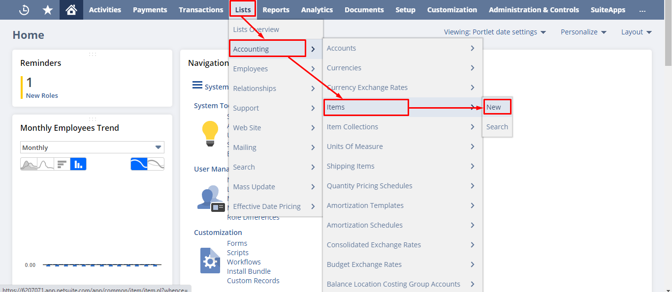

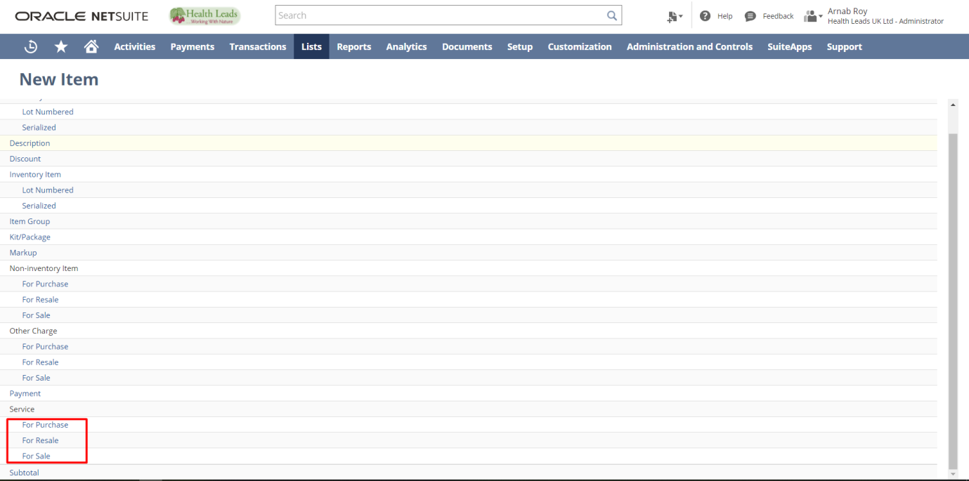
Step 2: Click on for ‘for Resale’ under Service

Step 3: Fill the required details for the Item. Mandatory Fields-Item Name/Number, Tax Schedule under Accounting subtab and put other necessary details & then click the “Save” button.

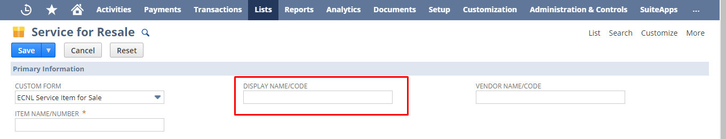
Under Accounting tab, put ‘Income’ & ‘Expense’ Account and Tax Schedule


2. Service for sale:-
Step 1: Service Item creation: Navigate to Lists->Accounting->Items->New.





Step 2: Click on for ‘for Sale’ under Service

Step 3: Fill the required details for the Item. Mandatory Fields-Item Name/Number, Tax Schedule under Accounting subtab and put other necessary details & then click the “Save” button.

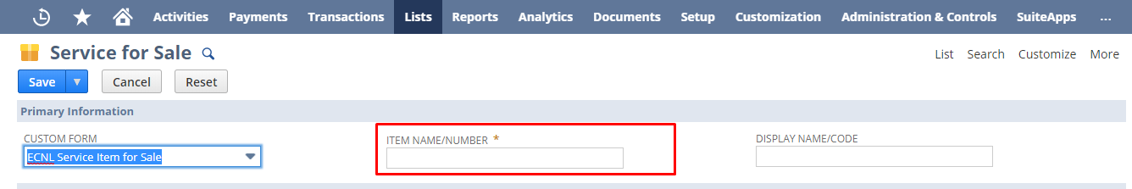
Under Accounting tab, put ‘Income Account’ and ‘Tax Schedule’.

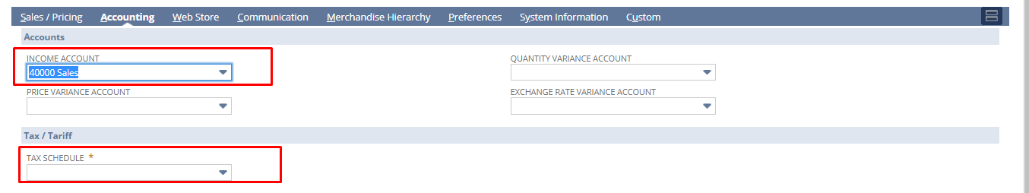

3. Service for purchase :-
Step 1: Service Item creation: Navigate to Lists->Accounting->Items->New.




Step 2: Click on for ‘for Purchase’ under Service

Step 3: Fill the required details for the Item. Mandatory Fields-Item Name/Number, Tax Schedule under Accounting subtab and put other necessary details & then click the “Save” button.

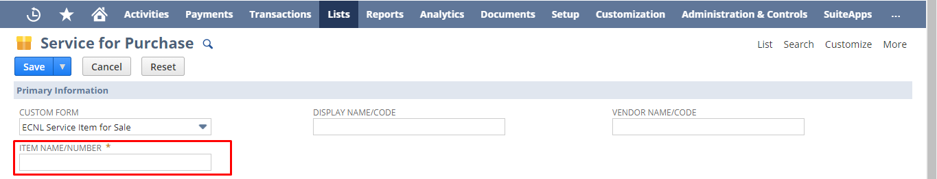

Under Accounting tab, put ‘Expense Account’ and ‘Tax Schedule’.

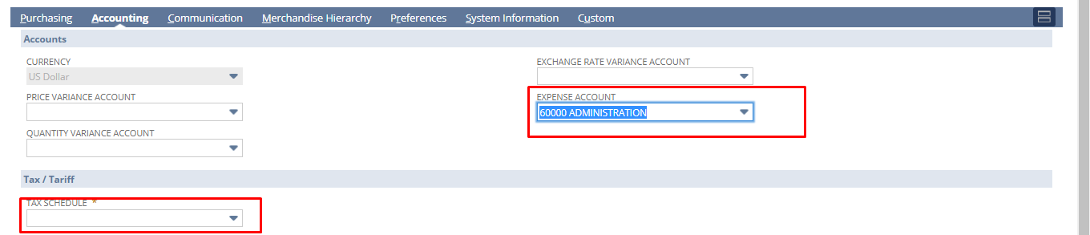

HEALTH LEADS UK LTD:
PROCURE TO PAY
DOCUMENT

Paapri Cloud Technology

Process Flow:
STEP 1: To create a Purchase order, follow the navigation below:
Transactions->Purchases -> Enter Purchase Orders
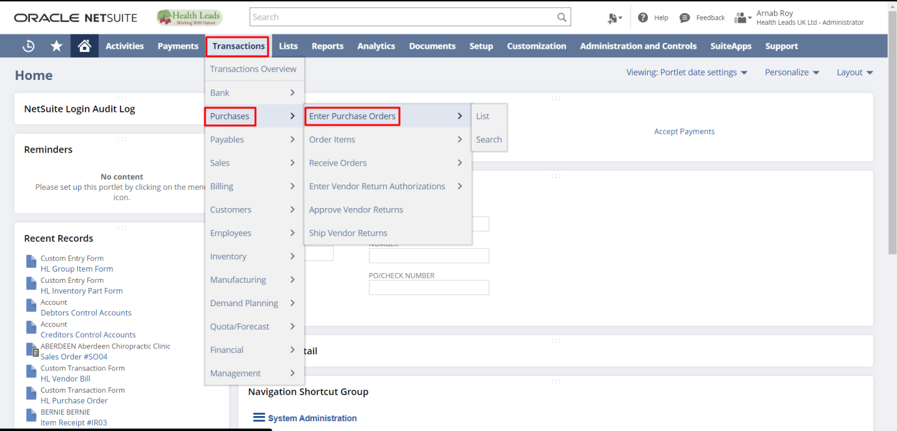

STEP 2: Enter the details for the Purchase Order (Mandatory Fields-Vendor) for the raw materials/finished goods.
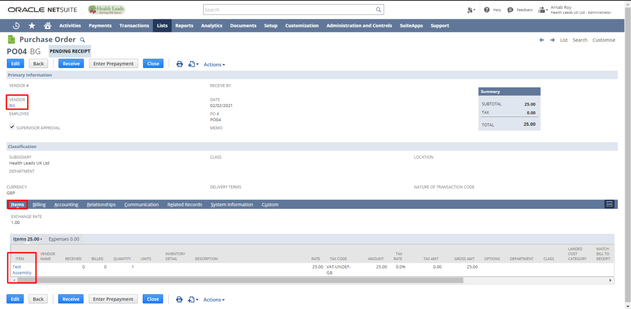

Select the Items from the Item dropdown. Enter the quantity. Click the “Add” button to add the Item. Click the “Save” button.

STEP 3: If the Purchase order needs to be printed hit the print button, the print button is highlighted.
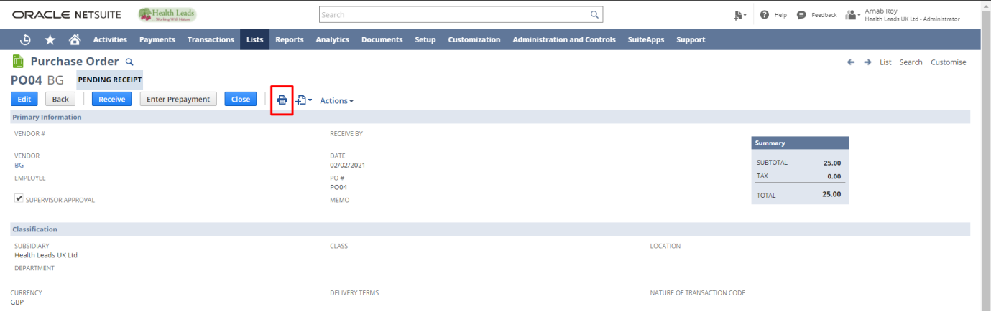
Printed purchase order will look like this,
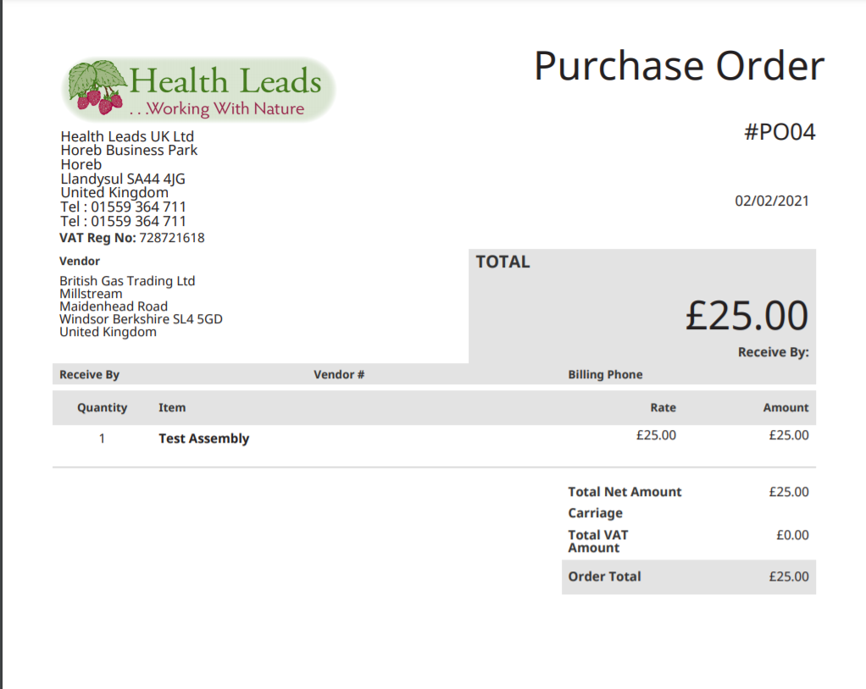

STEP 4: Once the Purchase Order is created then you have to receive them.
Click “View” button on the Purchase Order you want to receive.
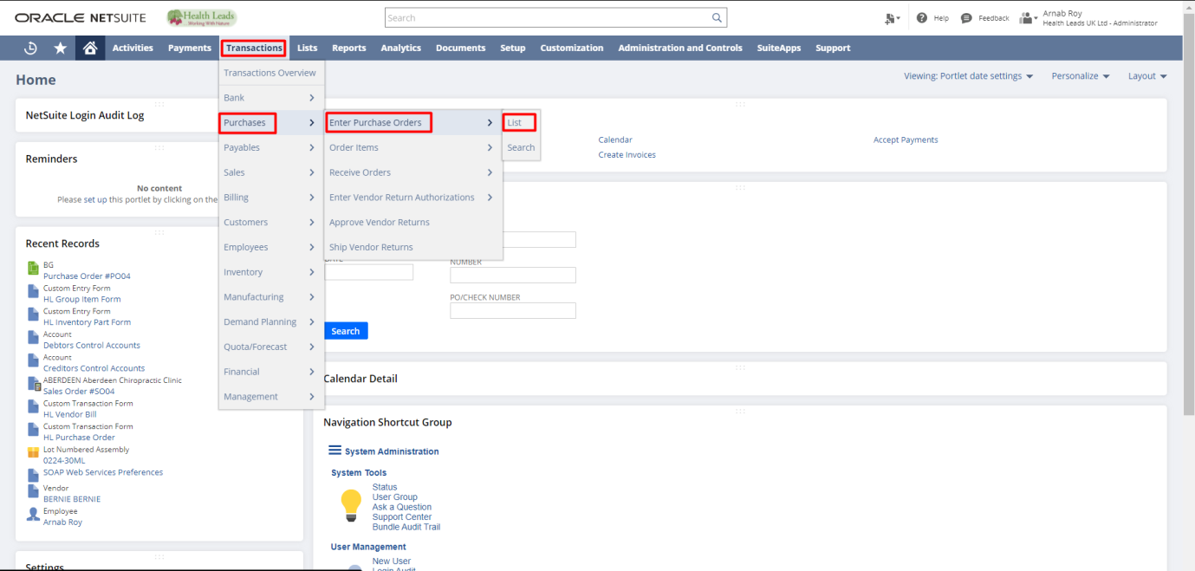
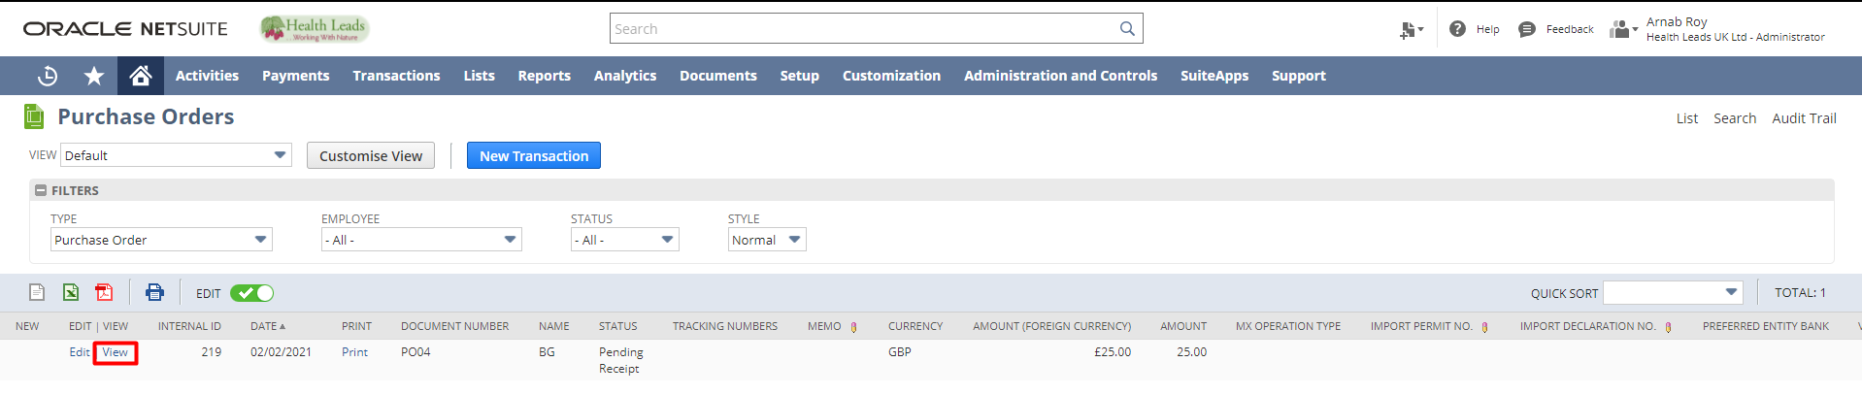

STEP 5: Click on the “Receive” button.
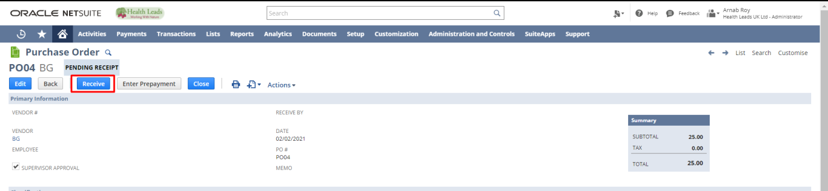
Select the Item and location then click the “Save” button.
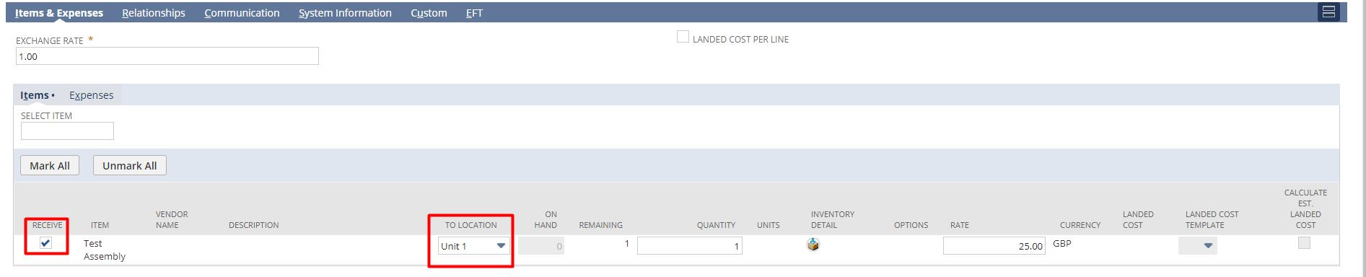

STEP 6: We can create Vendor Bills in NetSuite using Bill Purchase Orders functionality. It allows us to create a single bill for one or even multiple Purchase Orders for the same vendor.
Transactions->Payables -> Bill Purchase Orders
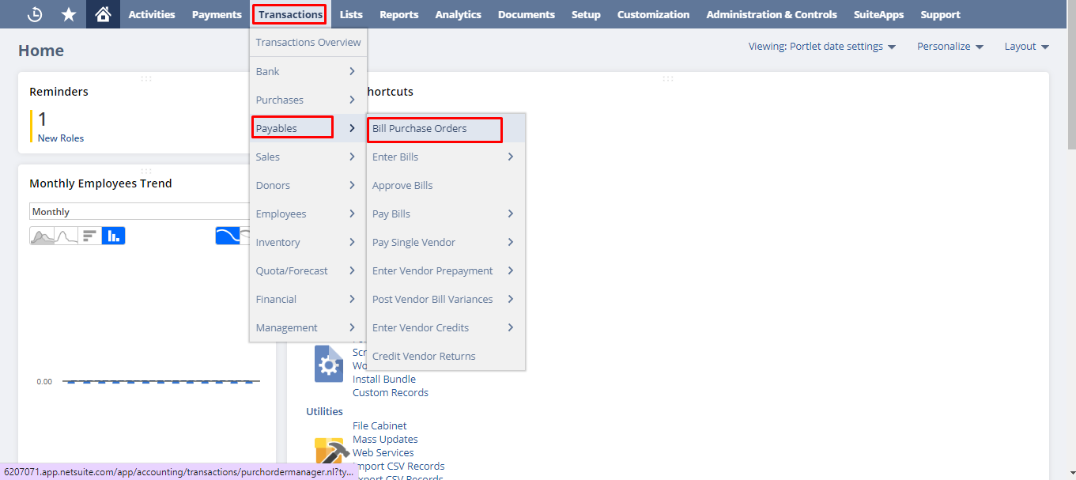

From the Vendor dropdown, select the Vendor. From the Bill list check the check box for the Purchase Orders you want to Bill. Click the “Submit” button.
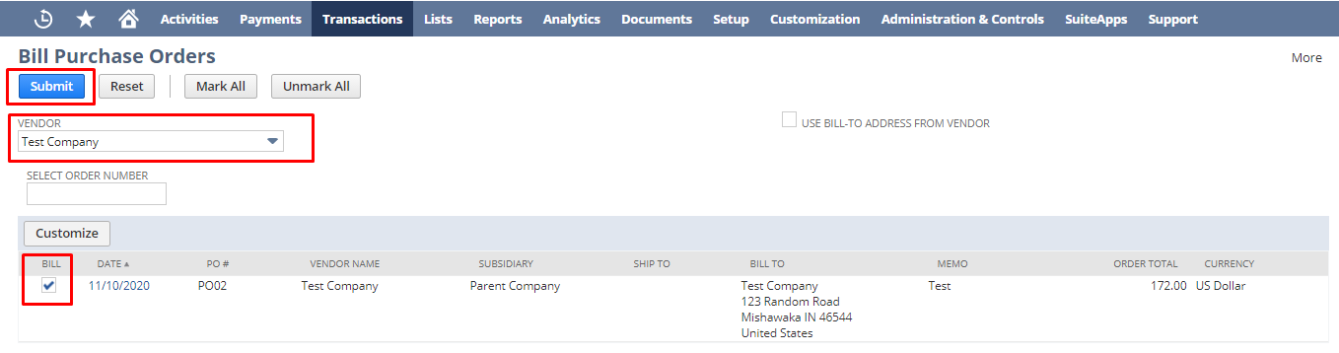

Enter the Reference No and other details if any. Click the “Save” button.
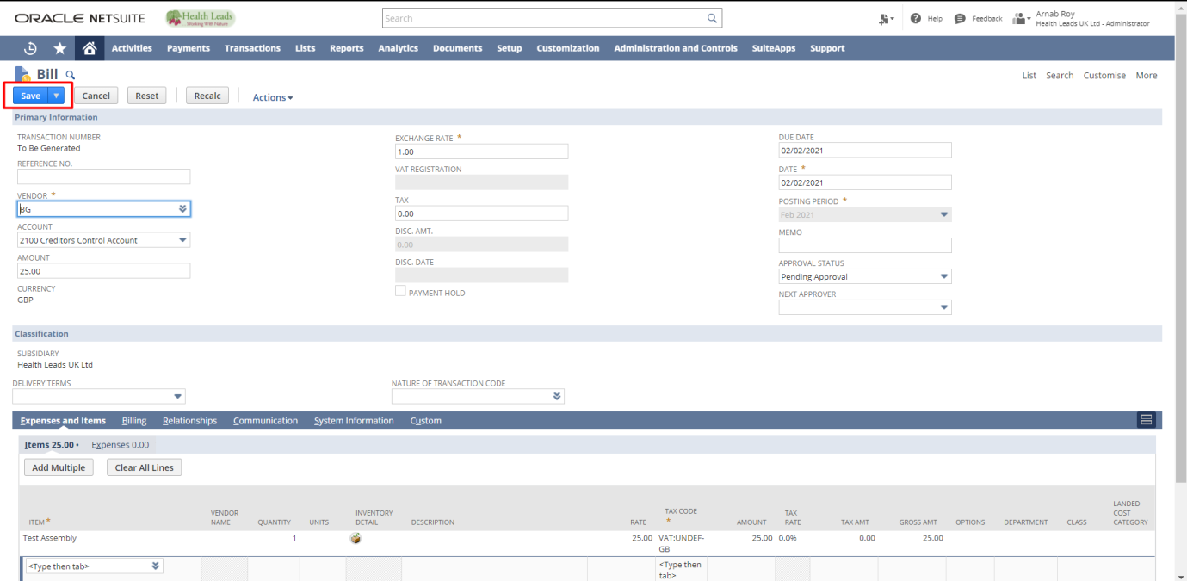

STEP 7: To make Payment for a Vendor Bill go to the Bill you want to pay.
Transactions->Payables ->Enter Bills->Lists
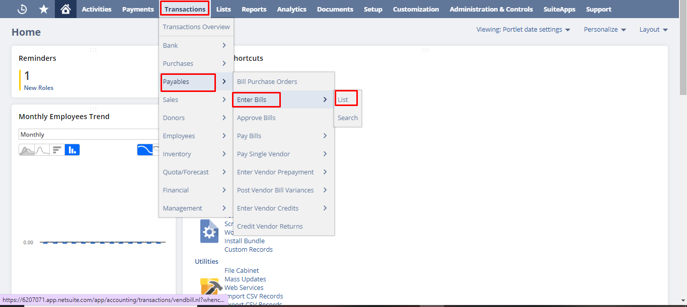

Click “View” button on the Bill for which you want to make payment.
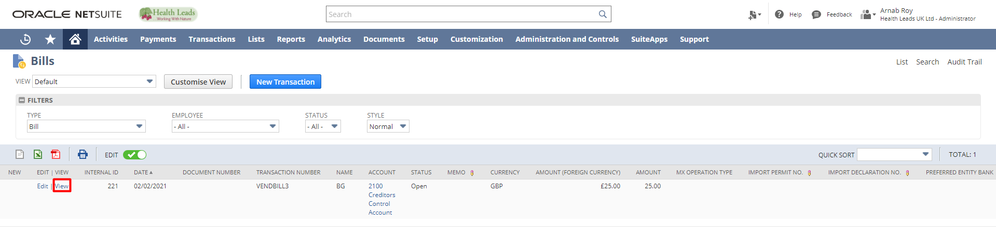

Click on the “Make Payment” button. If make payment button will not come then just change the Approval status to Approved and click save.
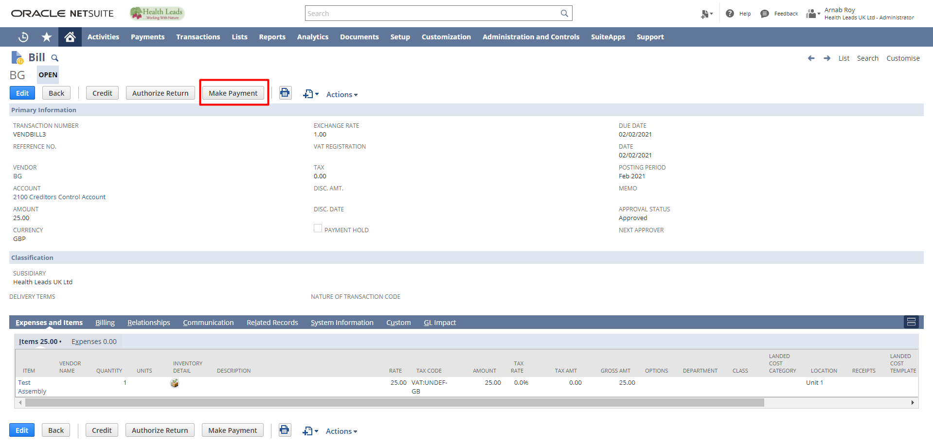

Enter other details if any for the fields in the form. Click the “Save” button.
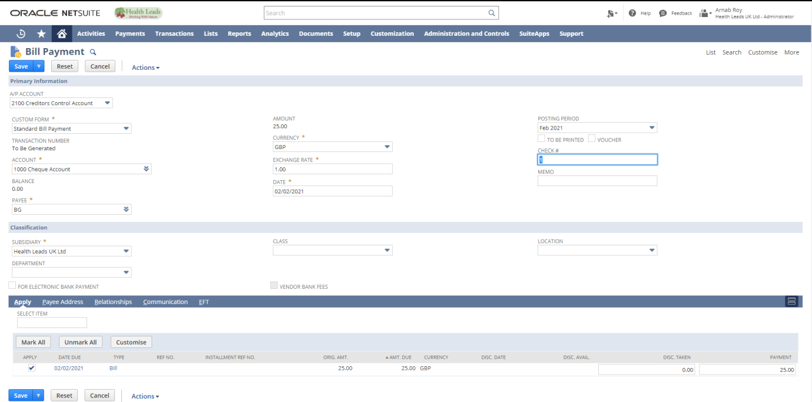

Bill Payment has been completed

STEP 8: To create Vendor Credit
Go to Transactions > Payables > Enter Vendor Credits
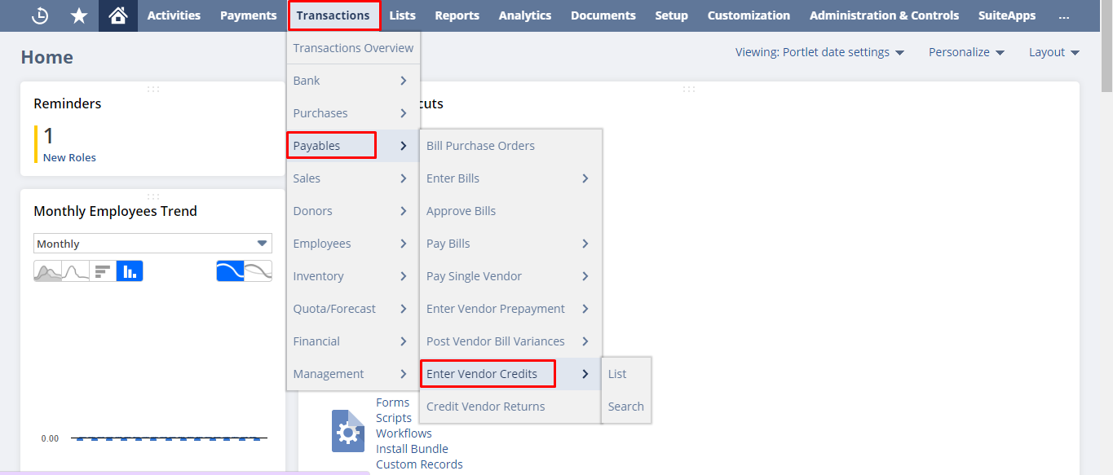

Enter credit details and Save.

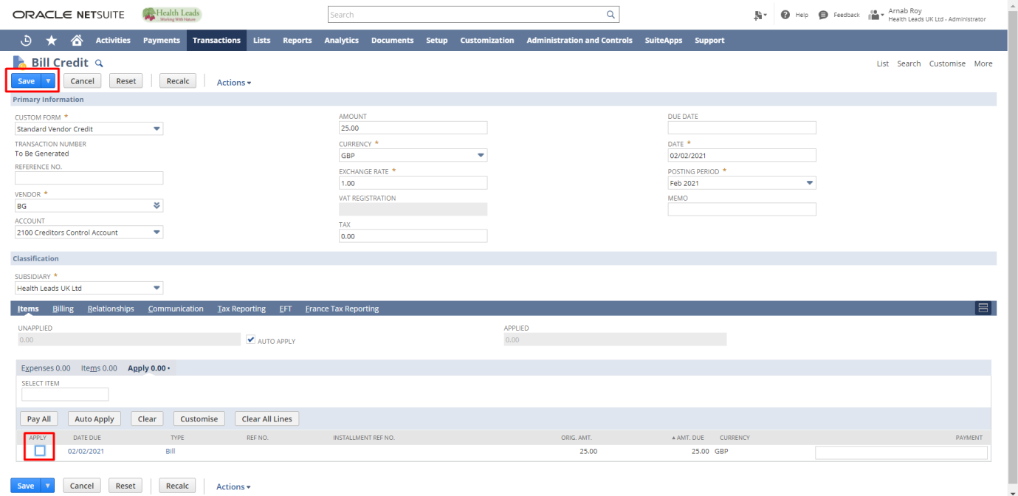

Check the box for the relevant bill under Apply under Items, and then click Save.
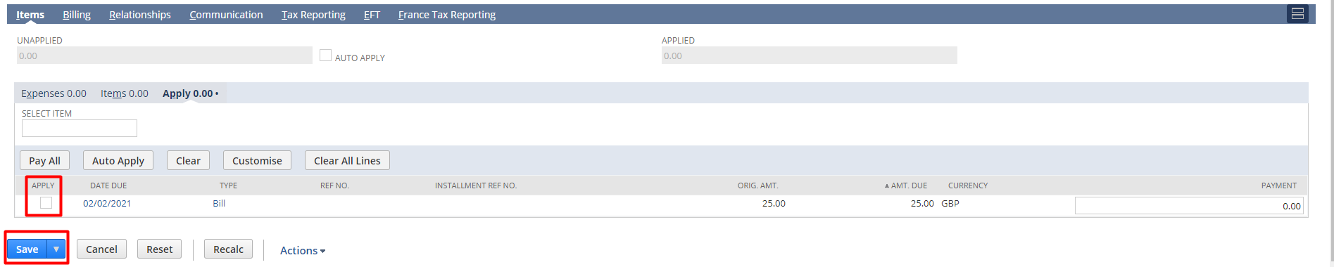

For Vendor Return Authorization

It can be initiated at either the Purchase Order or the Purchase Bill. You can click on the Authorize Return button on the Purchase Bill or the Purchase Order.
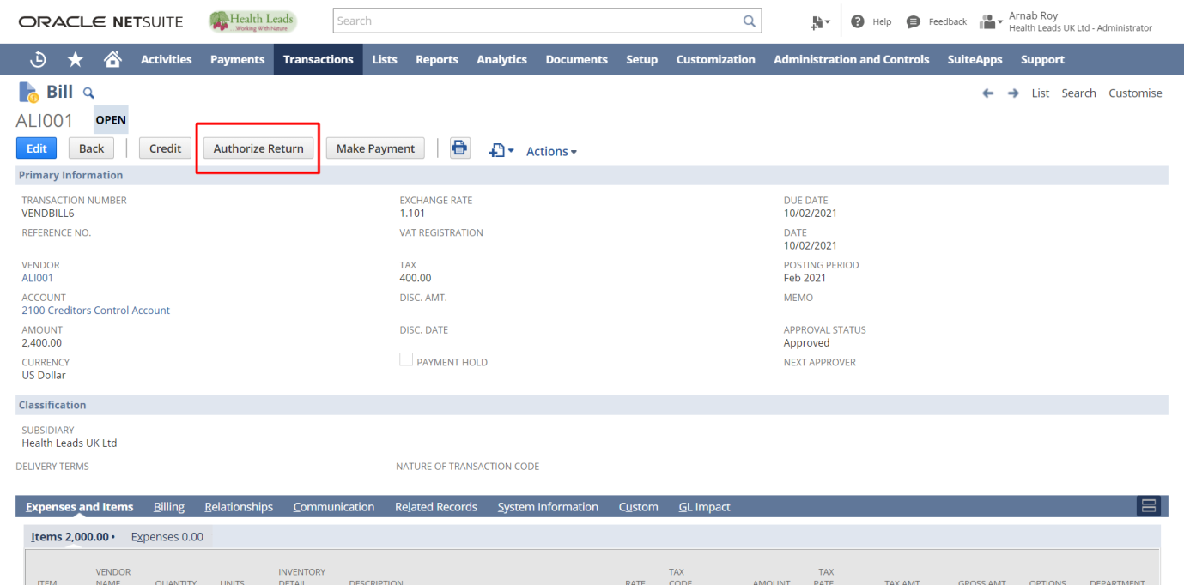

You would see all the default information will get auto loaded in the Vendor Return Authorization form, you can edit the quantity of Items you wish to return.
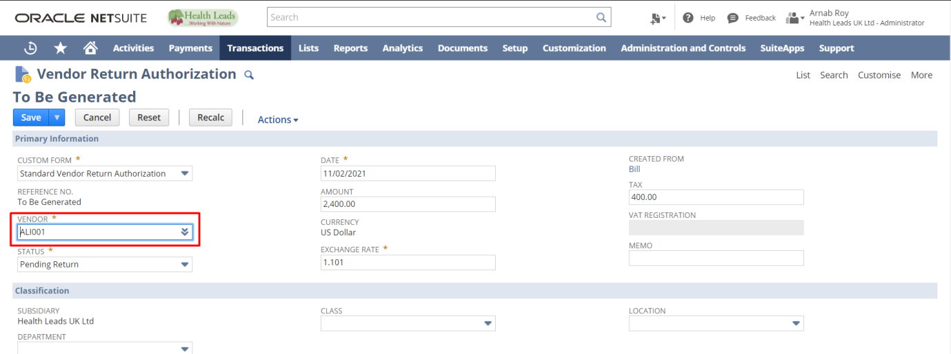
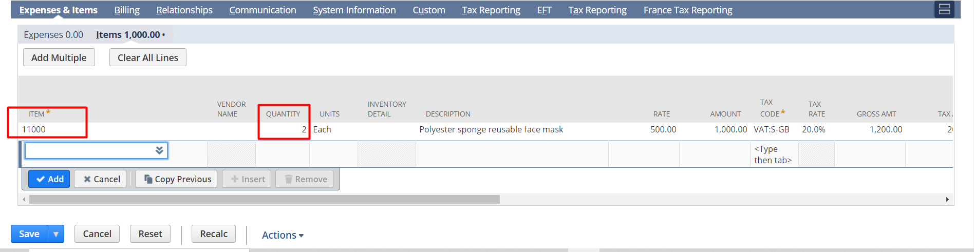

Click on ‘Save’.

Once you save the Vendor Return authorization, you need to fulfil the return of the items as it will be reduced from your inventory, to do that we navigate to Ship Vendor return authorization using the following navigation, TransactionPurchasesShip Vendor Returns.

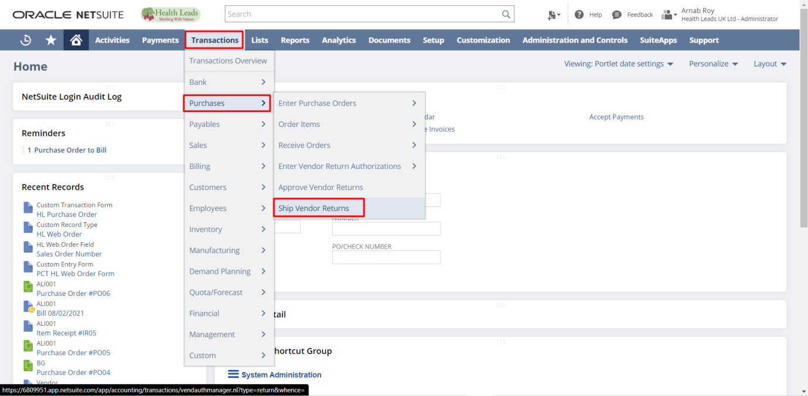

Select the appropriate Vendor return, you can filter by vendor or directly by the return number
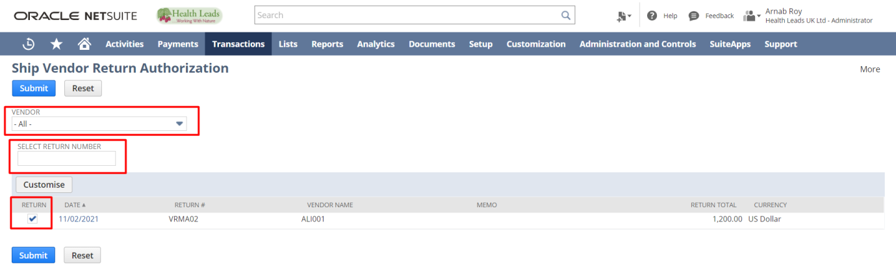
Then click on ‘Submit’.

You will be redirected to the Item fulfilment form, we recommend you to cross check the items and all the relevant details

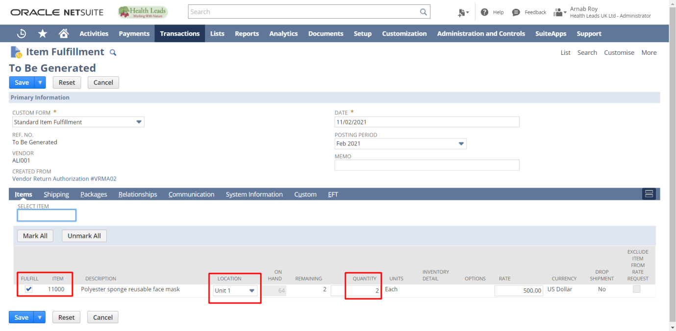

Then click on ‘Save’.

After saving you can click on credit, you will be redirected to the Bill credit screen
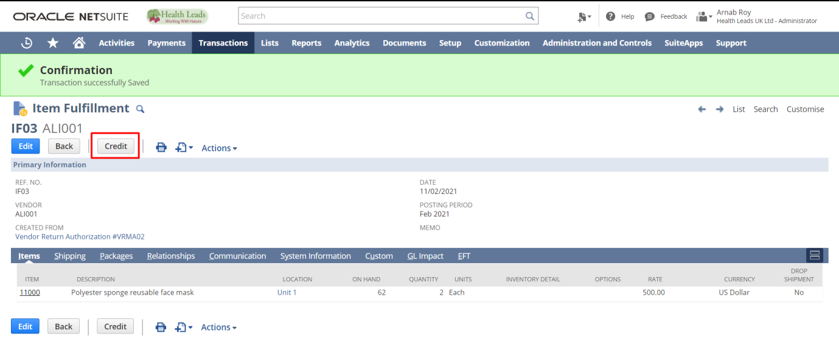

Now you can use this screen to adjust the credit with any outstanding Bills of the respective vendor

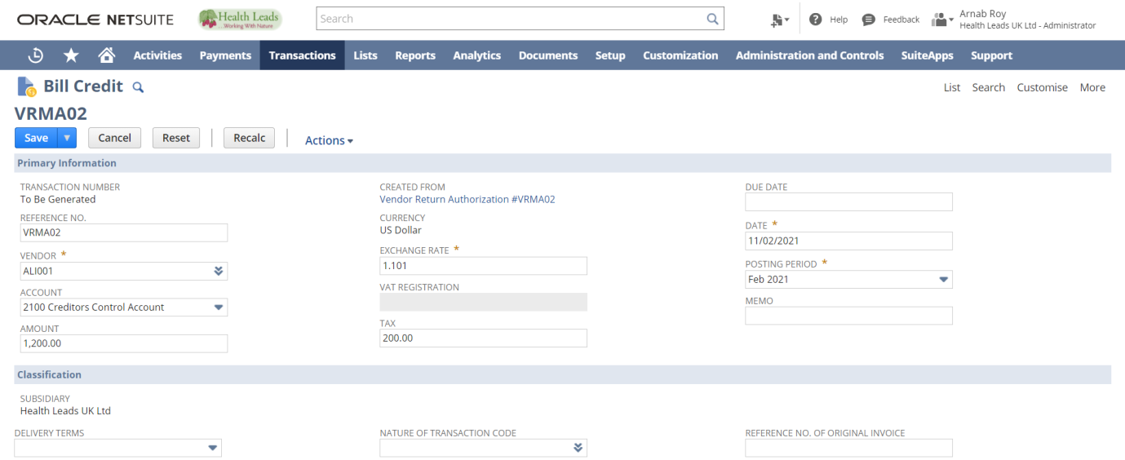

You can go to the ‘Apply’ tab and select the corresponding bill

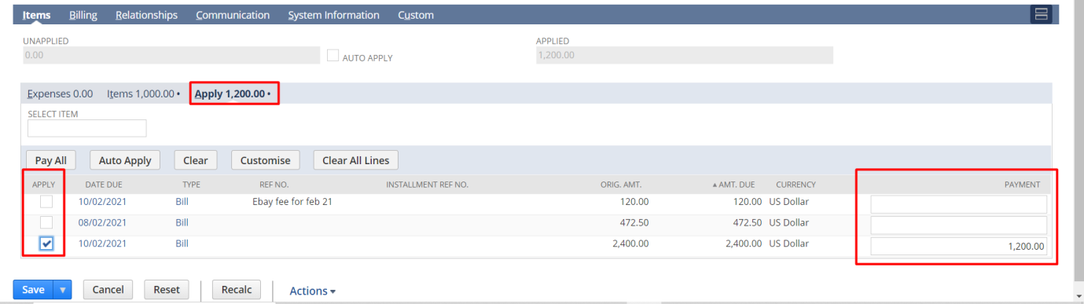

Then click ‘Save’.

When you make payment for the selected bill, the adjusted amount will automatically be deducted from the amount you need to pay for that particular bill. The above can be demonstrated as follows
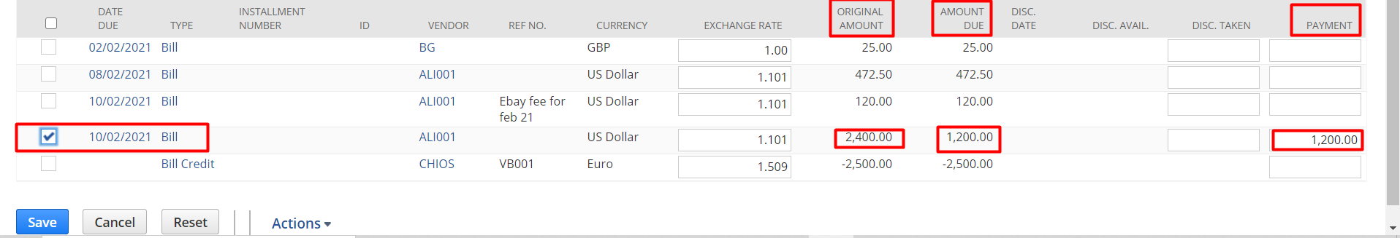

HEALTH LEADS UK LTD:
PLAN TO PRODUCE
DOCUMENT

Paapri Cloud Technology

Plan To Produce: Process Flow

Manufacturing Routing:
The Manufacturing Routing and Work Center feature enables you to schedule and record manufacturing operational activities against a complex work order that requires multiple teams of employees, or work centers. For example, you may have a set of operations for the following: a preparation team, an assembly run team, and a quality assurance team.
You can use Manufacturing Routing to record quantity assembly completions, team resource costs, and process overhead costs against individual work order operations.

Setting Up Manufacturing Routing:
The following steps must be completed to set up your account to use the Manufacturing Routing and Work Center feature.
- To enable the feature, see Enabling the Manufacturing Routing Feature.
- To set preferences, see Setting Routing Preferences.
- To define cost categories, see Defining Cost Categories for Routing.
- To define manufacturing charge items, see Defining a Manufacturing Charge Item.
- To group manufacturing charge items into a cost template, see Creating Manufacturing Cost Templates.
- To define resources, see Creating Manufacturing Work Centers or Groups and Work Center Calendars. Click Help and read Creating Manufacturing Work Centers or Groups.
- To create routings, see Creating a Manufacturing Routing.
- To set up standard costing, (for accounts using the Standard Costing feature), see Standard Costing for Manufacturing Routing.

Setting Routing Preferences:

When you use the Manufacturing Routing and Work Center feature, you have the option to enable the Show Planned Capacity on Work Orders preference to help manage work order planning. This preference lets production managers and planners monitor planned completion times for work order builds against work centre capacity.

Zip

Defining Cost Categories for Routing:

You can create one of eight cost categories to use with Manufacturing Routing. These cost categories help define expenditures associated with a work order. For example, you have a warehouse and employ workers to assemble widgets that you sell. You need to track costs associated with employee labor, warehouse machines, and overhead associated with each work order. The cost categories below can be used to help track these cost:
Direct Cost
The costs are calculated when you record time for these items.
- Labor Setup – Cost of time for labor to set up a run For example, this is the cost of paying an employee to set up the machine that will be used to paint the widget.
- Labor Run – Cost of time for labor to run an assembly For example, this is the cost of paying an employee to use the machine that paints the widget during the assembly run.
- Machine Setup – Cost of time spent to set up a machine to be used in a run For example, each time you set up the machine that paints the widget, wear and tear costs you .02 cents.
- Machine Run – Cost of time spent to run a machine during assembly For example, each time you use the machine that paints the widget for an assembly run, wear and tear costs you .04 cents.
Overheads
- Labor Setup Overhead – Cost of overhead associated with labor to set up a run For example, this is the safety training expense incurred for an employee who sets up the machine used to paint the widget.
- Labor Run Overhead – Cost of overhead associated with labor to run an assembly For example, this is the safety training expense incurred for an employee completes an assembly run.
- Machine Setup Overhead – Cost of overhead associated with setting up a machine used in a run For example, this is the water expense incurred by running a machine during the machine set up.
- Machine Run Overhead – cost of overhead associated with running a machine during assembly For example, this is the water expense incurred by running a machine during an assembly run.

To set up a cost category for Manufacturing Routing:
  - To add choices to this list, go to Setup > Accounting > Setup Tasks > Accounting Lists.
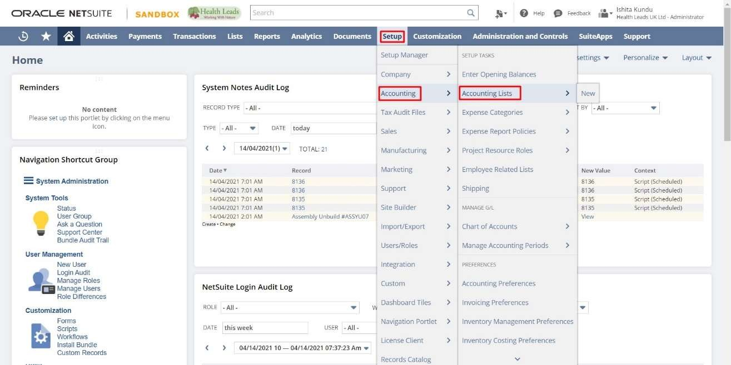

Click “New”.
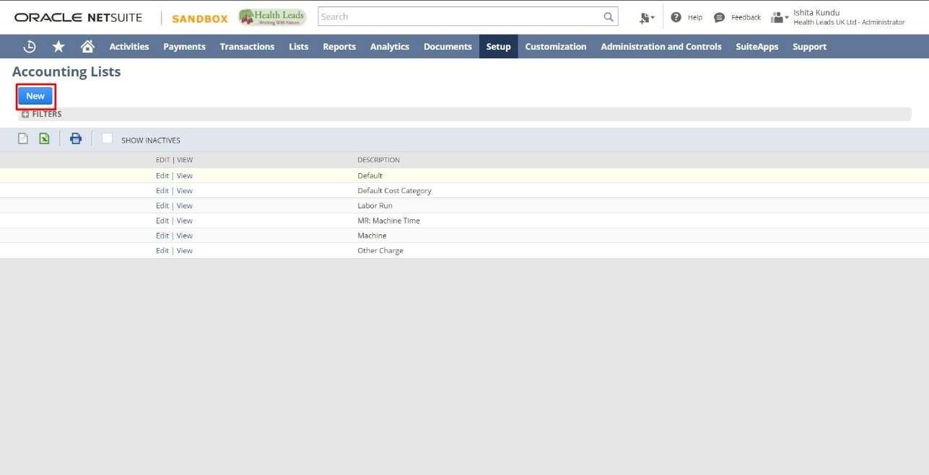

  - Click “Cost Category”
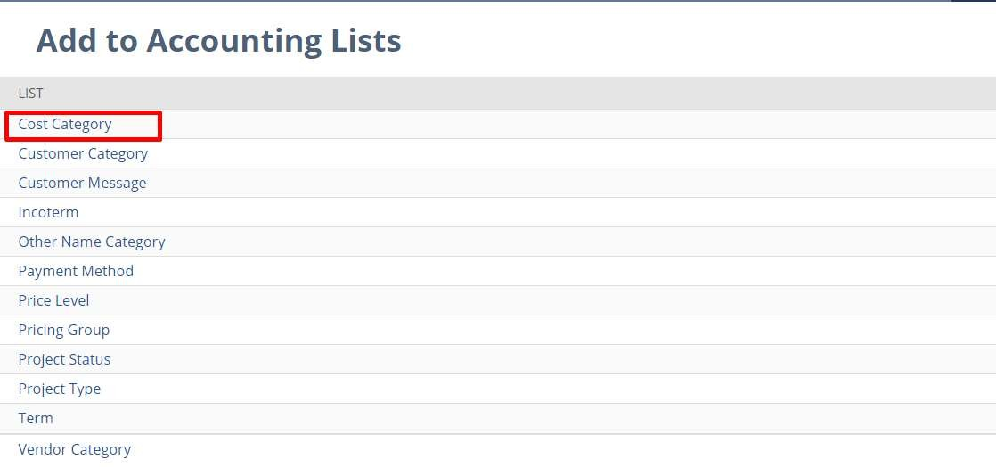

  - Enter a name for the “cost category”. For example, Labor Run.
  - Select a “cost type” for this category. Choose from the following:
    - Labor Run
    - Labor Run Overhead
    - Labor Setup
    - Labor Setup Overhead
    - Machine Run
    - Machine Run Overhead
    - Machine Setup
    - Machine Setup Overhead
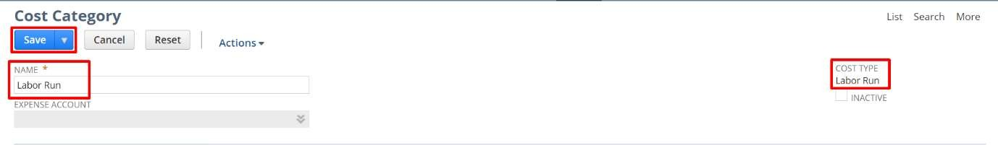
  - Check the “Inactive box” if you do NOT want this category to show in lists.
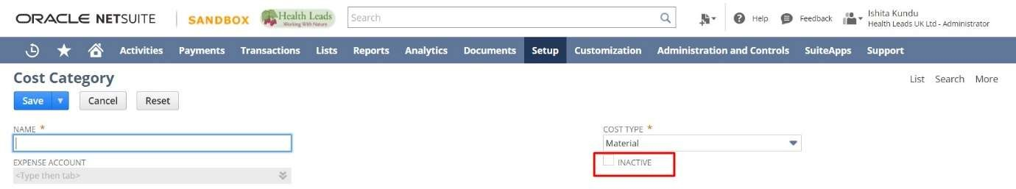

Defining a Manufacturing Charge Item:

With manufacturing routing, when a specific routing operation is recorded you can use items to define charges for the activity. For example, you can define the hourly cost of activities being performed and the expense account charges are logged against. To do so, you must set up the item record to define the item as a manufacturing charge item.
To define an item as a manufacturing charge item:

Go to Lists > Accounting > Items > New.
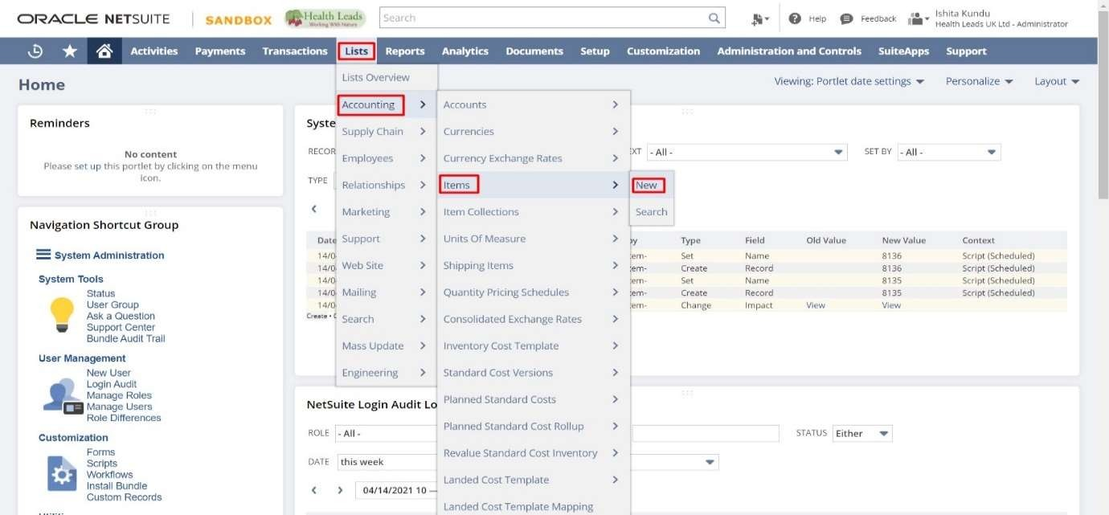

- Click a link to create a charge item. You can track routing charges and expenses using the following item types:
  - Other Charge for Purchase
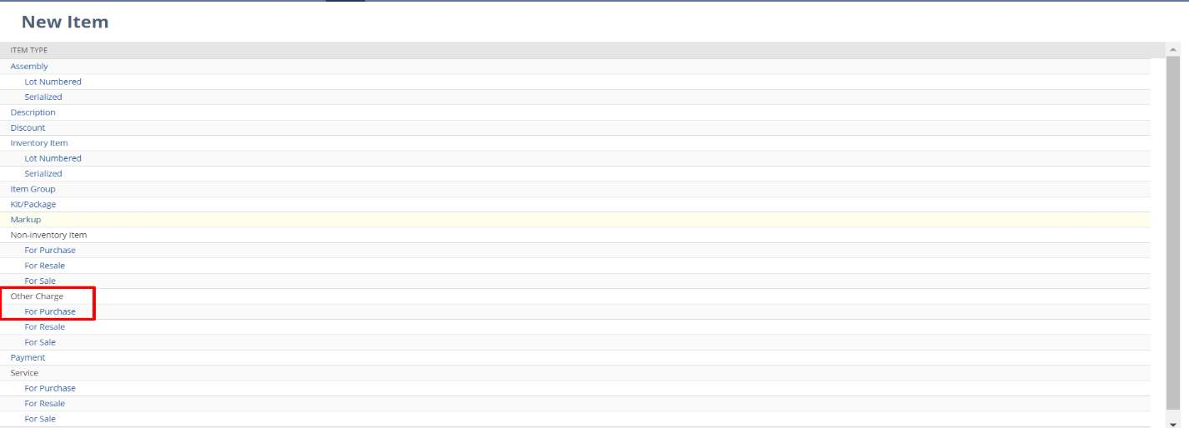
  - Service (for Purchase or for Resale)

- Enter a name. For example, Labor Charges.

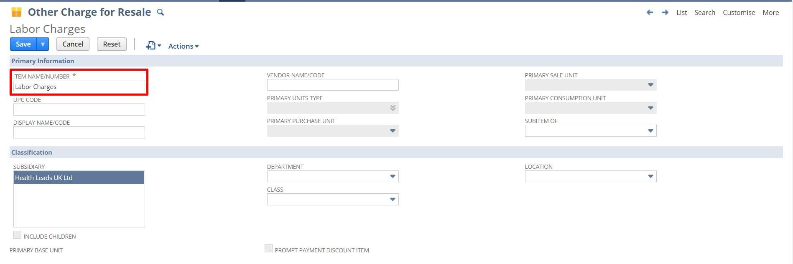

- On the item record, check the “Manufacturing Charge Item” box. The Manufacturing Charge Item box cannot be cleared if the item is included in a cost template.
- After the Manufacturing Charge Item box is checked, you can select a “Cost Category” in the field below.
The cost category cannot be changed if the manufacturing charge item is included in a cost template. You cannot check the Include Children box on the item record when the Manufacturing Charge Item box is checked. Only manufacturing charge items can use the labor and machine cost categories.
- Define an hourly rate in the “Purchase Price” field up to 7 decimal places. Charges are based on hourly rate (Amount/Hour)
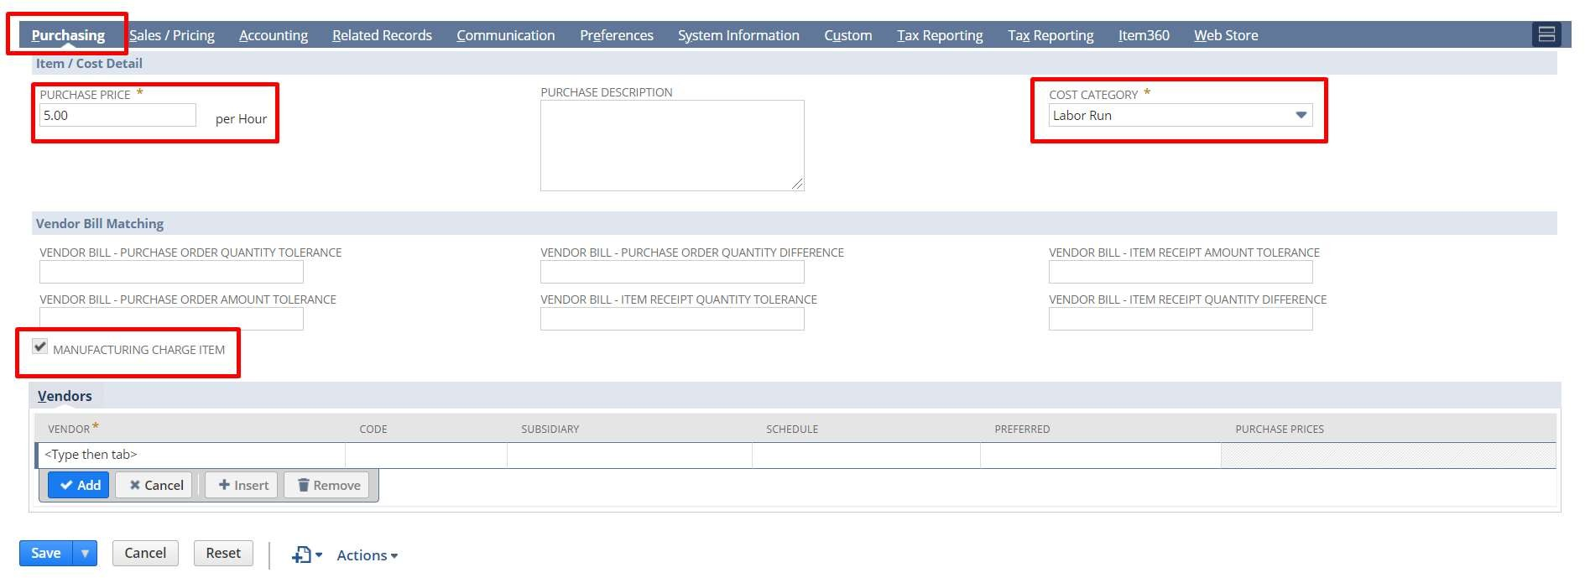

- Click the “Accounting” subtab.
- Select the “expense account” these hourly charges should be logged against. Complete any
Additional necessary fields.
- Click “Save”.

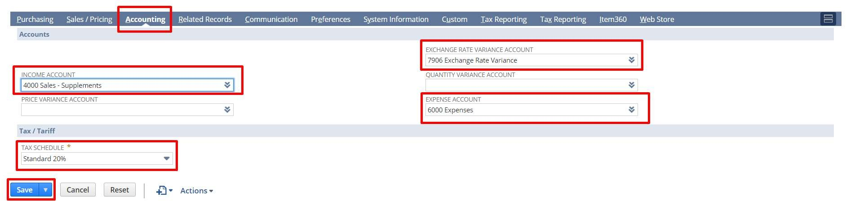

Creating Manufacturing Cost Templates:

A manufacturing cost template is a list of rates that can be associated with completing a specific operation. The template defines the activities that occur and related costs to be recorded each time this step is completed. Using a manufacturing cost template streamlines tracking assembly process costs by making it easier to know which rates and accounts are commonly used for each step in an assembly process.
To create a manufacturing cost template:

Go to Lists > Supply Chain > Manufacturing Cost Template > New.
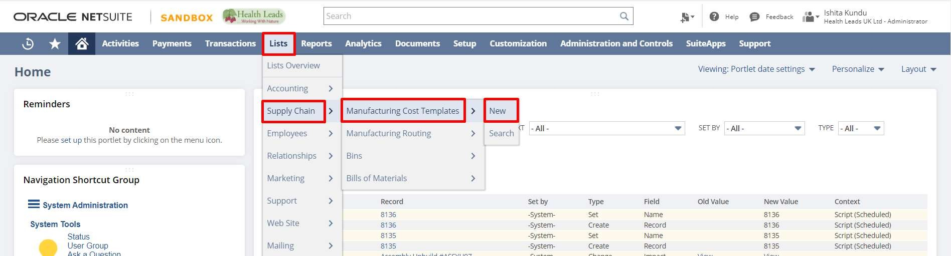
- Enter a name for the template.
- Optionally enter a memo. You can search for text you enter here to find this template later.
- Check the “Inactive box” if you do not want this template to show in lists on forms and records. Clear this box if you do want this template to show in lists.

Select a “cost category”.
- Select an “item”. Only items that have been marked as Manufacturing Charge Items show on this list.
- Enter rates for this line item up to 7 decimal places.
  - If this is a Setup category, enter a fixed rate. This is a one-time charge for a setup activity.
  - If this is a Run category, enter a run rate. This is an amount charged for each run completed.

Click “Add”.

- Repeat steps 5 through 8 for each category. Enter one category for each activity associated with this operational step. You can add only one of each of the following

cost category types: Labor Run, Machine Setup, or Machine Run. However, you can add multiple categories for Overhead cost category types.

- When all necessary categories have been added, click “Save”.
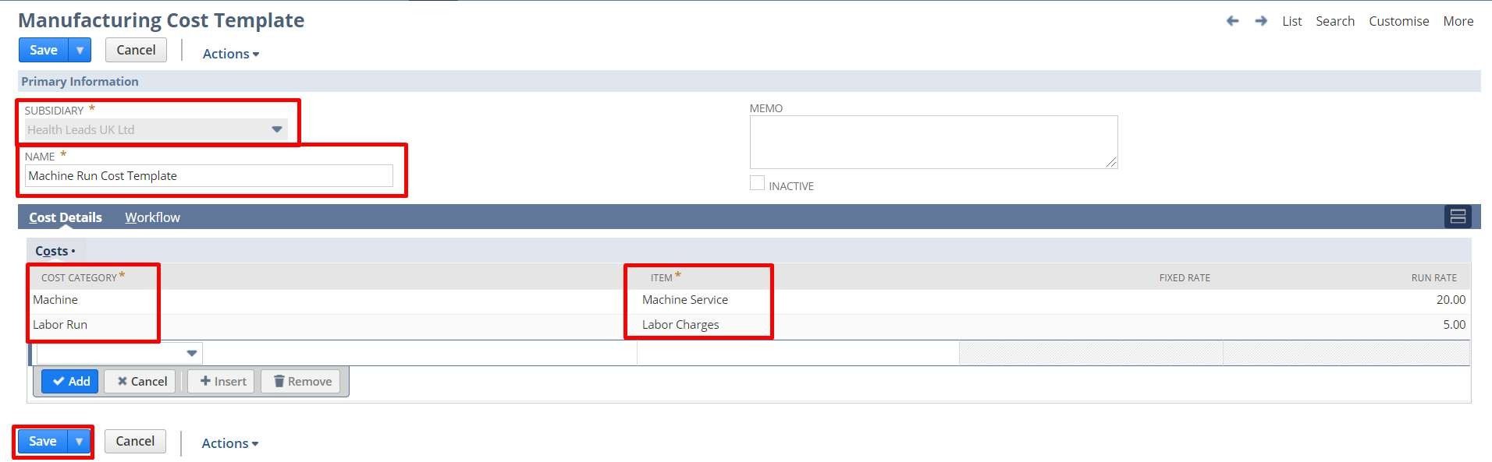

Creating Manufacturing Work Centers or Groups:

A work centre is a group of people that perform a specific step in the manufacturing process. After you have defined a work centre group, that work centre can be assigned to cover specific steps in the manufacturing process. For example, your assembly process might require the following: a manufacturing group, a quality assurance group, and a packing machine group.
Work centers are set by creating a static group and identifying it as a manufacturing work centre.

To create a manufacturing work centre:

Go to Lists > Relationships > Groups > New
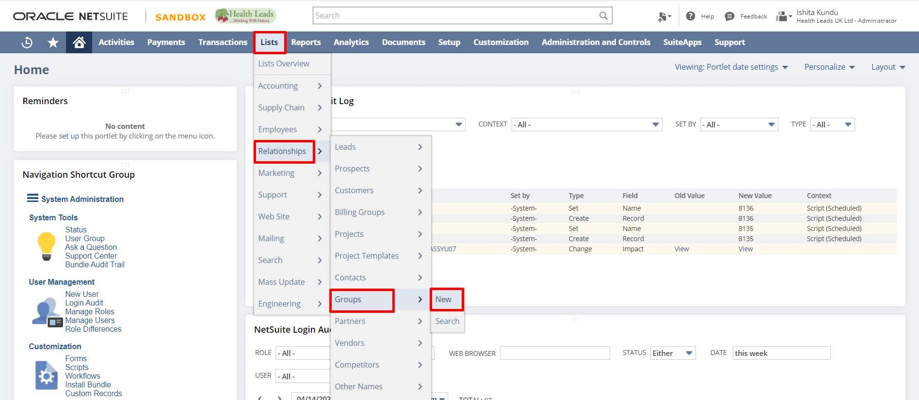
- Select “Static” as the kind of group
- Select “Employee” as the kind of members.
- Click “Continue”.

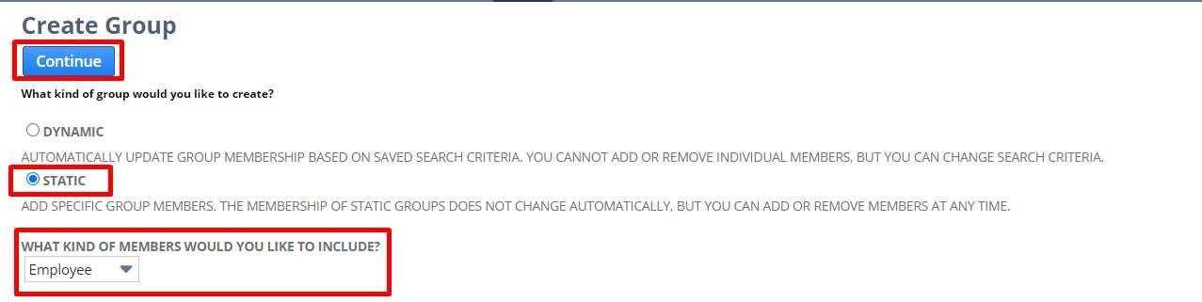

- On Create Static Employee Group page, enter a name for this group. For example, enter Manufacturing Work Center. This name shows in work center lists on records and forms.
- Select the “owner” of this group.
- Check the “Manufacturing Work Center” box. This enables this group to be used as a work center with routing records.
- Click the “Manufacturing Work Center Settings” subtab.
- Select one or more locations to associate with this work center. If you use NetSuite OneWorld, you can select multiple locations within a subsidiary.
- Enter number of machine resources for this work center.
- Enter number of labor resources for this work center.
- Complete any additional fields necessary for this group record.

Click “Save”.
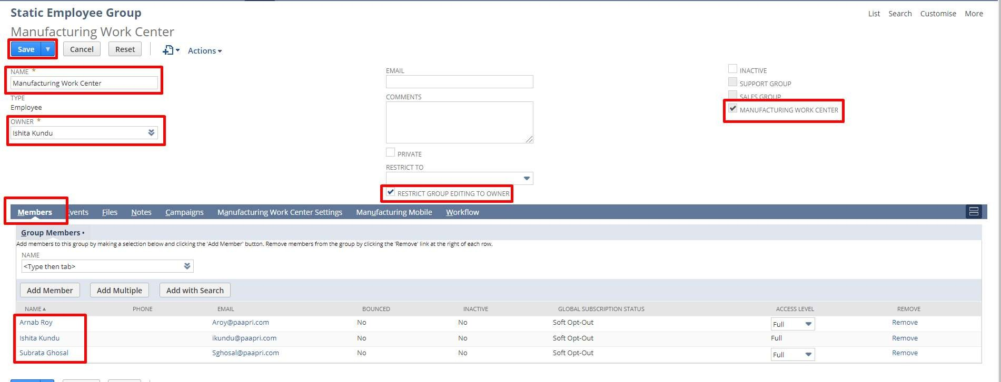
Work Center Calendars

For each work center, you can create a work calendar specific to the needs of that work center that represents the times the center is available to process work orders. Specified work center calendars enable you to manufacture products efficiently within time and resource constraints. For example, your work centers operate as follows:
- Work Center 1: Operates five days a week for eight hours
- Work Center 2: Operates four days a week for ten hours
Your production manager can set up a work calendar for each work center that specifies the hours available for each. Based on this work center calendar information, you have real-time visibility into total scheduling capacity, as well as intelligent manufacturing routing that calculates the processing time.
After you have created the necessary calendar, define that work calendar on the work center record. Then, NetSuite can use the designated work calendar to determine the time when resources should schedule for associated manufacturing operation tasks. Based on the requirement date, the supply planning engine determines the start date of a planned order using backward scheduling considering the work calendar assigned. The supply planning engine also considers work center calendars for forward scheduling when creating work orders.
To use work center calendars, complete the following steps:

To set up a work center calendar:

Go to Lists > Employees > Work Calendars > New
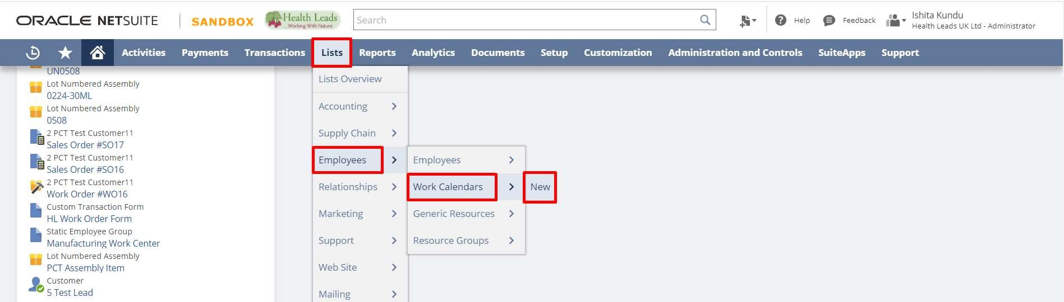
- Enter a name for the calendar.
- On the “Working Days” subtab, define the working hours and days.
- On the “Non-working days” subtab, define exceptions to the working days rules.
- Click “Save”

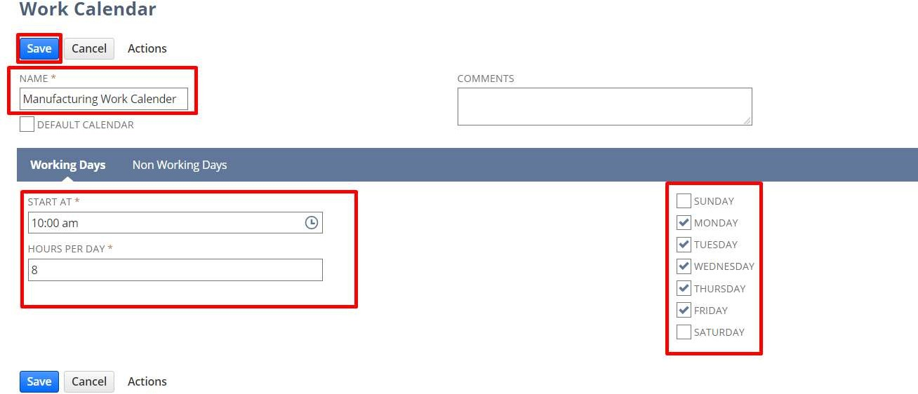

To assign a work calendar to a work center:

- Click the Static button.
- In the members list, select Employee.
- Click Continue.
- Check the “Manufacturing Work Center” box. This enables the Work Calendar field on the Manufacturing Work Center Settings subtab.
- Click the “Manufacturing Work Center” Settings subtab.
- In the “Work Calendar field”, select the appropriate work calendar from the list.
- Enter additional information as needed.

Click “Save”.
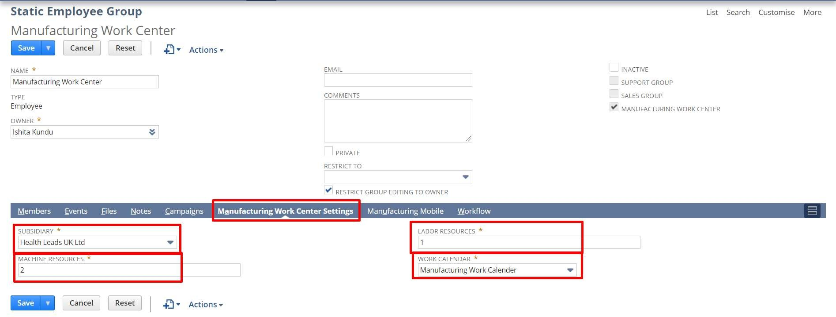

Creating a Manufacturing Routing

A manufacturing routing is a template that contains a list of steps required to build an assembly item. Each step is in a sequential order necessary to complete the operational sequence for completing the assembly. After you have created a routing record, that routing can be selected on a work order to direct the completion of the assembly. The routing determines the work center, cost template, labor resources, and machine resources that will be used during the assembly. Routings are unique for each assembly item, but routings may be shared across multiple locations.
To enter a manufacturing routing:

Go to Lists > Supply Chain > Manufacturing Routing > New.
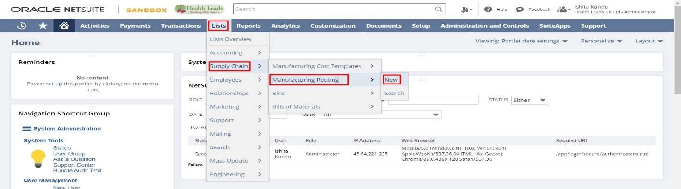

- Select the “Item” you are creating an assembly sequence for.
- Enter one or more “Locations” where this assembly will be performed.
- Enter a routing template “Name”. This name will be displayed in the list of routings in the Manufacturing Routing field on records and forms.
- Optionally, enter a “Memo”. You can search for the text you enter in this field.
- Check the “Default” box to use this routing by default for this item on forms. This denotes the default steps for creating a new special work orders and mass created work orders.
- Click the “Routing Steps” subtab.
Routing Steps:

To enter routing steps:
- Enter the Operation Sequence number for the step you are entering. For example, if you are entering the first step to be performed to build this assembly, enter 1. Sequence number determines dependencies between different operations. For example, operation 1 comes before operation 3 in the assembly process.
- Enter the “Operation Name”.
- Select a “Manufacturing Work Center”. This is the labor team that will complete this step. After you select a work center, the labor resources and machine resources are automatically entered from the work center record.
- Select a “Manufacturing Cost Template” for this operation.
- Enter the operation “Setup Time” in minutes. This is the amount of time required (fixed time per step) to prepare for this step in the sequence. There is one setup time per order.
- Enter the operation “Run Rate” in minutes. This is the amount of time required to complete a run and produce one unit.
  - The setup time and run rate recorded here are used in conjunction with the default calendar to schedule the completion of each step when a work order is created using this routing.
  - If you use the Demand Planning feature, backwards scheduling is used to determine the appropriate start date. There is one run time per base unit.
  - The setup time + run time = total manufacturing task time
- If you did not enable auto-calculate lag in the header, set Lag Type, Lag Amount, and Lag Unit as necessary.

Click “Save”.

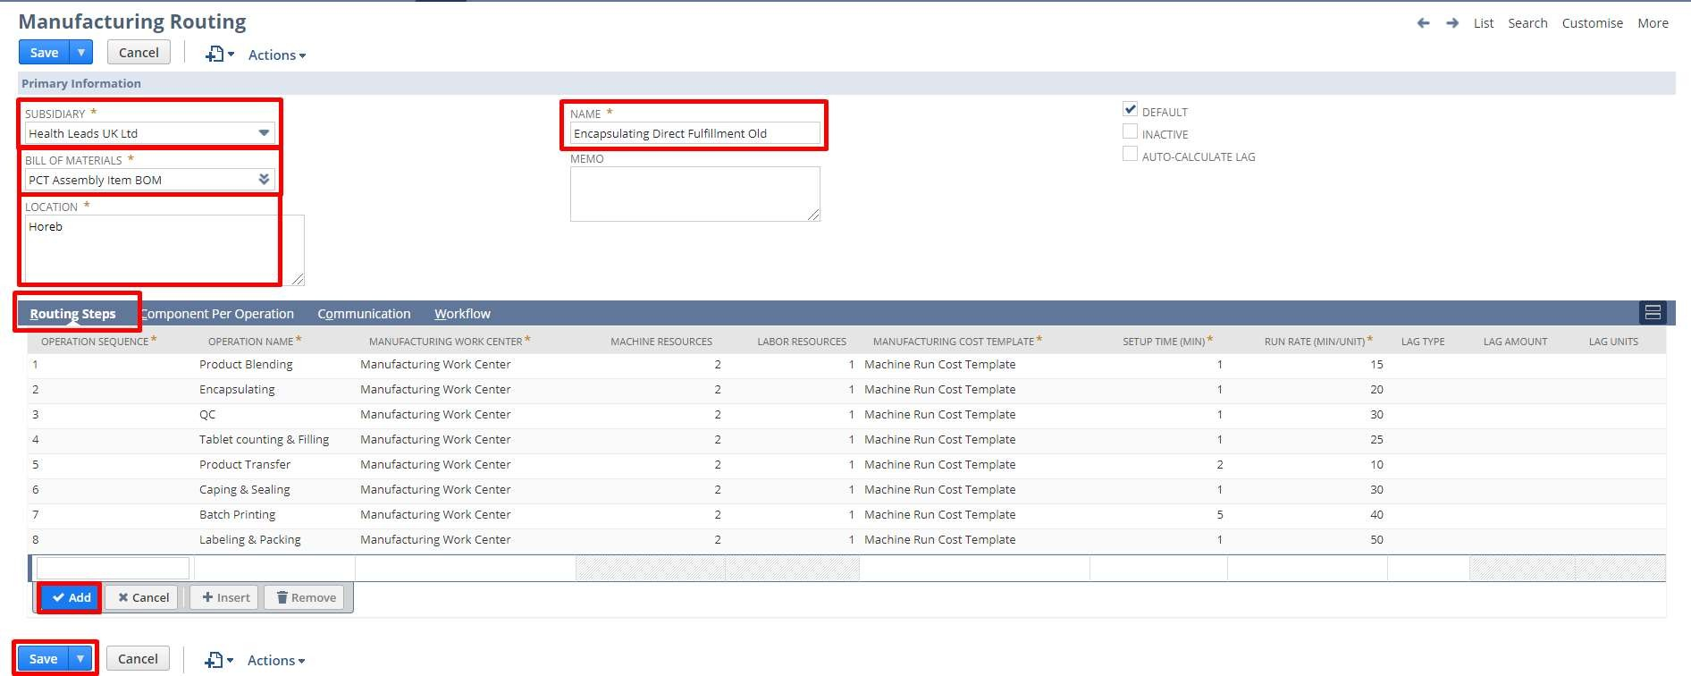

Manufacturing Routing and Work Orders

When the Manufacturing Routing and Work Center feature is enabled, you can use routings on work orders to manage your assembly process. A routing you select on a work order is a template describing a list of sequential steps required to build the assembly item. The routing directs the completion of the assembly by determining the work center, cost template, labor resources and machine resources to be utilized during the assembly. To use routings with work orders, be sure you have completed the routing setup process.
To use Manufacturing Routing on a work order:
- Create a work order new work order.
- Select a location. If you use NetSuite OneWorld, select a subsidiary
- Designate the Work Order as Work In Process (WIP)
A routing can be designated on an assembly work orders that is designated as Work in Process (WIP). NetSuite uses WIP accounting to issue materials in the designated WIP account. If the WIP box is not checked on a work order, you are not able to select a routing for that assembly.
- Select the appropriate Manufacturing Routing.
- Save the work order. After it is saved, you can see the following:
  - The Items subtab shows components that are issued.
  - The Operations subtab shows all operation tasks required for a particular assembly run.
Operation tasks are created based on the routing. These tasks define the list of steps that must be completed to finish the assembly process. Tasks can be viewed and edited from the Operations subtab of the work order.
Changing Work Order Quantities
If you change the assembly item quantity on the work order and re-save it, the Operations subtab information is updated to reflect the new requirements. For example, entering a higher quantity on the work order results in more time being required to complete the run.

Routing and Time Zones

The associated work calendar applies for all routing work orders created.
  - If you do not use NetSuite OneWorld, the time zone of the schedule is based on the time zone selected for the company.
  - If you do use NetSuite OneWorld, the time zone of the schedule is based on the time zone of the subsidiary selected on the work order.
Planned Time Subtab
When you use the Manufacturing Routing and Work Center feature and enable the Show Planned Capacity on Work Orders preference, work orders show a Planned Time subtab that details work allocated to each work center and NetSuite automatically generates planned time entries.
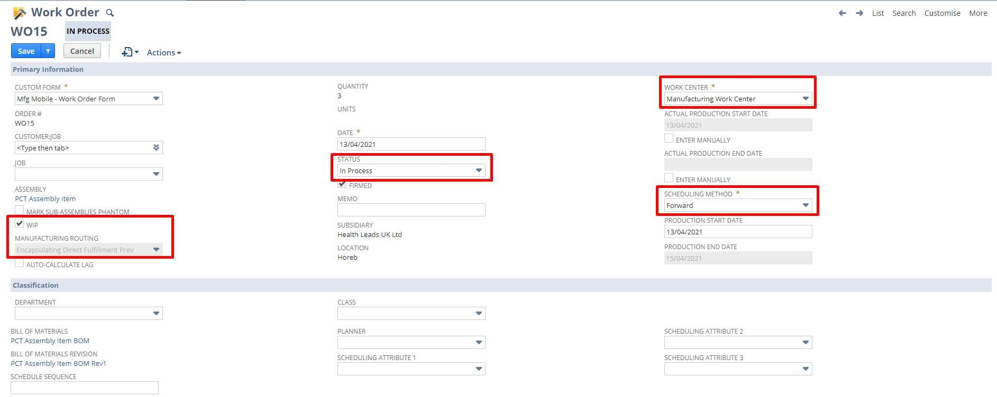
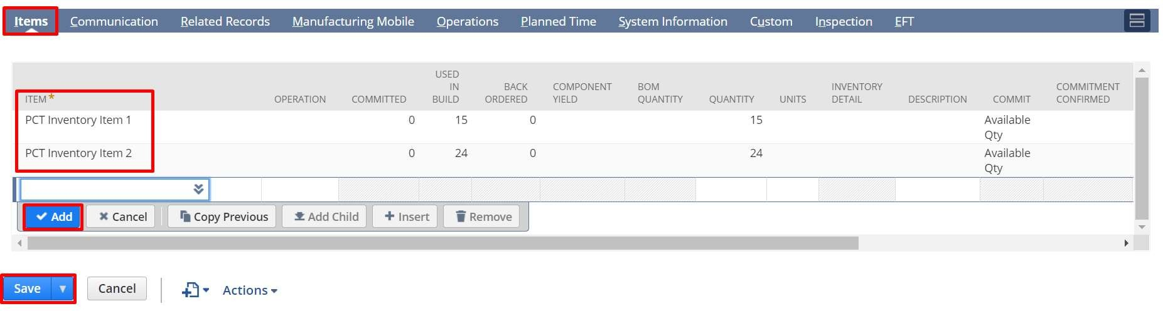

Manufacturing Operation Tasks
After you save a WIP work order that has a designated routing, manufacturing operation tasks are created based on the routing. Each of these tasks is a step that must be done in order for the assembly process to be finished. After work for the task has been done, manufacturing operators can log progress against each task on a work order completion form.
To view a list of operation tasks:

Go to Transactions > Manufacturing > Enter Work Orders > List.
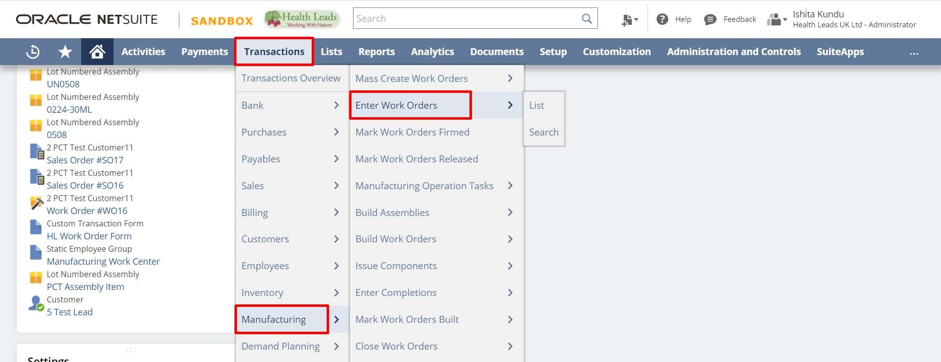
- Click “View” next to the work order.
- Click the “Operations” subtab.
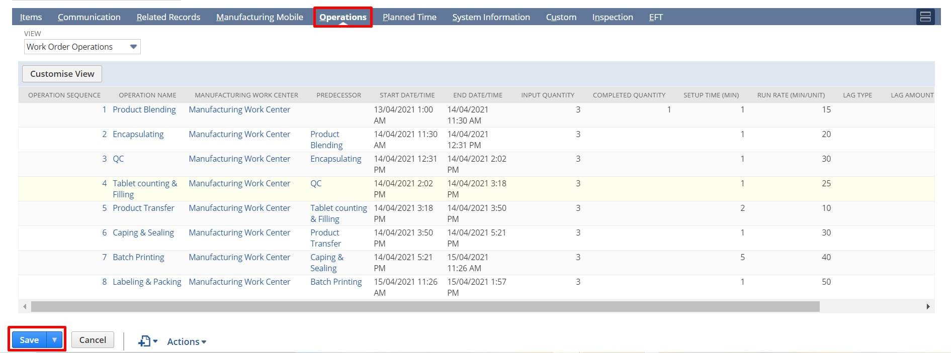

- Optionally select a custom view for the operations list
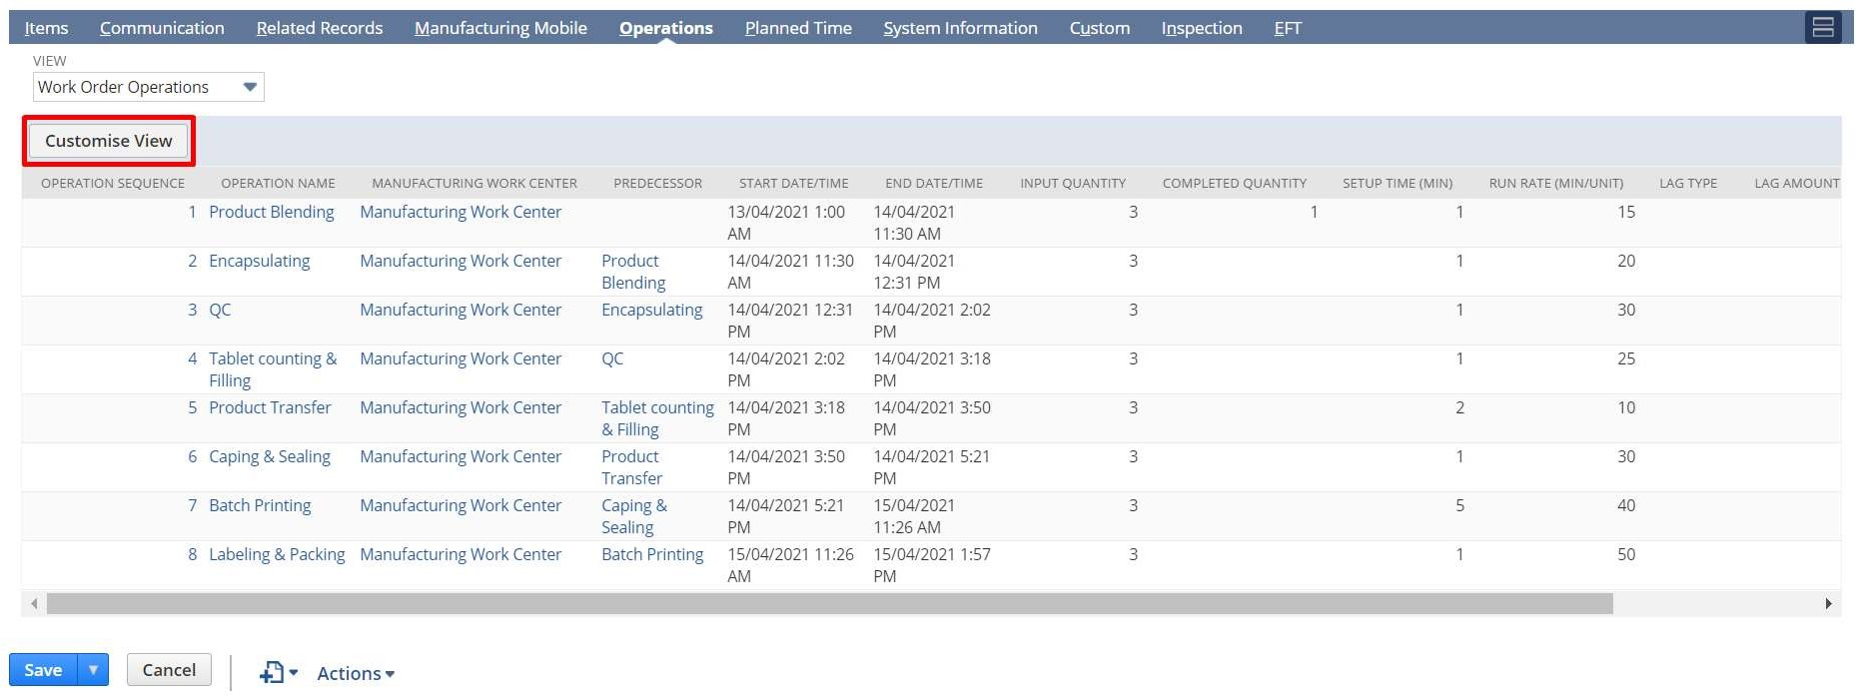

The list displays the following for each operation task:
  - Operation Sequence
  - Operation Name
  - Predecessor
  - Start Date
  - End Date
  - Input Quantity
  - Completed Quantity
  - Setup Time (Min)
  - Run Rate (Min/Unit)
Click an operation name to open the task record.

Work Order Issue

Go to Transactions > Manufacturing > Enter Work Orders > List.
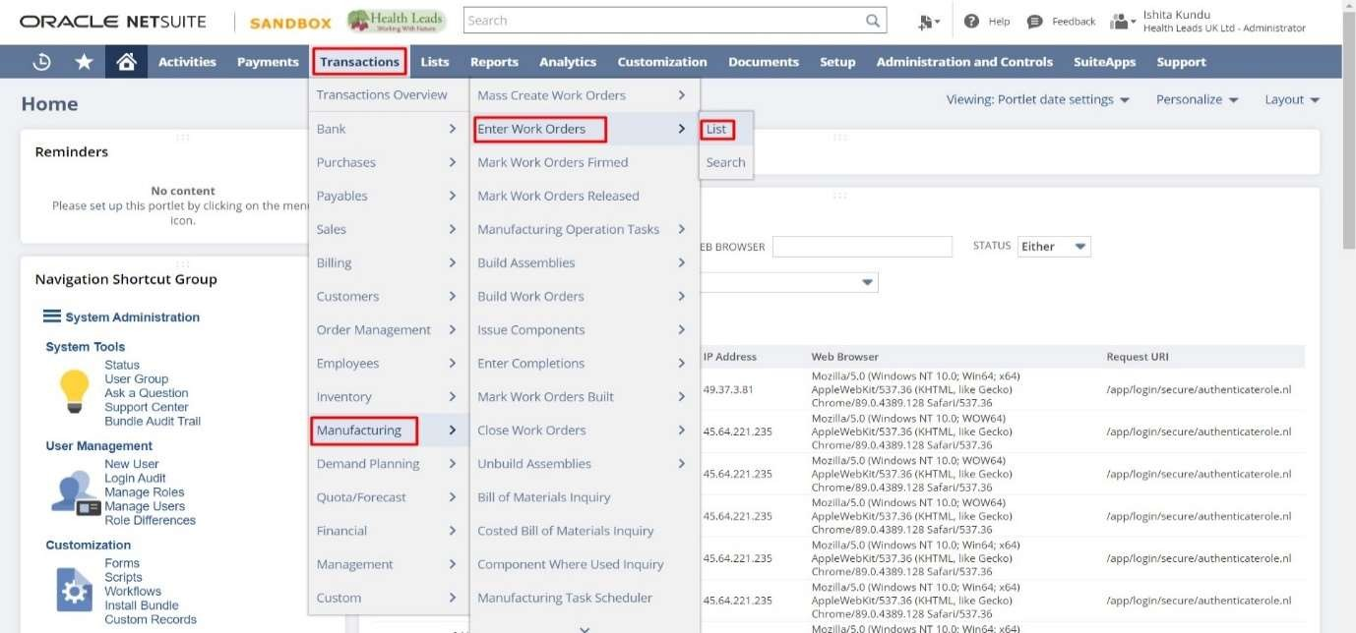
- Open the created work order and click on the “Issue Components” button.
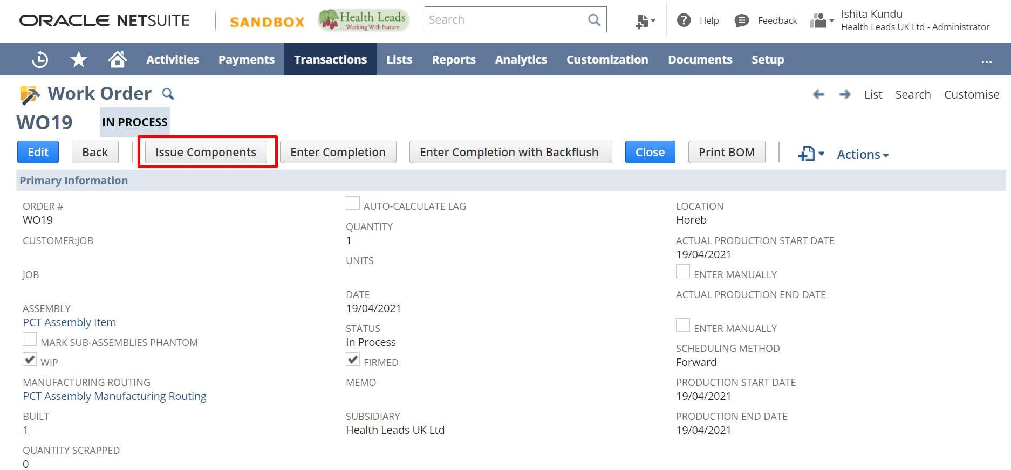

- Select the Starting Operation and the Ending Operation.
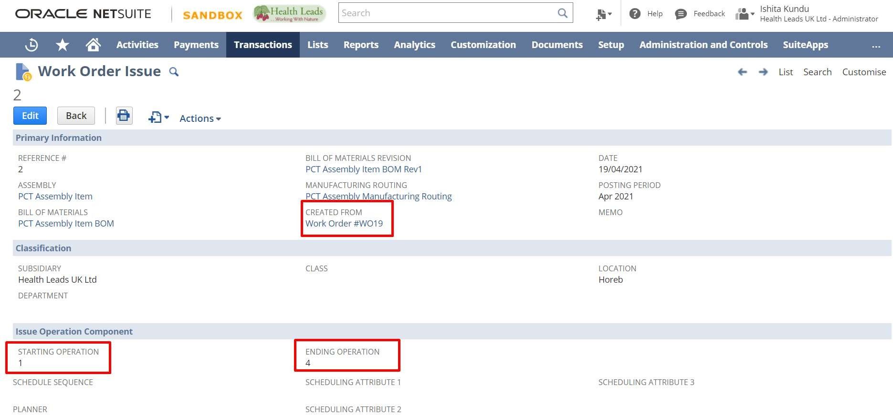

Work Order Completion

Go to Transactions > Manufacturing > Enter Work Orders > List.
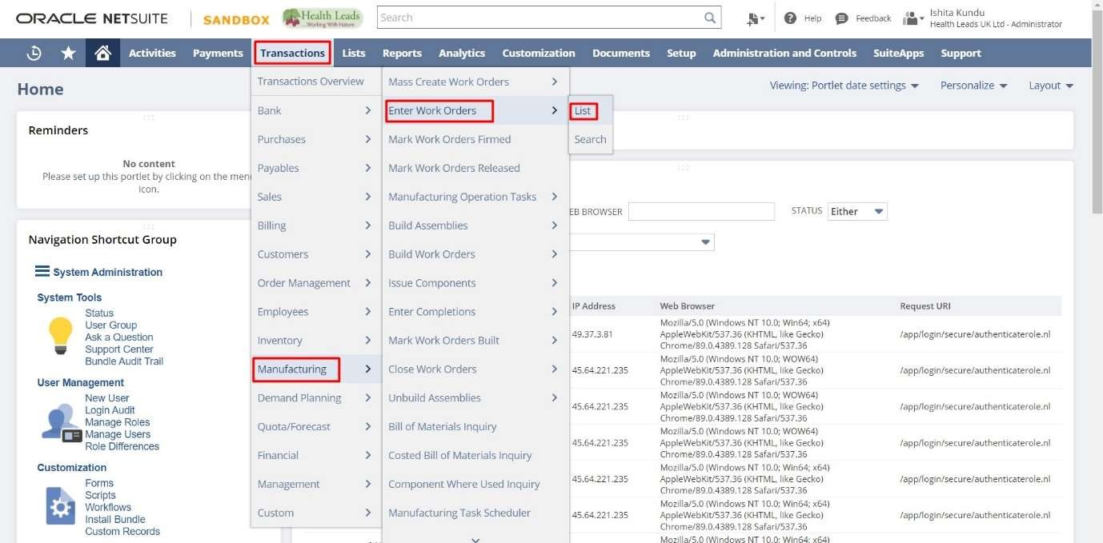
- Open the created work order and click on the “Enter Completion” button.

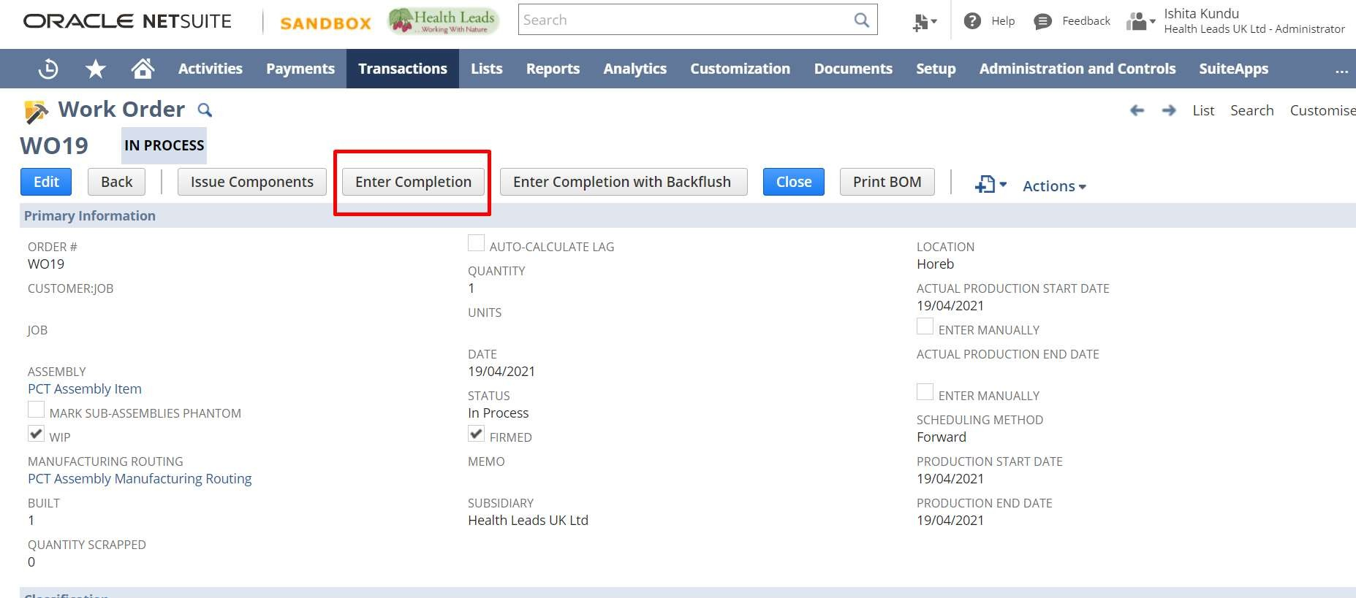

- Select the Starting Operation, Ending Operation and completed quantity.
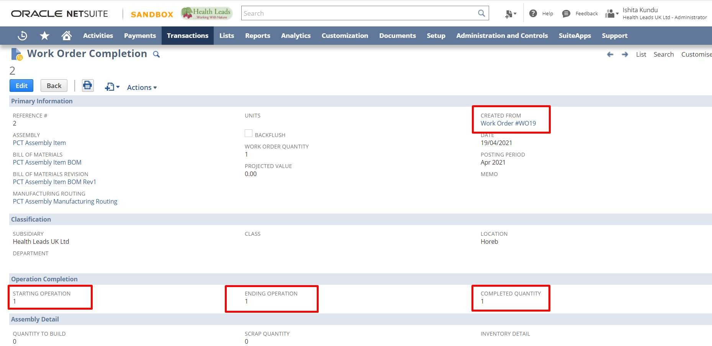

M anufacturing Task Scheduling

Go to “Transactions > Manufacturing > Manufacturing Task Scheduler”.
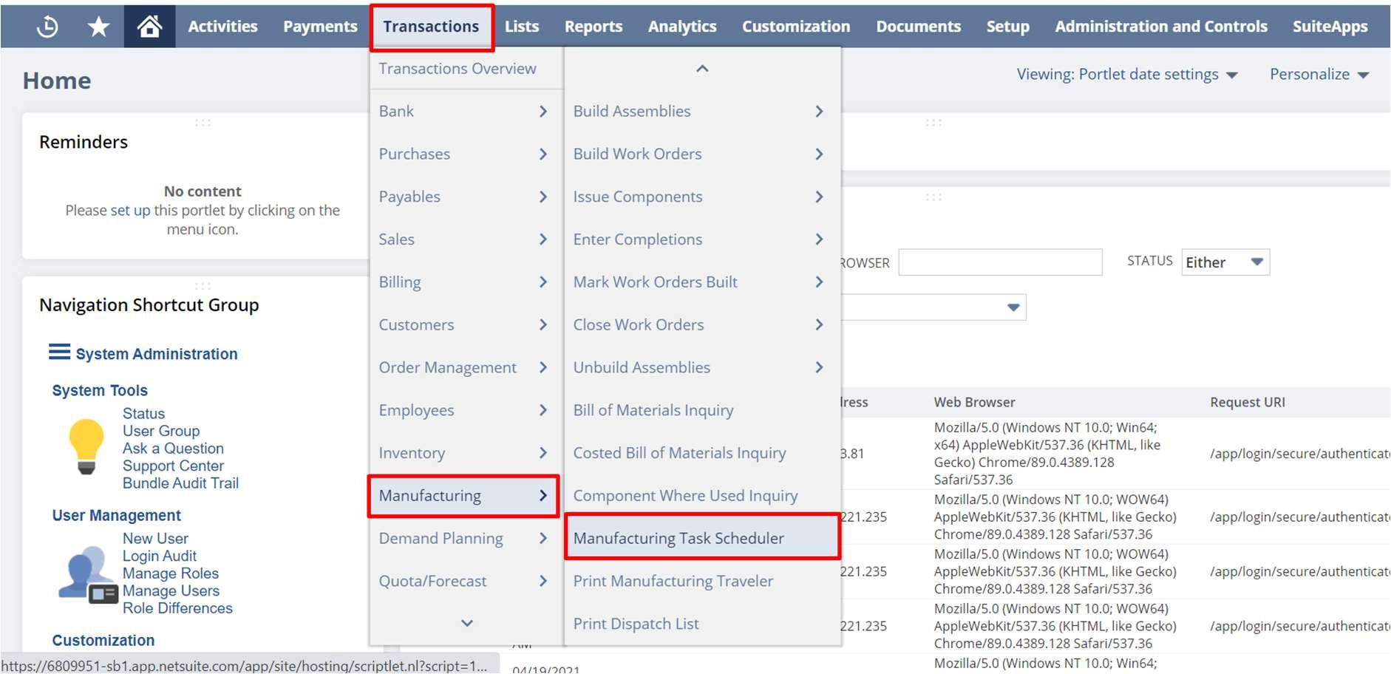
- You can check the Task Scheduler Daily, Weekly or Monthly basis according to the Work Centers or the Work Orders.
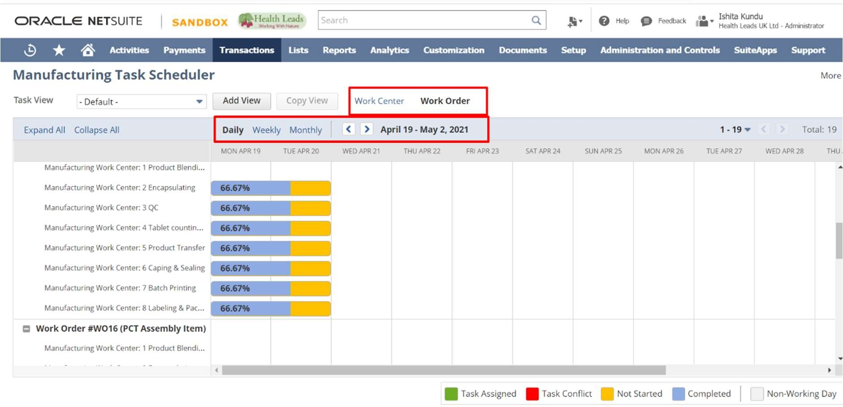

HEALTH LEADS UK LTD:
ORDER TO CASH
DOCUMENT

Paapri Cloud Technology

ORDER TO CASH
Creating a Sales Order:
You can create a Sales Order in any of the two ways:
- Enter Sales Order functionality. (Standalone Sales Order)
- Clicking on Sales Order button on the Quote. (Generate Sales Order from Quote)
- From Web Sales order. ( Magento, EBay ,Amazon)

Enter Sales Order functionality
- From Administrator Role
- From Sales Manager Role

- Login to NetSuite using Administrator Role. Navigate: Transactions -> Sales -> Enter Sales Orders.
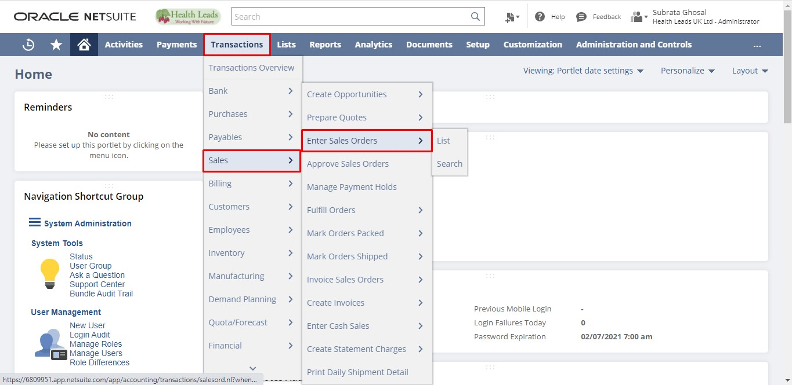
- Login to NetSuite using Sales Manager Role. Navigate: Opportunities -> Transactions -> Sales Orders ->New. 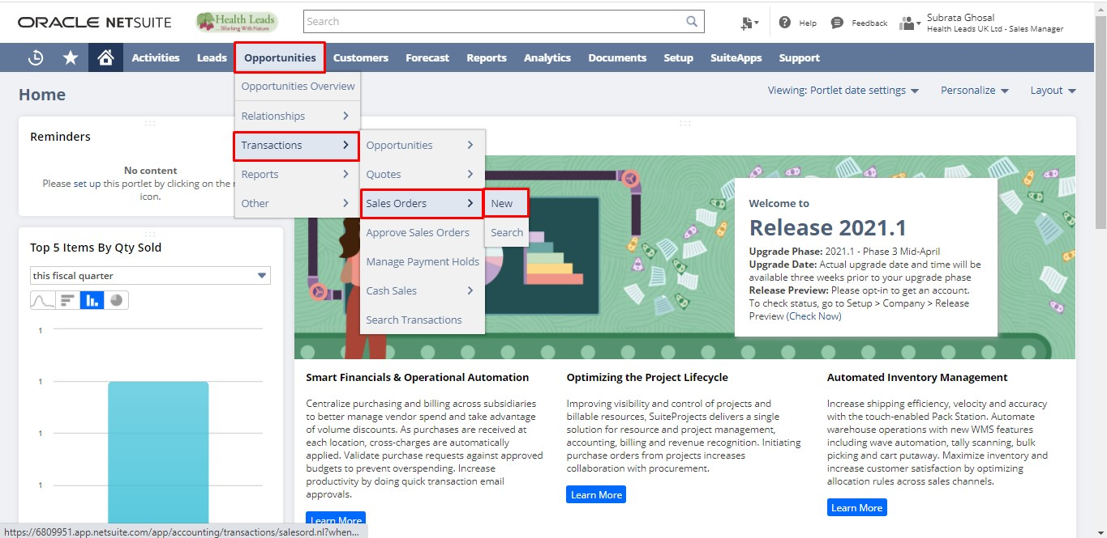
Select the Customer. Select an Item. Enter the Rate, Quantity and other required fields. Click the “Save” button.
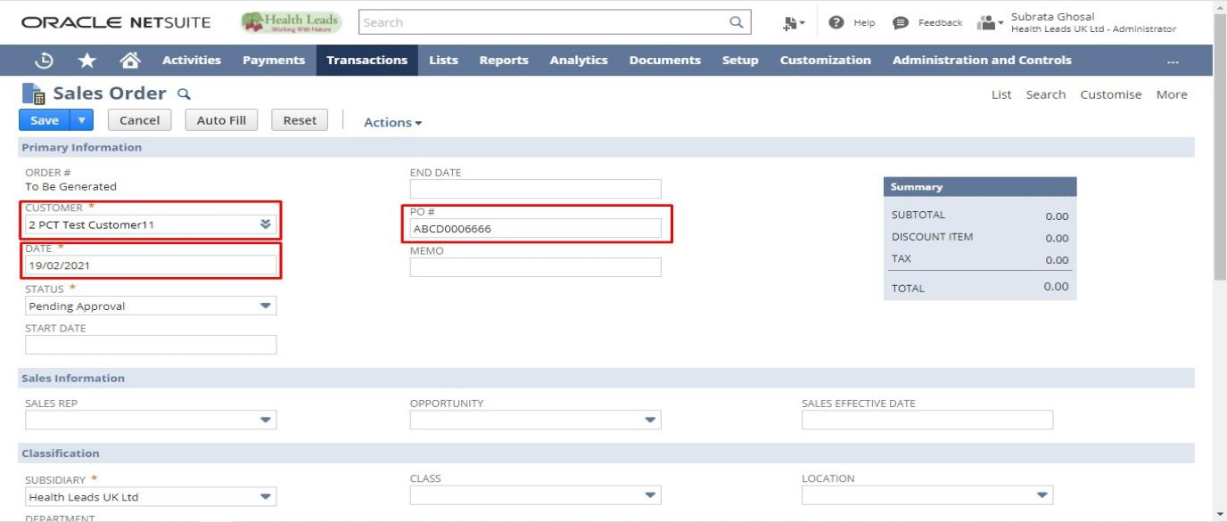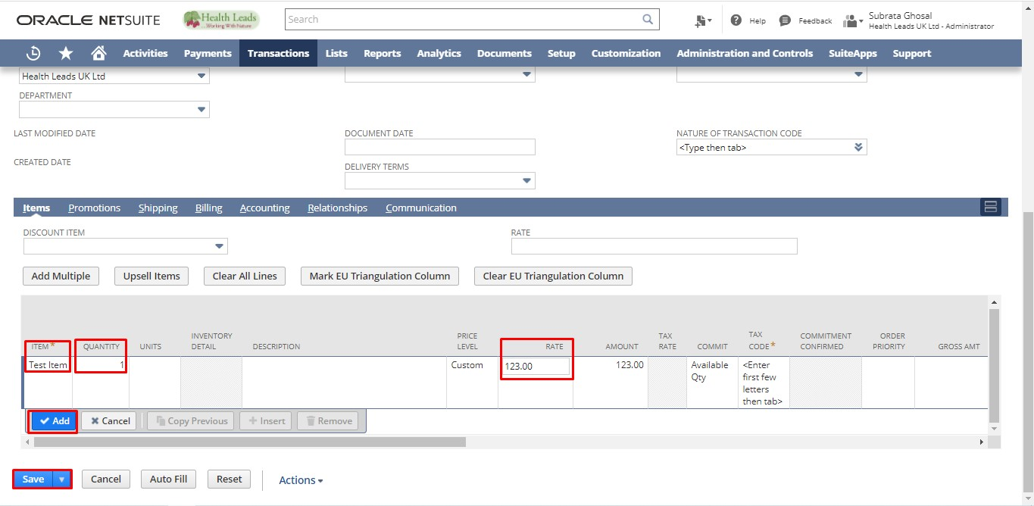
NOTE: This is a Standalone Sales Order.

Clicking on Sales Order button on the Quote
- From Administrator Role
- From Sales Manager Role

- Login to NetSuite with Administrator Role. Navigate: Transactions -> Sales -> Prepare Quotes -> List.
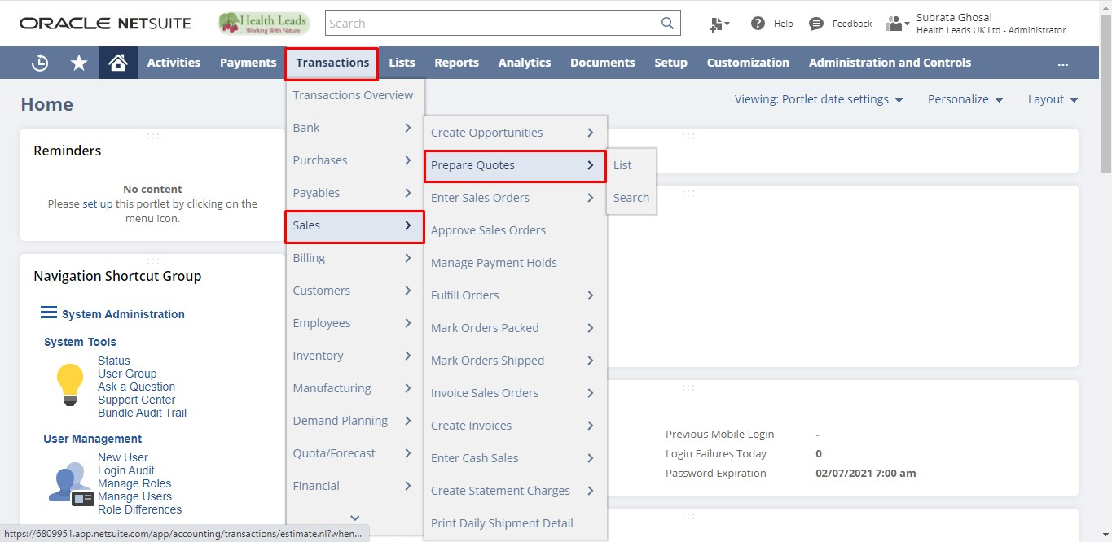
- Login to NetSuite with Sales Role. Navigate: Opportunities -> Transactions ->Quotes.
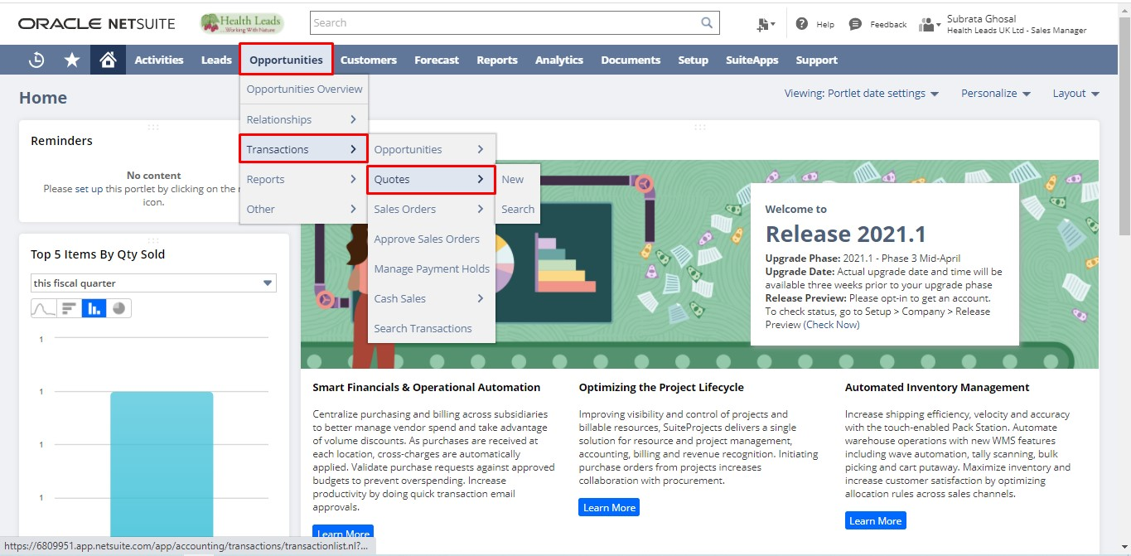
Click “View” on the Quote you want to make Sales Order.
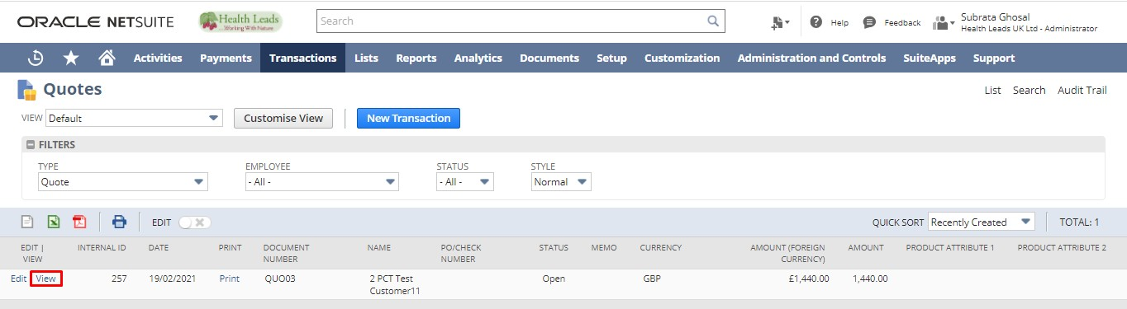
Click the “Sales Order” button.
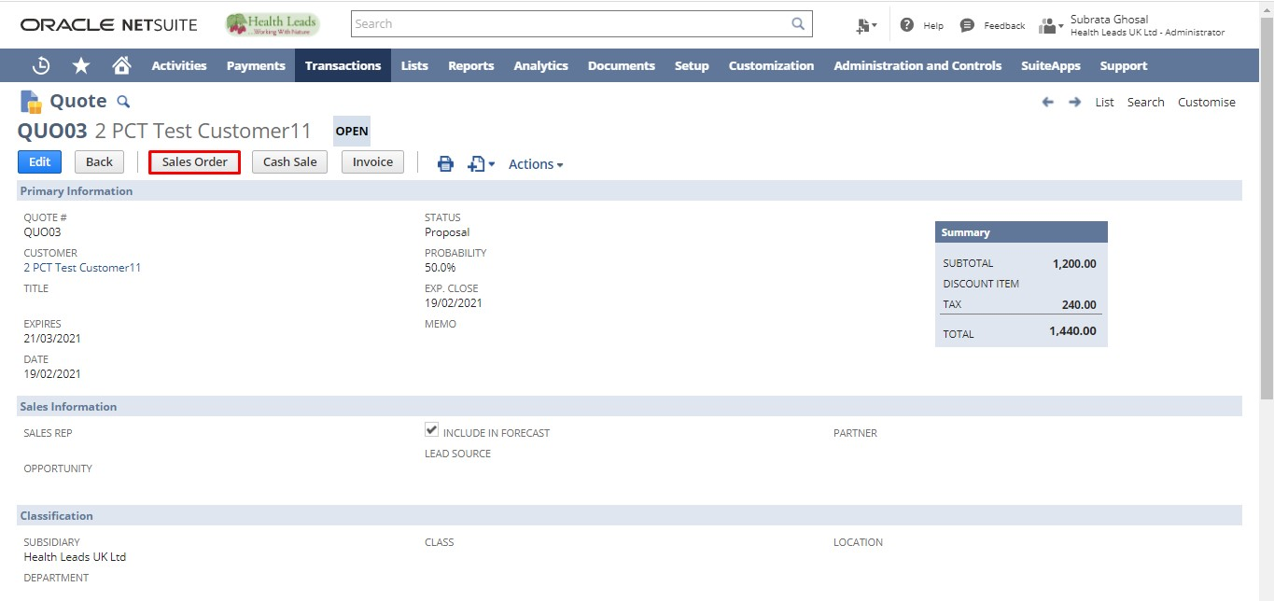
NOTE: Creating a Sales Order in this manner links the Quote to the created Sales Order. Creating a Sales Order converts a Prospect to a Customer.
From Web Sales Order. (Magento, EBay ,Amazon)
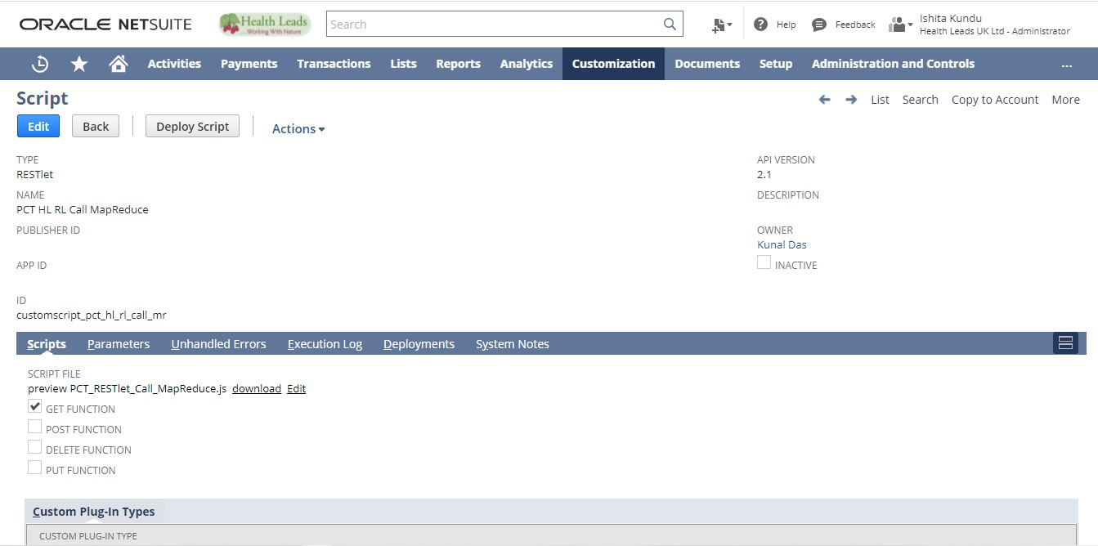
The following script on action is entitled to do the required functionality of generation of HL WEB ORDER from Magento, EBay and Amazon.

Login to NetSuite with Administrator Role. Navigate: Customization -> Lists, Records and Fields -> Record types.
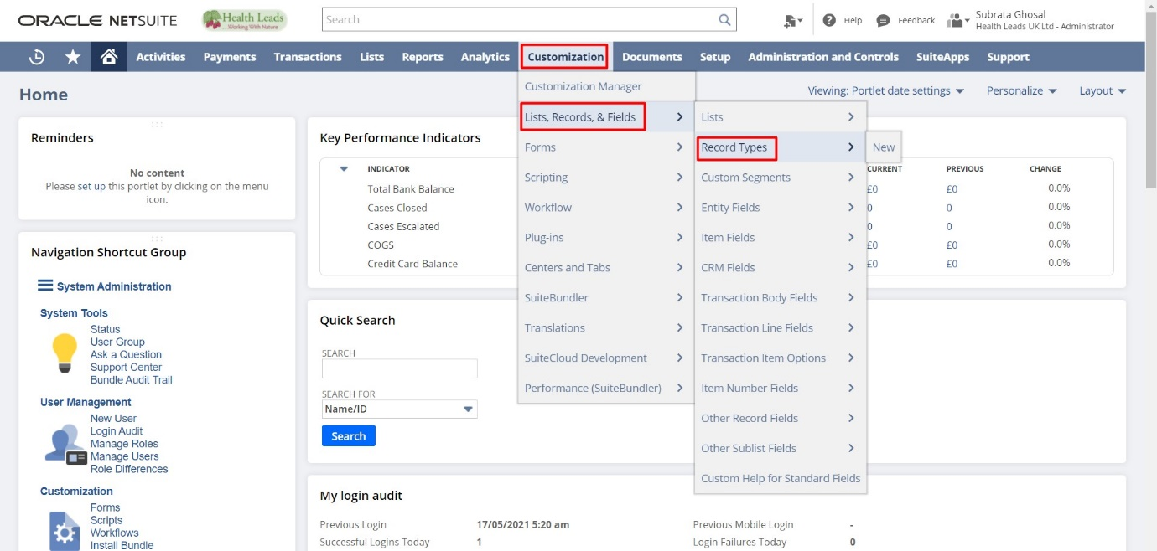

Click on the “List” of HL Web Order Record.

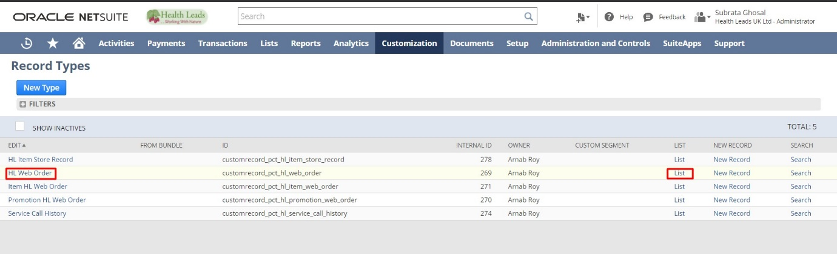
Open any web order and validate the relevant sales order to it.
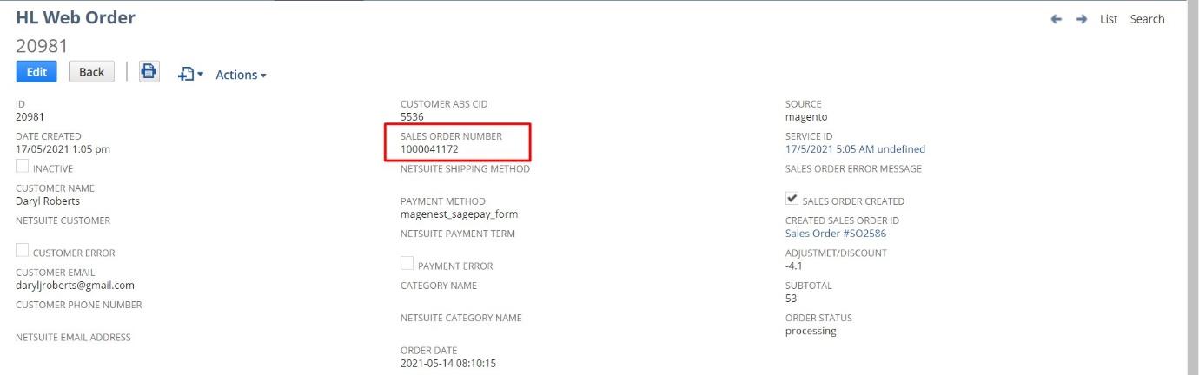
After that, the map reduce will be initiated for the generation of Sales Order based on the following Script. 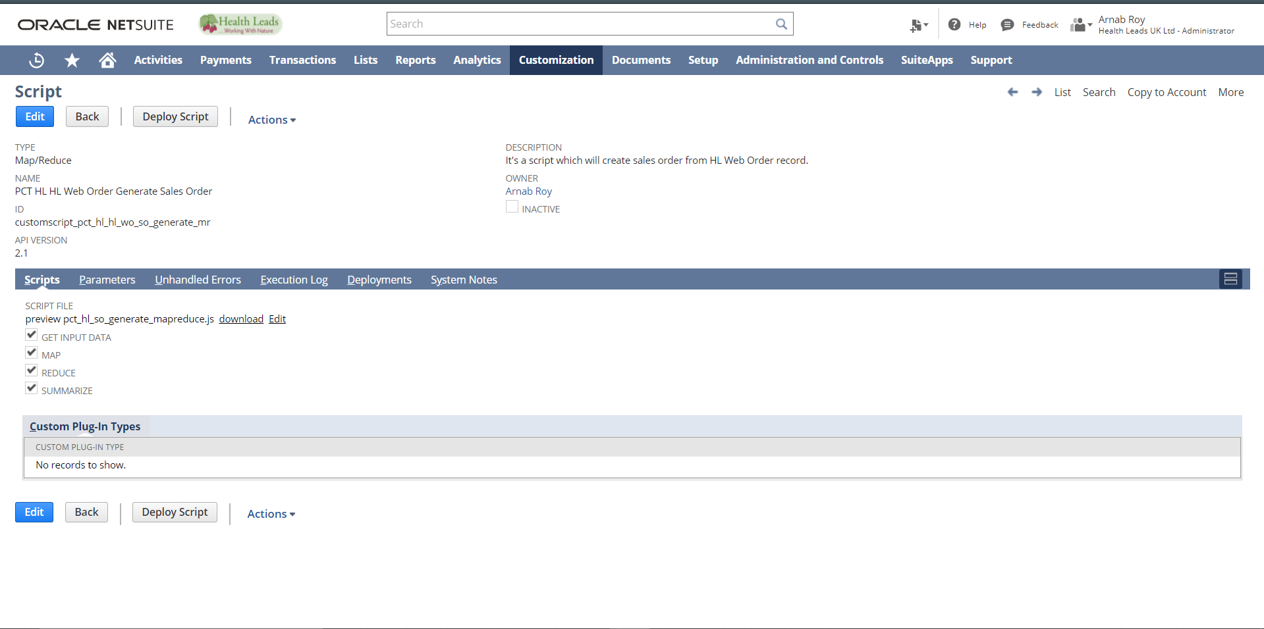
Login to NetSuite with Administrator Role. Navigate: Transactions -> Sales -> Enter Sales Order -> List. And validate the same.
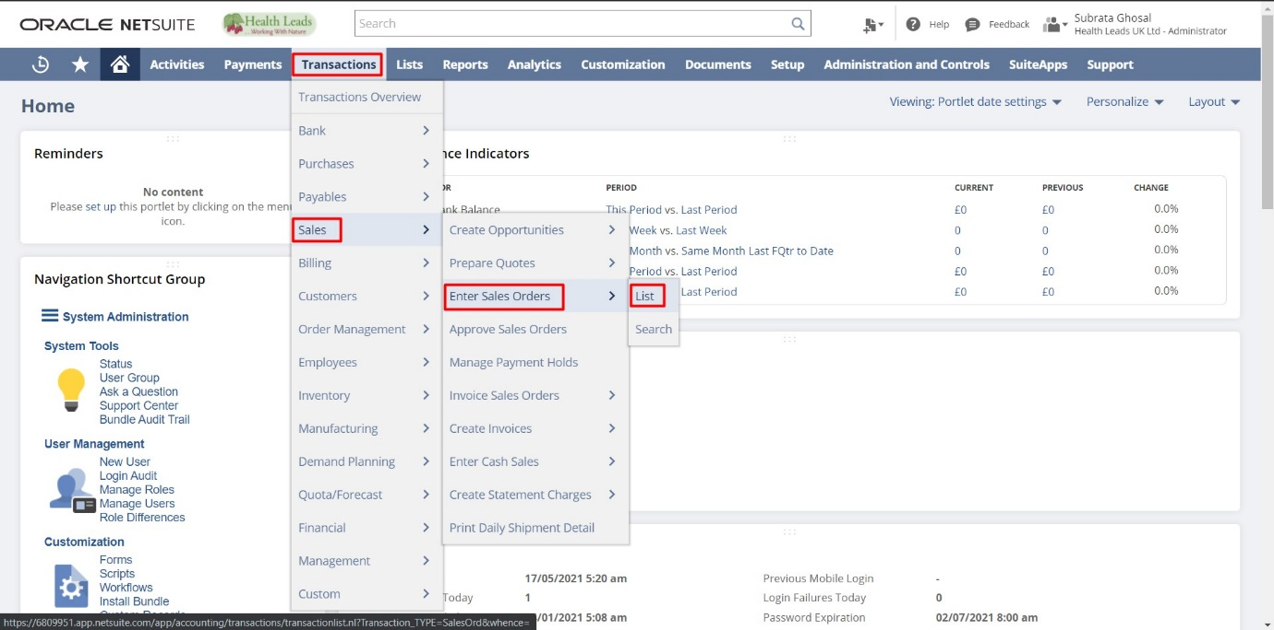
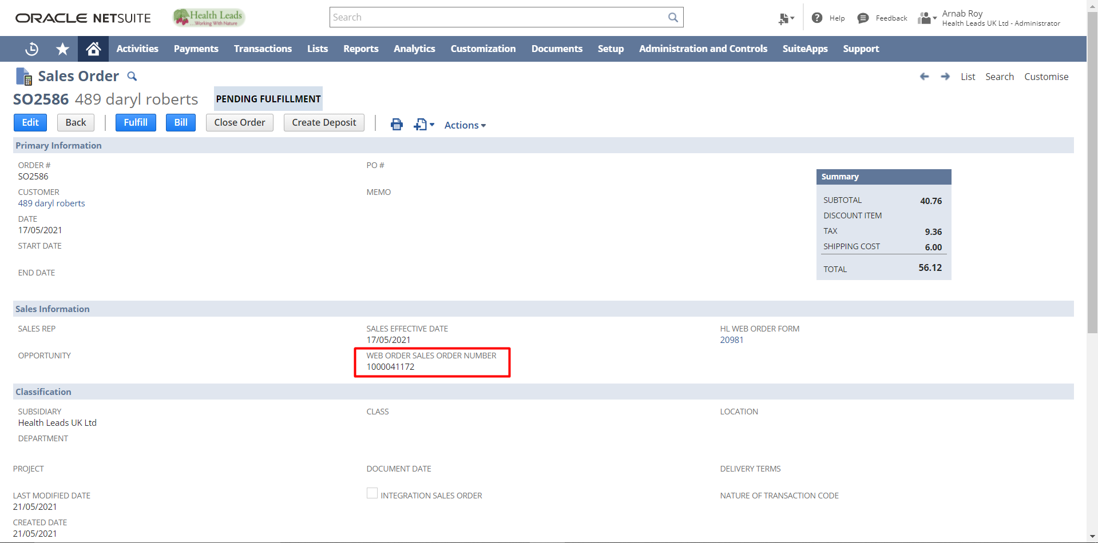

CREATING DROP SHIP ORDERS
You can use Create PO functionality to create Drop Ship Orders.
Note: A Vendor must be preferred on the Item Master for this functionality to work automatically.

Selecting Preferred Vendor on Item Master:
Step 1: Navigate to the Item for which you want to select a Preferred Vendor. Click “Edit”. You can do the same when creating an Item. Multiple Vendors can be selected here.
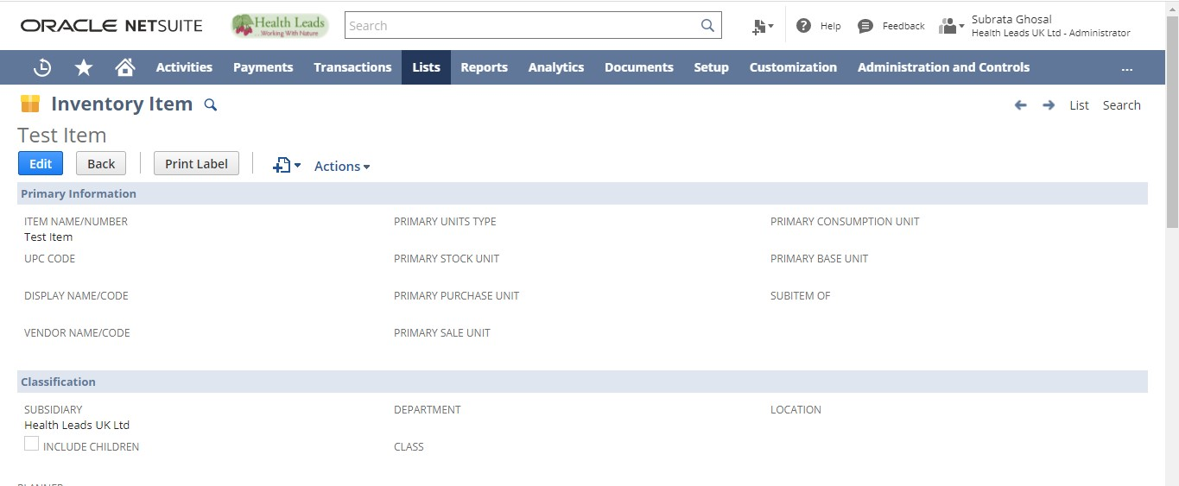
Step 2: Scroll down to the “Vendors” sub list under Purchasing subtab. Select a Vendor. Check the “Preferred” checkbox. Click on the icon under Purchase Prices.
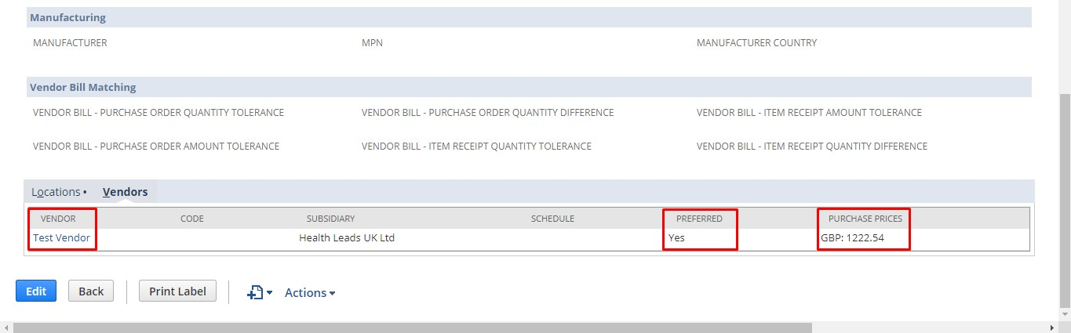
Step 3: A new popup window opens over the existing form. Select a Currency. Enter a Purchase Price. This would be the default rate at which the Purchase Order for this Item would be created when procured from this Vendor. Click “Add”. Click “Ok”.

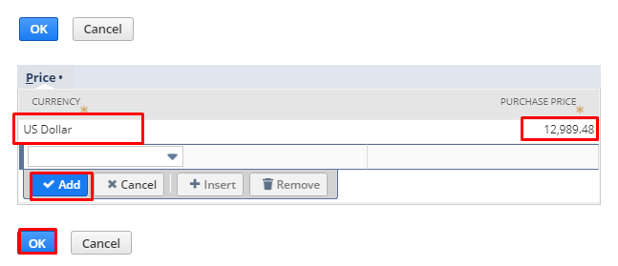
Step 4: Click the “Ok” button. Click the “Save” button.
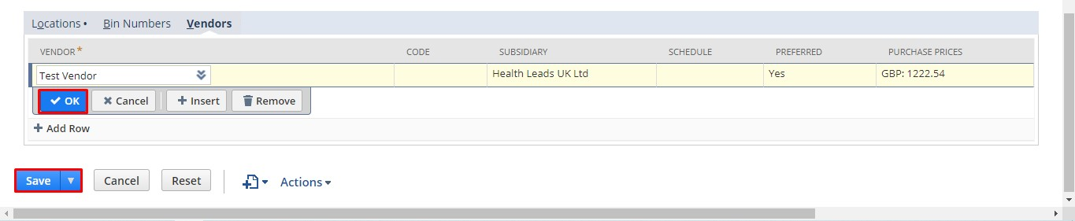
This creates a Preferred Vendor for the Item.

Use the Create PO Field to automatically create a PO from SO:

Step 1: Go to the Sales Order form. Select the customer. Enter date and additional information.

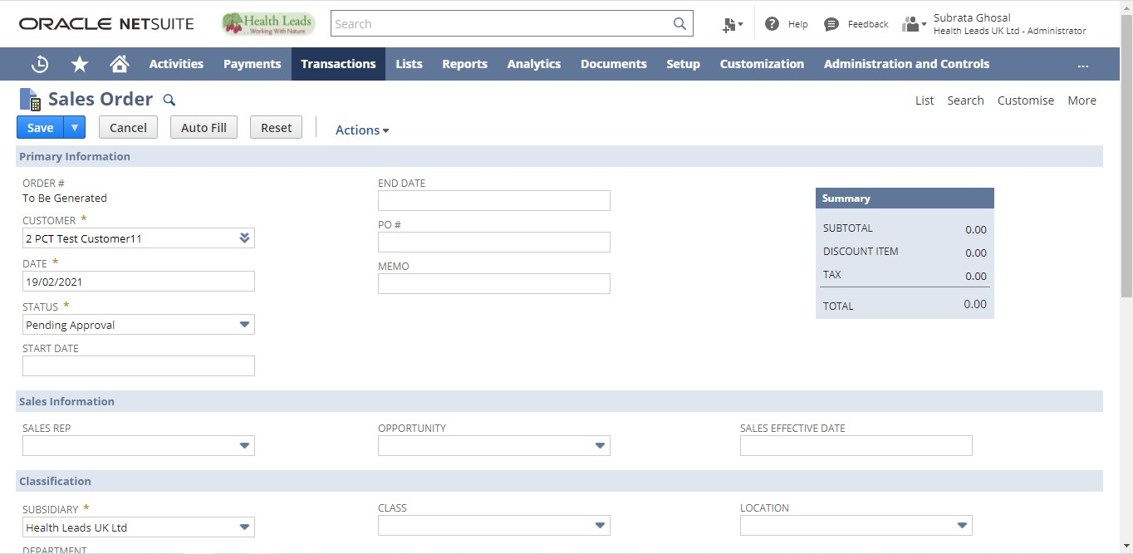

Step 2: Select the Item. From the “Create PO” field select Drop Ship, you can change the vendor name and PO rate if required. Click “Ok” to add the line Item. Click on the “Save” button.

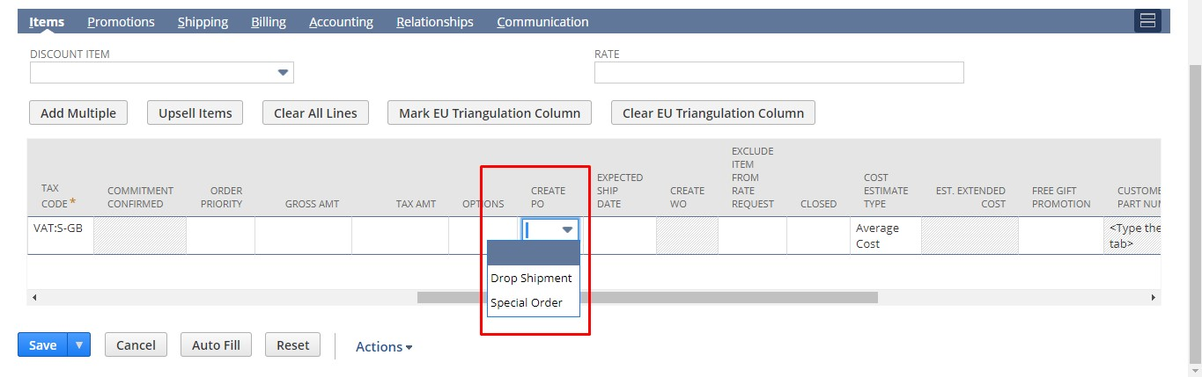
Once the record is saved a Purchase Order is automatically created for the Item to the Preferred Vendor.

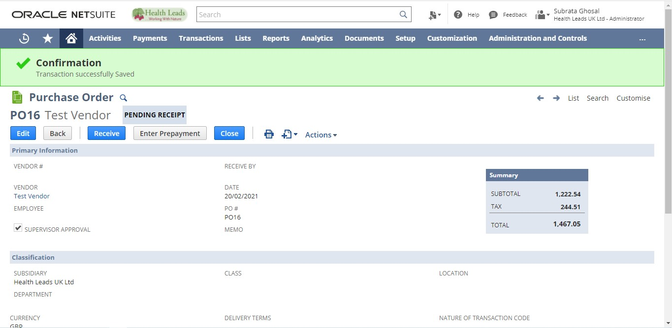
You see this screen once you save the Sales Order. Clicking on Original Number takes you to the processed Sales Order whereas clicking on Processed Number takes you to the corresponding Purchase Order.
You can also see the linked Purchase Order under “Create PO” field once the Sales Order is saved.

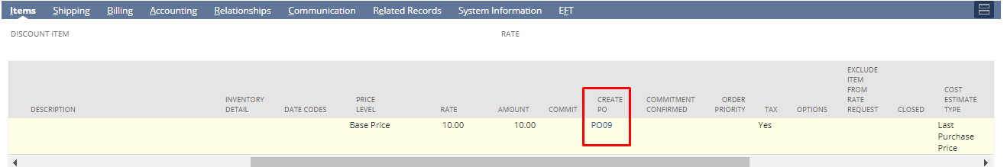

If you click on the value under “Create PO” you will be directed to the Purchase Order.
“Created From” field shows the corresponding Sales Order link on the Purchase Order.

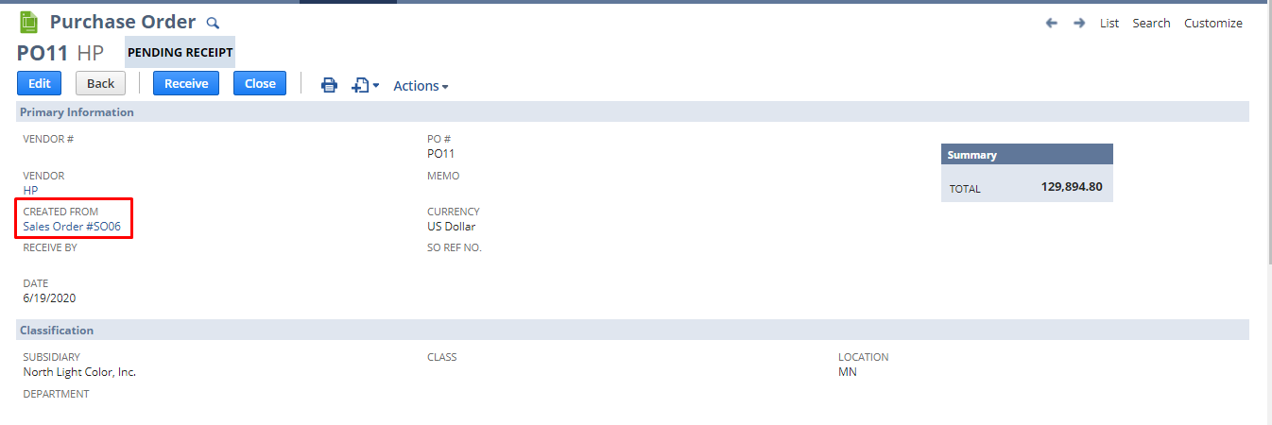

Fulfilling a Sales Order:
If there is enough Inventory/enough quantity available in your warehouse to fulfill a Sales Order you can directly fulfill it. However, if you are short of inventory to fulfill a Sales Order /if not, you can create a Purchase Order to increase inventory for the Item.
To fulfill a Sales Order, follow these steps:
There are two ways to Fulfill Sales Order
- From Sales Order
- Bulk Fulfilment
- Web Fulfilment

From Sales Order
- From Administrator Role
- From Warehouse Manager Role

Login to NetSuite with Administrator Role. Navigate: Transactions -> Sales ->Enter Sales Order -> List.
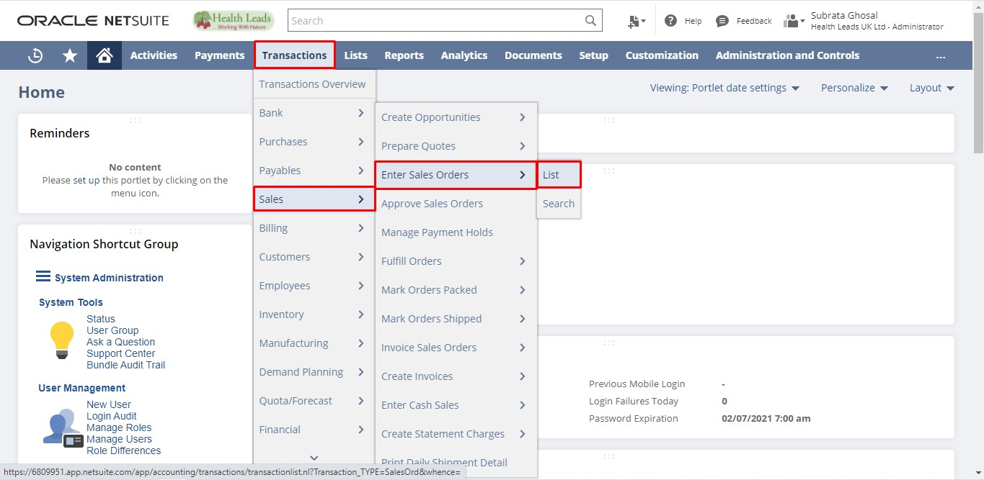

Login to NetSuite with Warehouse Manager Role. Navigate: Shipping -> Other -> Enter Sales Orders -> List.
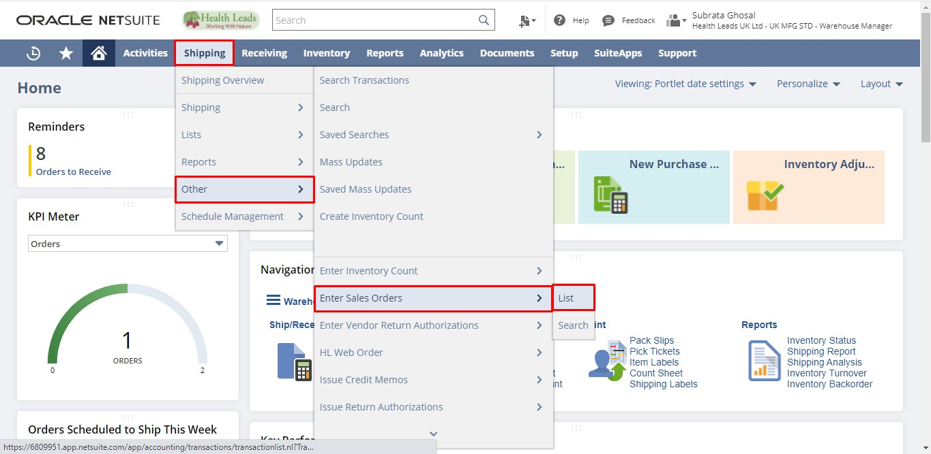
Click “View” on the Sales Order you want to fulfill.
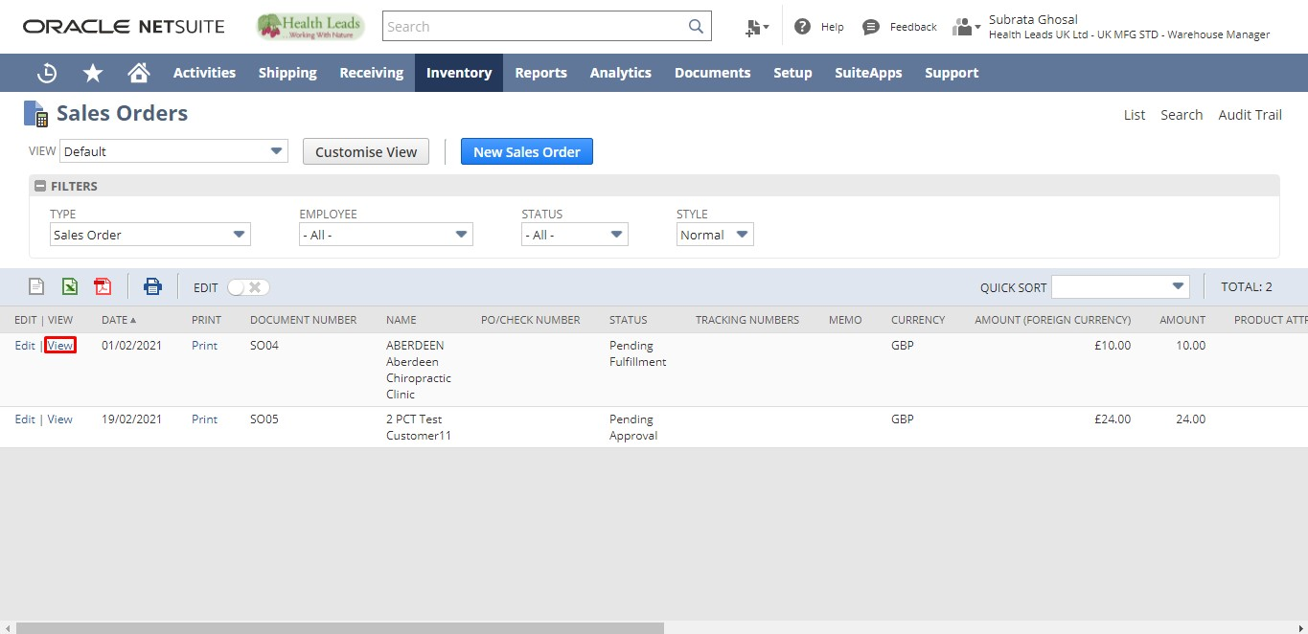
Click on the “Fulfill” button.
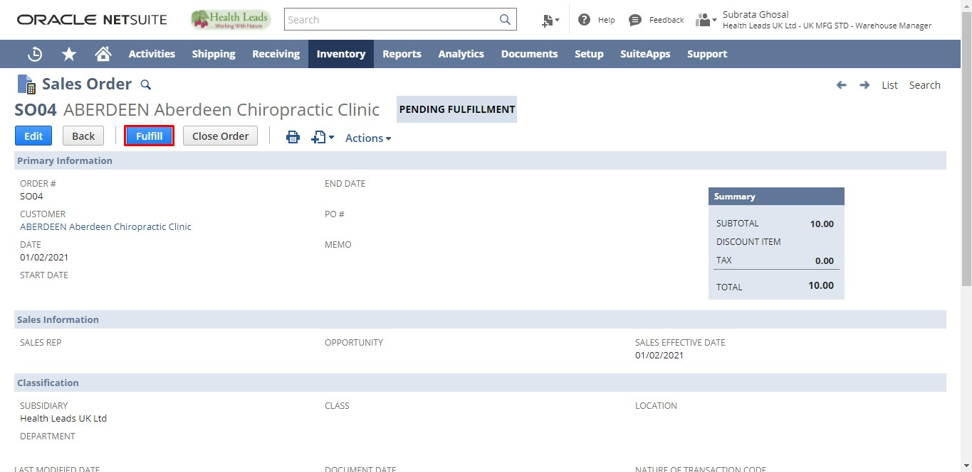
Select a Status for the Fulfillment. In the line level check the fulfill checkbox for the Items you want to Fulfill. Select a Location for the fulfillment. Click on the “Save” button.
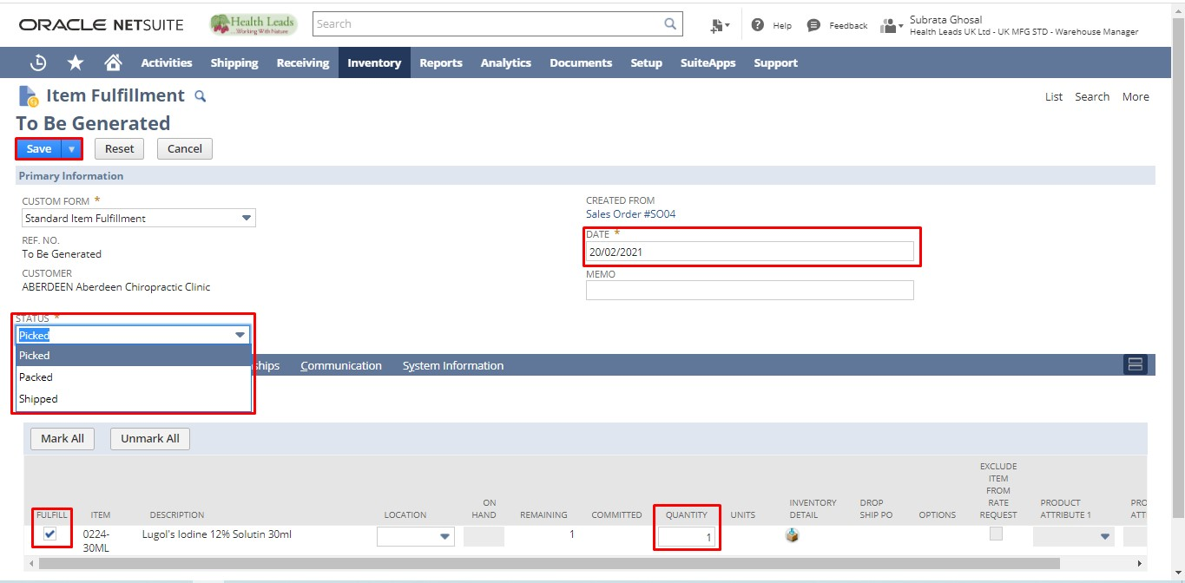
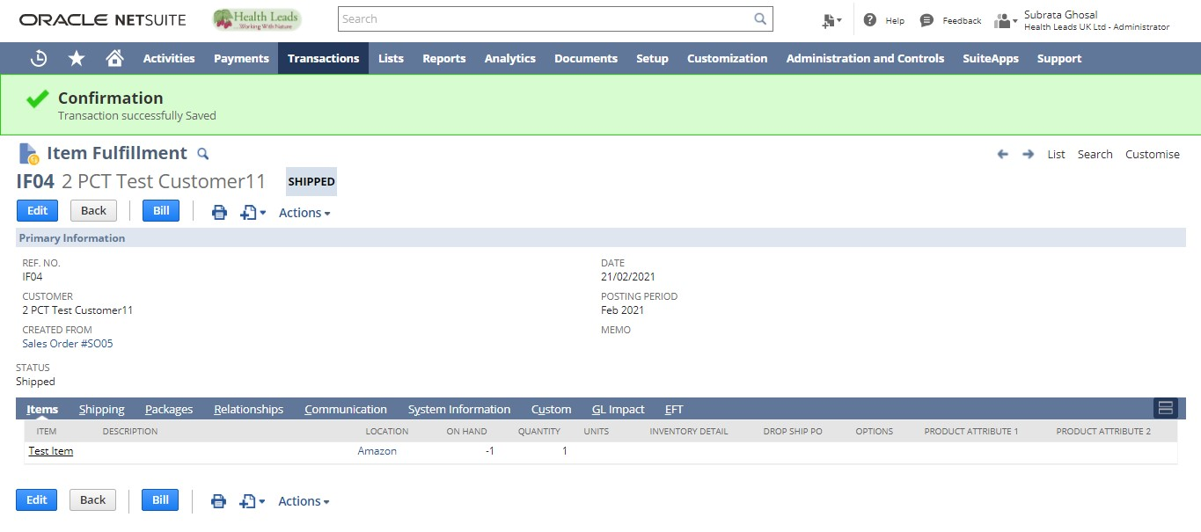

Bulk Fulfillment
- From Administrator Role
- From Warehouse Manager Role

- Login to NetSuite with Administrator Role. Navigate: Transactions -> Sales -> Fulfill Order.
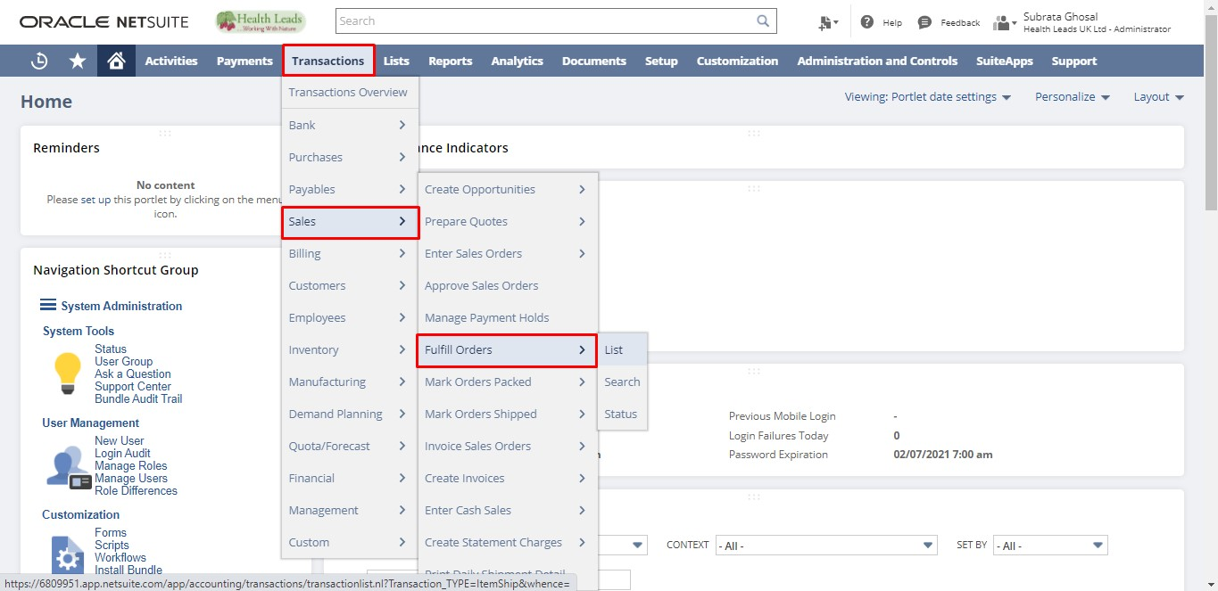
- Login to NetSuite with Warehouse Manager Role. Navigate: Shipping -> Shipping -> Fulfill Orders.
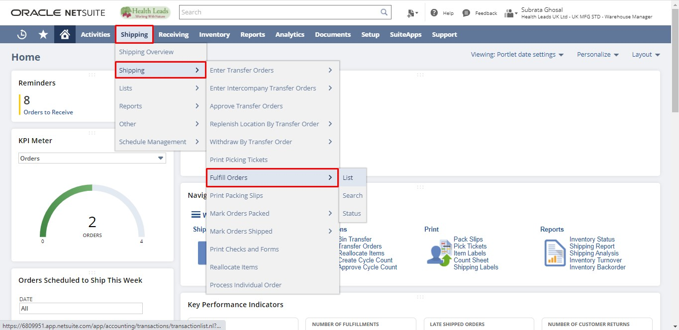

Web Fulfilment
Item fulfilment from sales order by means of Web Fulfilment is carried out through the following script.
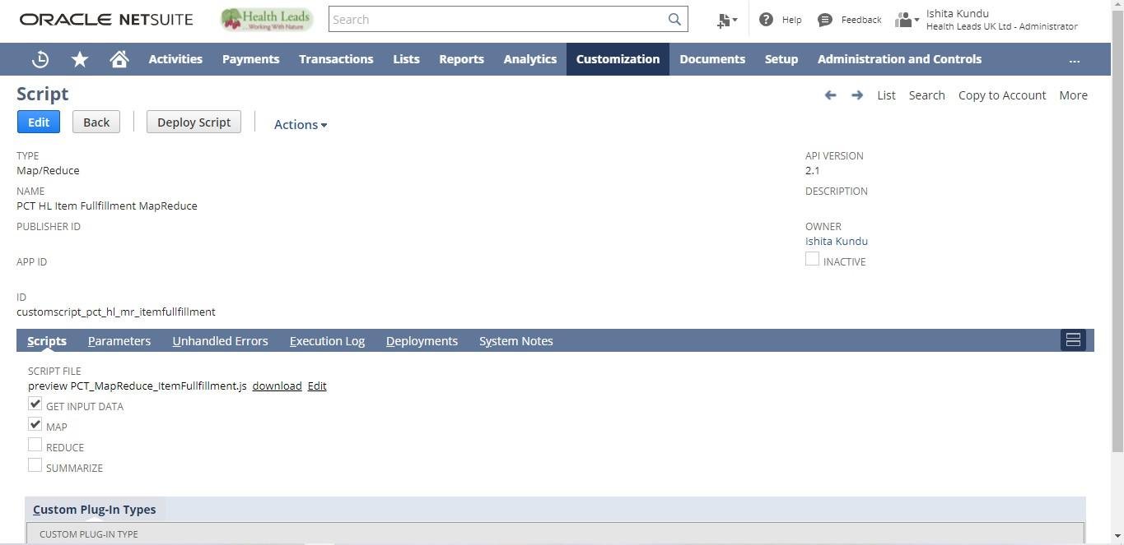
Login to NetSuite with Administrator Role. Navigate: Transactions -> Order Management -> Fulfill Orders -> List and validate the same.
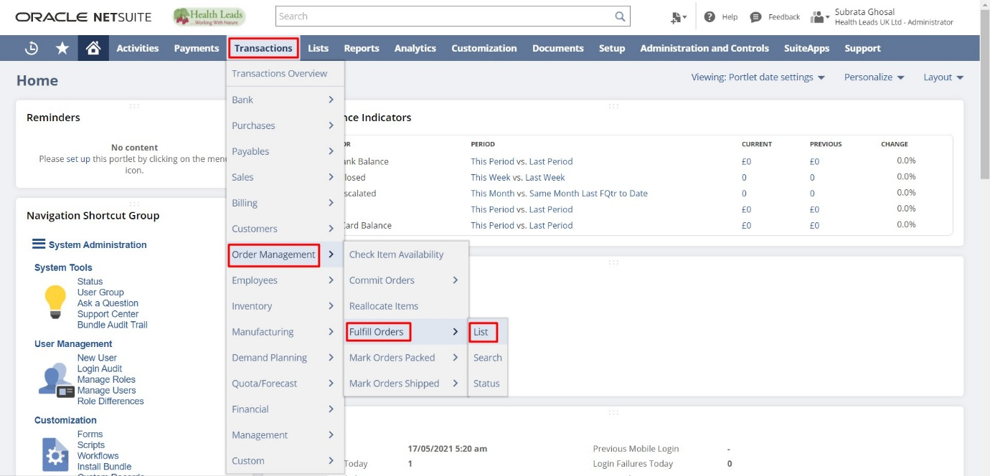

The list opens as follows.

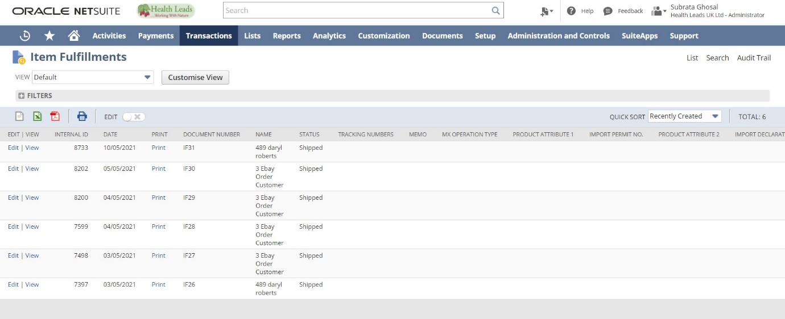

Creating Invoices:
- Stand Alone
- From Sales Order

Stand Alone Invoice
- From Administrator Role
- From Cost Accountant Role

- Login to NetSuite with Administrator Role. Navigate: Transactions -> Sales -> Create Invoices.
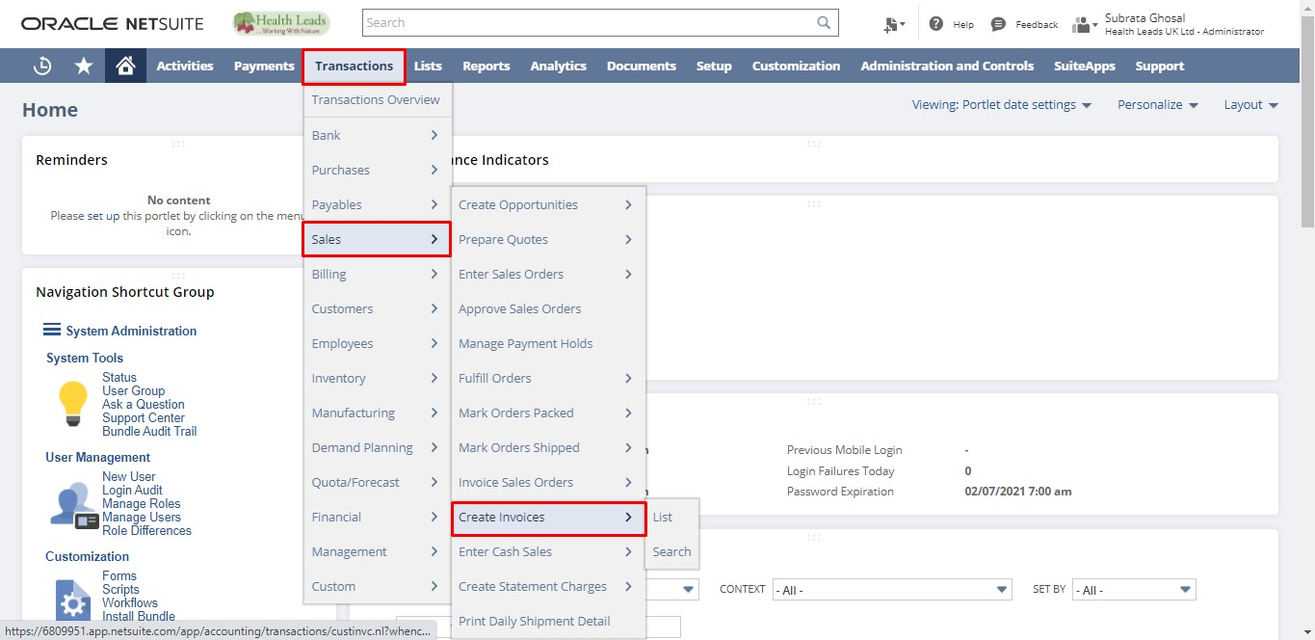
- Login to NetSuite with Cost Accountant Role. Navigate: Billing -> Sales ->Create Invoices.
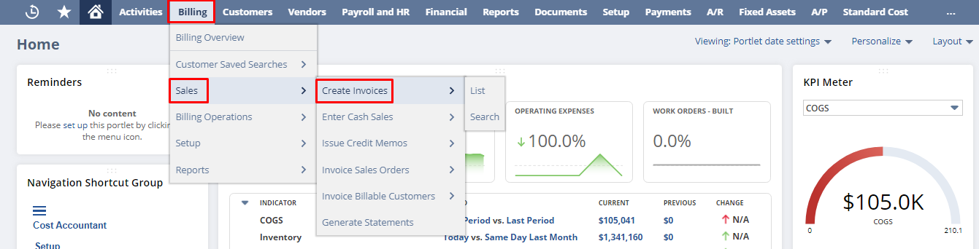
Select Customer, Location, Item and all the required details. Click on the “Save” button.
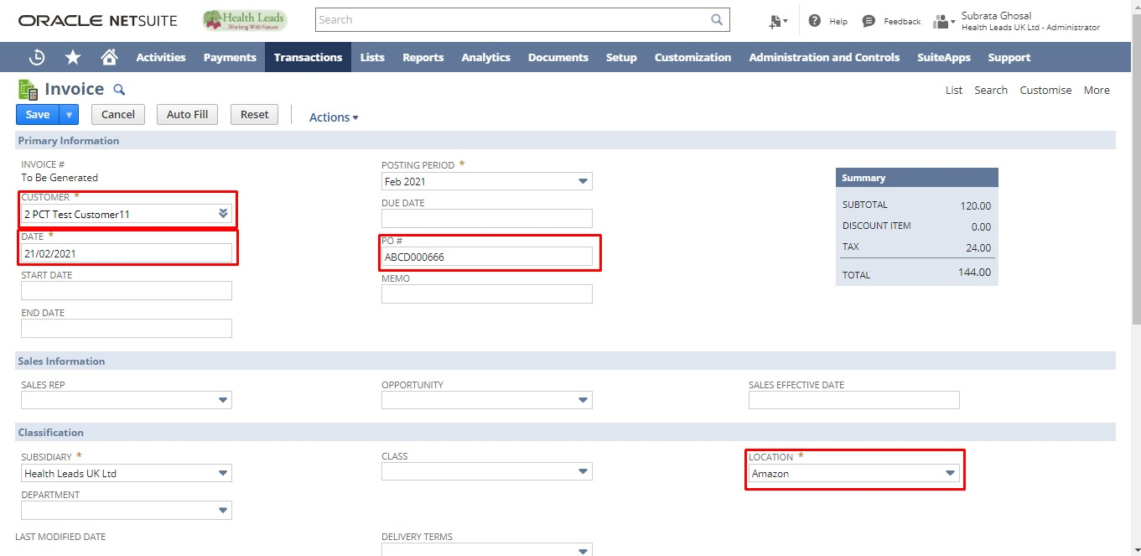
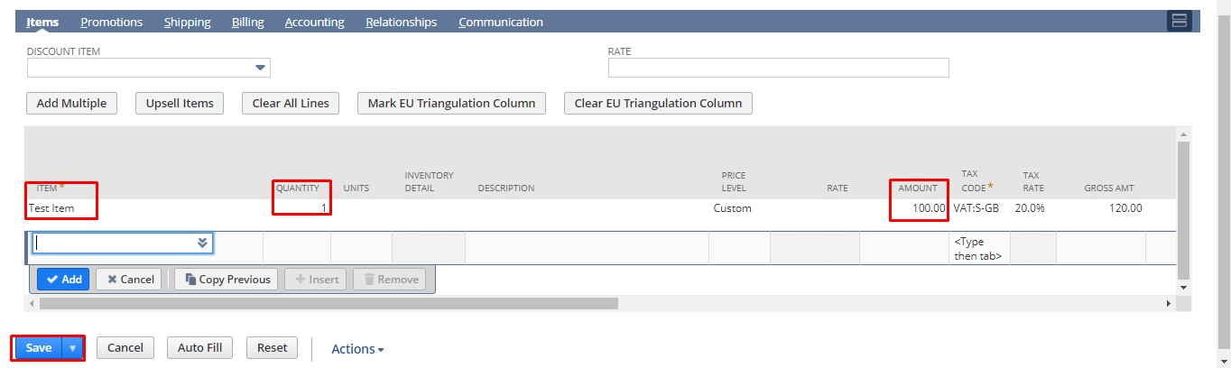
Invoice from Sales Order
- From Administrator Role
- From Cost Accountant Role

- Login to NetSuite with Administrator Role. Navigate: Transactions -> Sales -> Enter Sales Orders -> List.
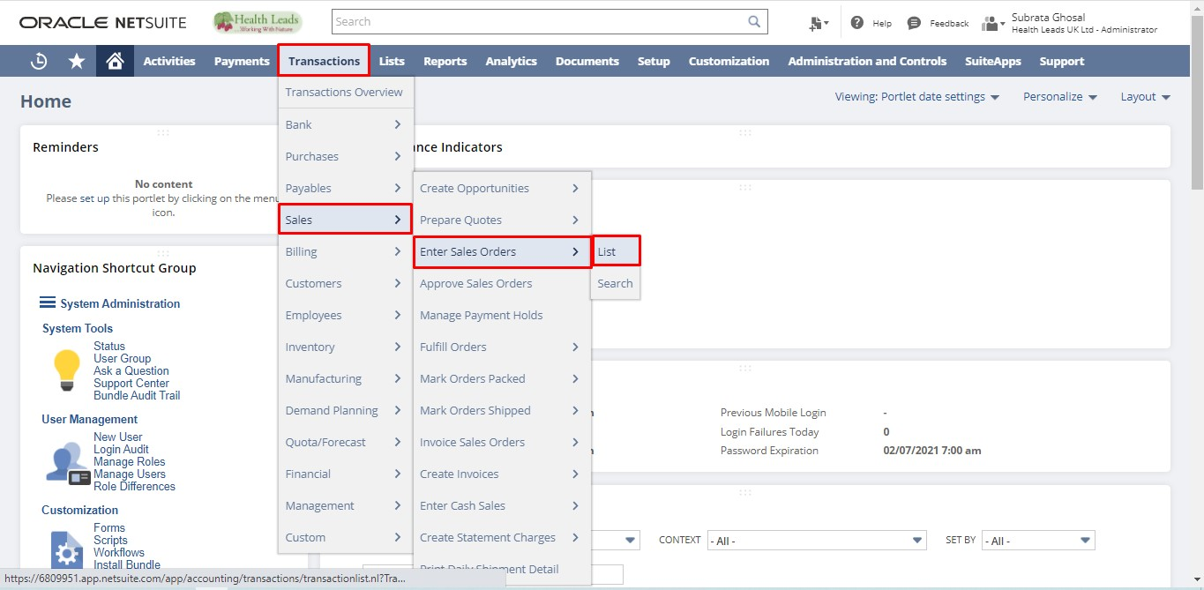
Login to NetSuite with Cost Accountant Role. Navigate: Customers -> Sales ->Enter Sales Orders->List
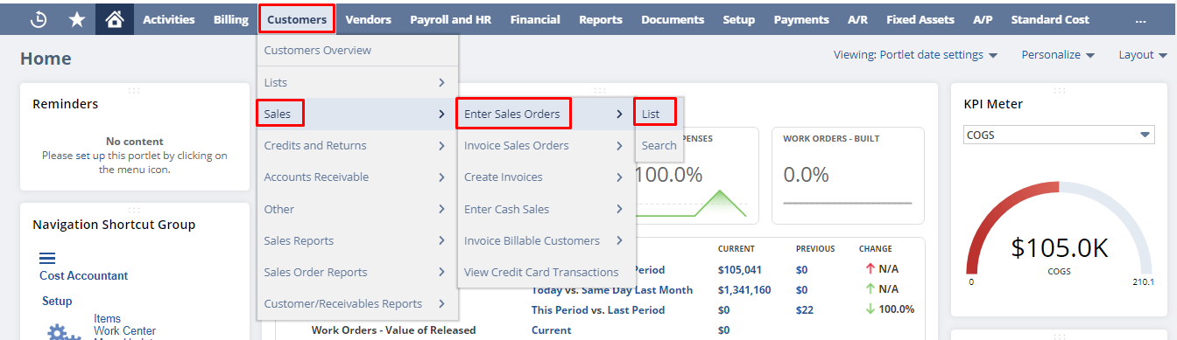
Click “View” on the Sales Order you want to Invoice.
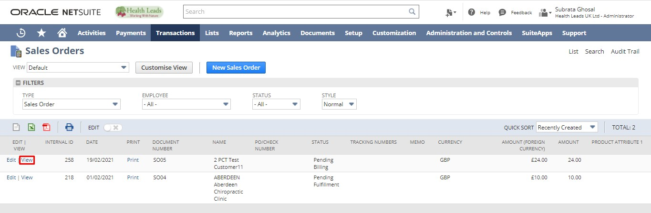
Click on the “Bill” button.
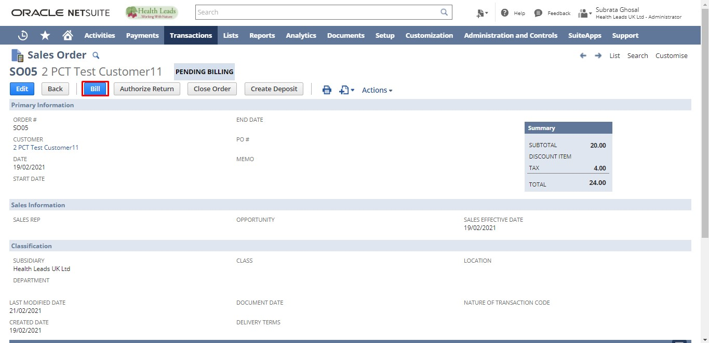
Enter additional details if any. Click the “Save” button.
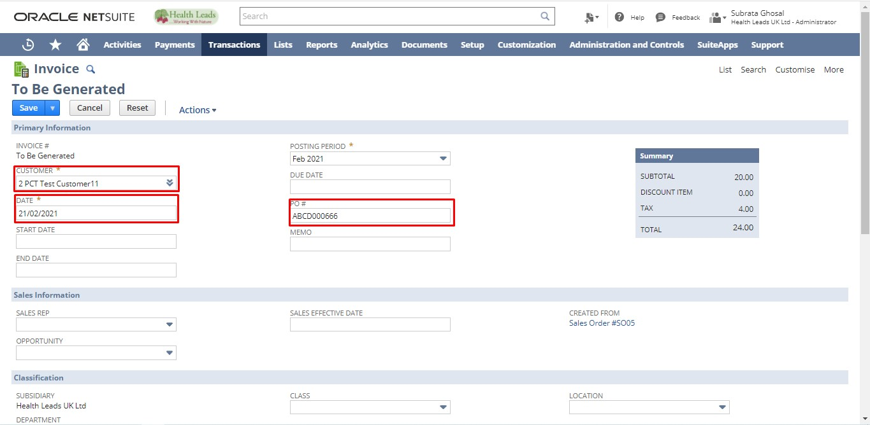
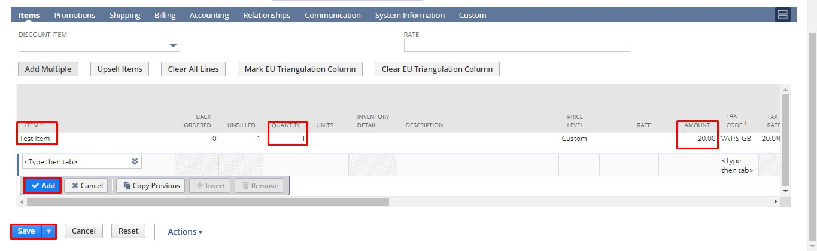
Creating Customer Payments
- Stand Alone
- From Invoice

Stand Alone Payment
- From Administrator Role
- From Cost Account Role

- Login to NetSuite with Administrator Role. Navigate: Transactions -> Customers -> Enter Customer Payments -> List.
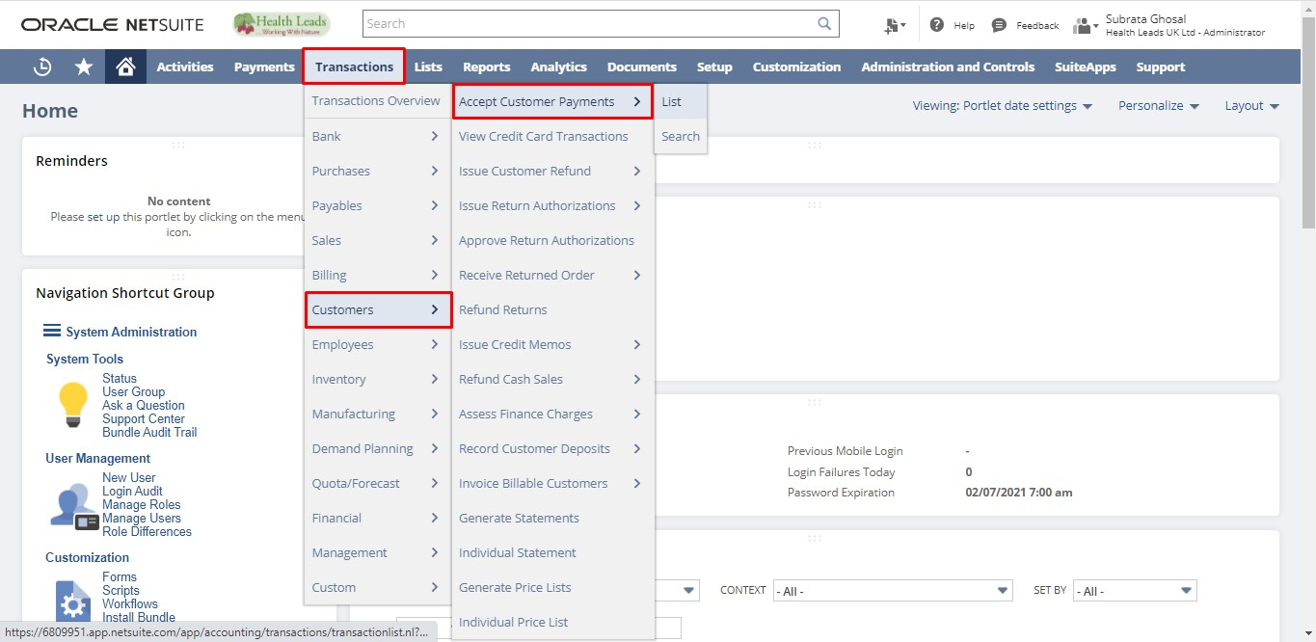
- Login to NetSuite with Cost Account Role. Navigate: Customers -> Account Receivable -> Accept Customer Payments -> New.
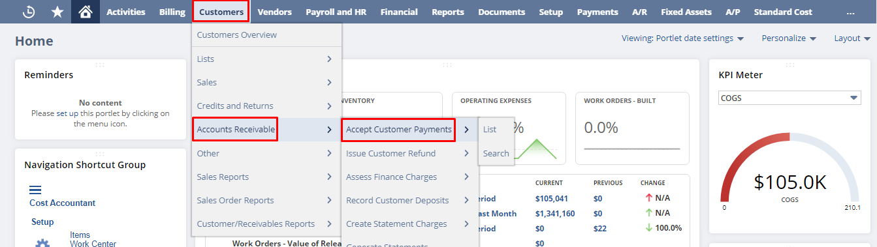
Select Customer and all the required details. Click on the “Save” button.
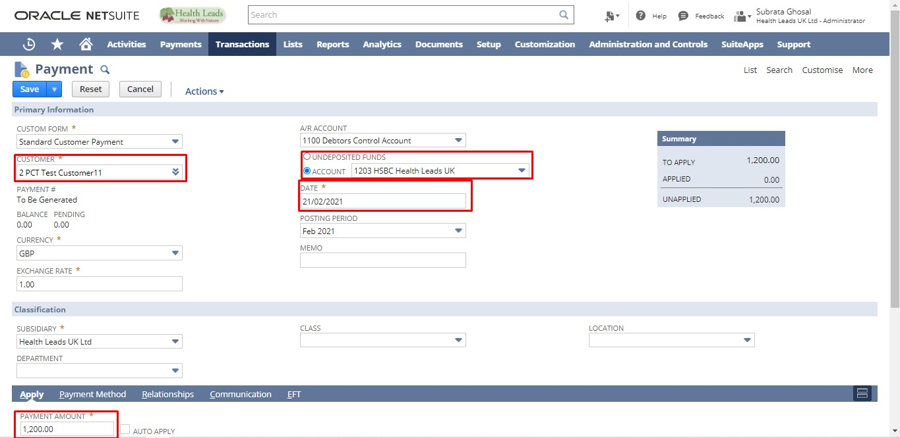
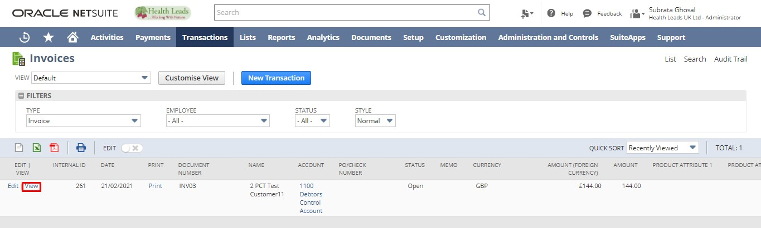

Accepting Payment from Invoice
- From Administrator Role
- From Cost Accountant Role
- Login to NetSuite with Administrator Role. Navigate: Transactions -> Sales -> Create Invoice -> List.
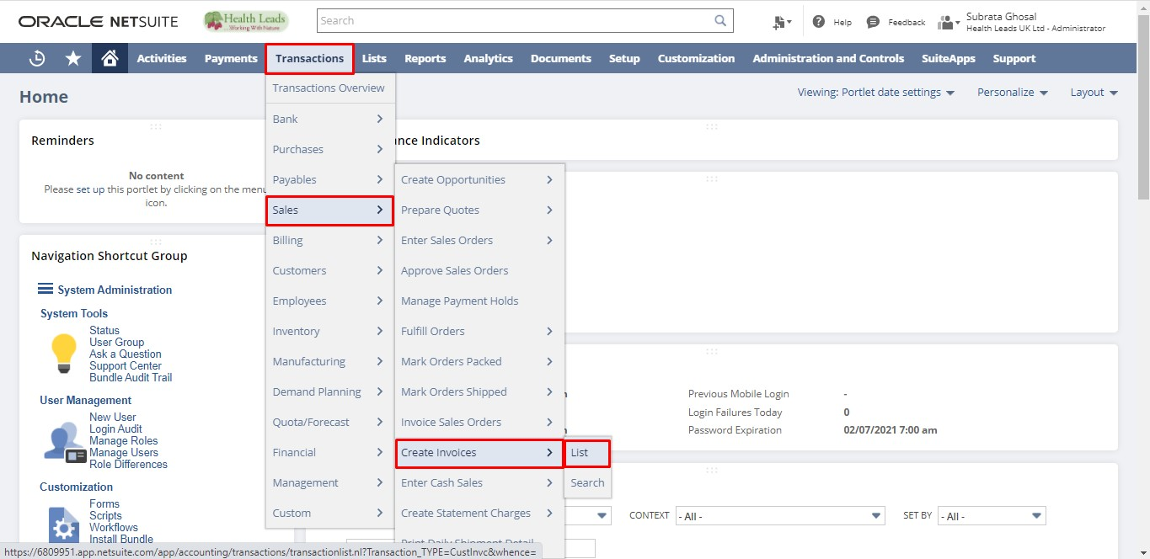
- Login to NetSuite with Cost Accountant Role. Navigate: Billing -> Sales ->Create Invoices->List.
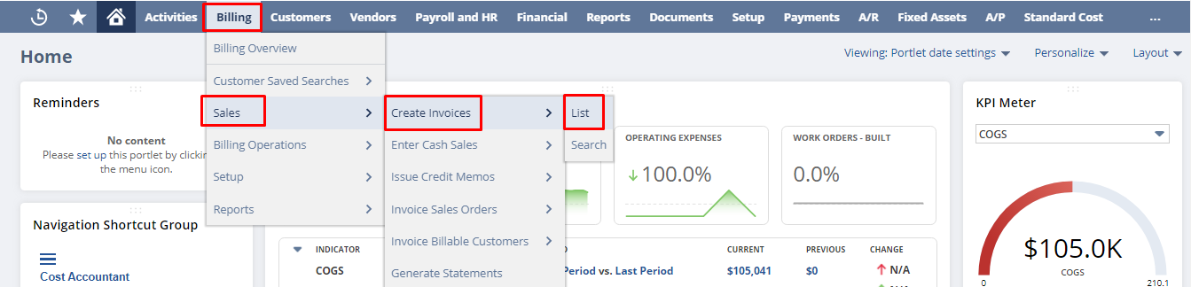
Click “View” on the Invoice for which you want to create a customer payment.

Click on the “Accept Payment” button.
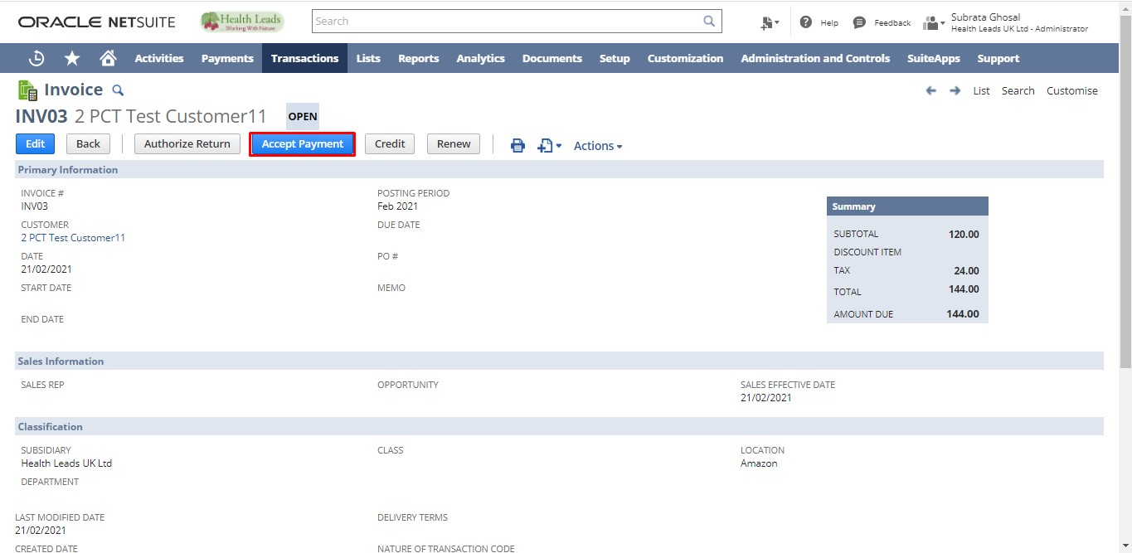
Enter Additional Information in the fields if any. Click on the “Account” radio button. Select the Account for the Payment. Click the “Save” button.
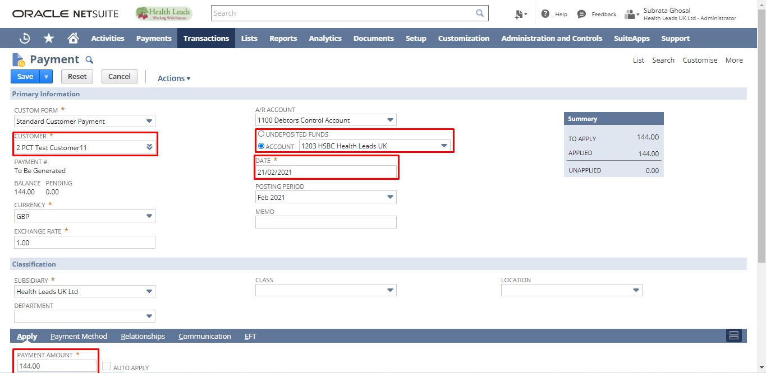
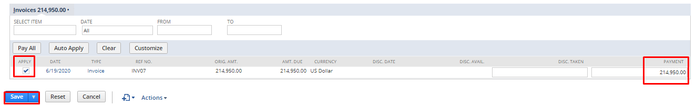

Creating Return Authorization
- Stand Alone
- From Invoice

Stand Alone Return Authorization
- From Administrator Role
- From Sales Manager Role

- Login to NetSuite with Administrator Role. Navigate: Transactions -> Customers -> Enter Return Authorizations.
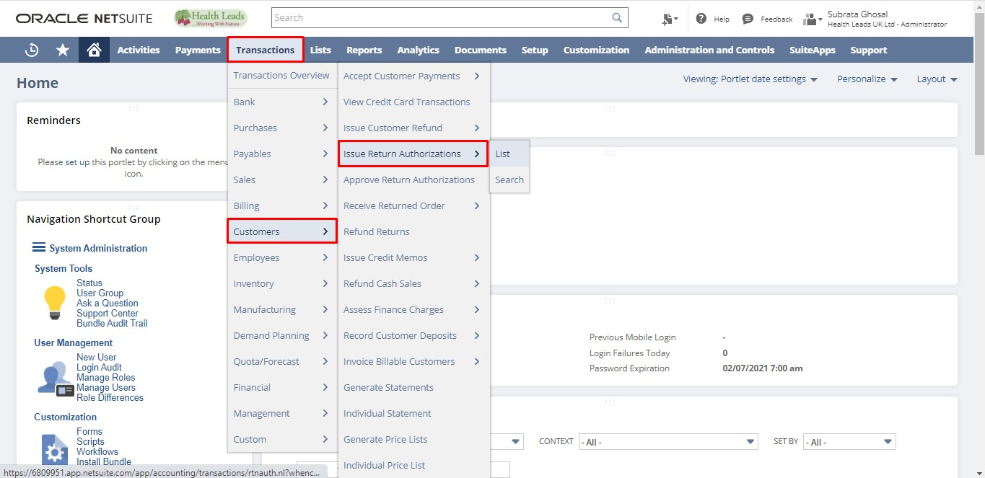
Login to NetSuite with Sales Manager Role. Navigate: Customers -> Transactions -> Return Authorizations -> New.
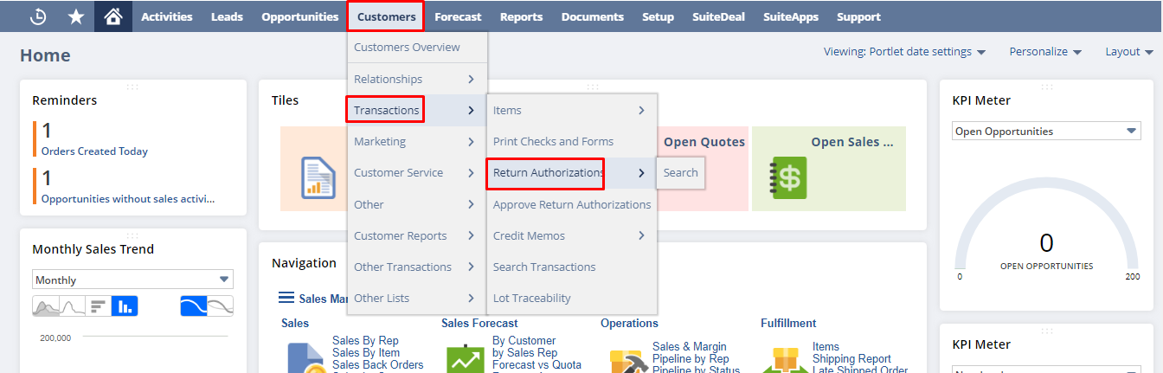
Select Customer and all the required details. Click on the “Save” button.
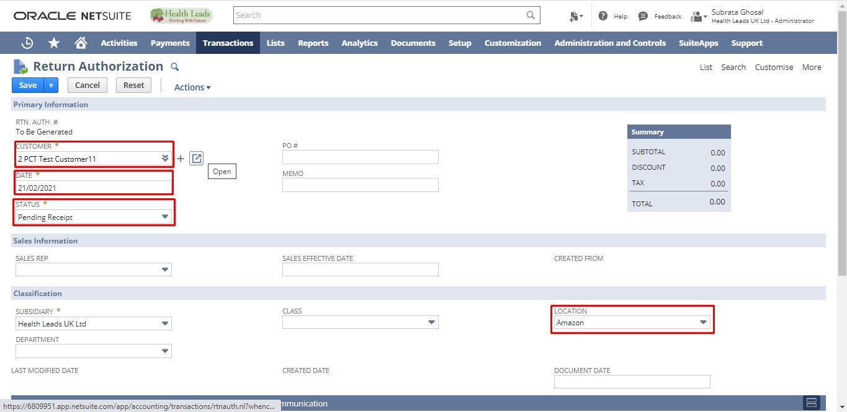
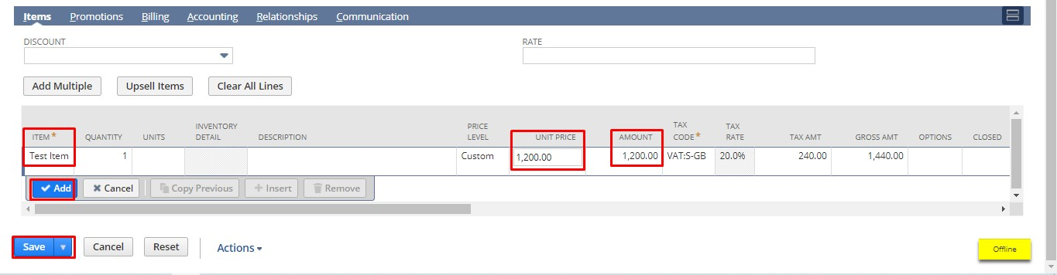

Return Authorization from Invoice
- From Administrator Role
- From Sales Manager Role

- Login to NetSuite with Administrator Role. Navigate: Transactions -> Sales-> Create Invoices -> List.
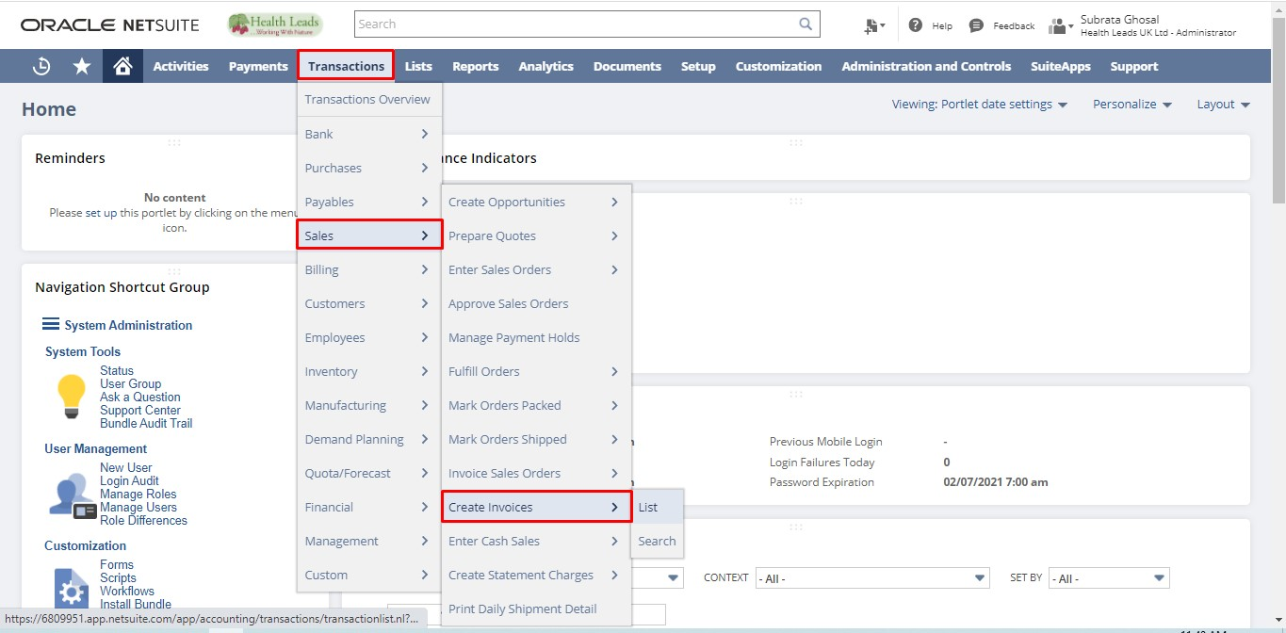
- Login to NetSuite with Sales Manager Role. Navigate: Opportunities -> Transactions -> Invoices.
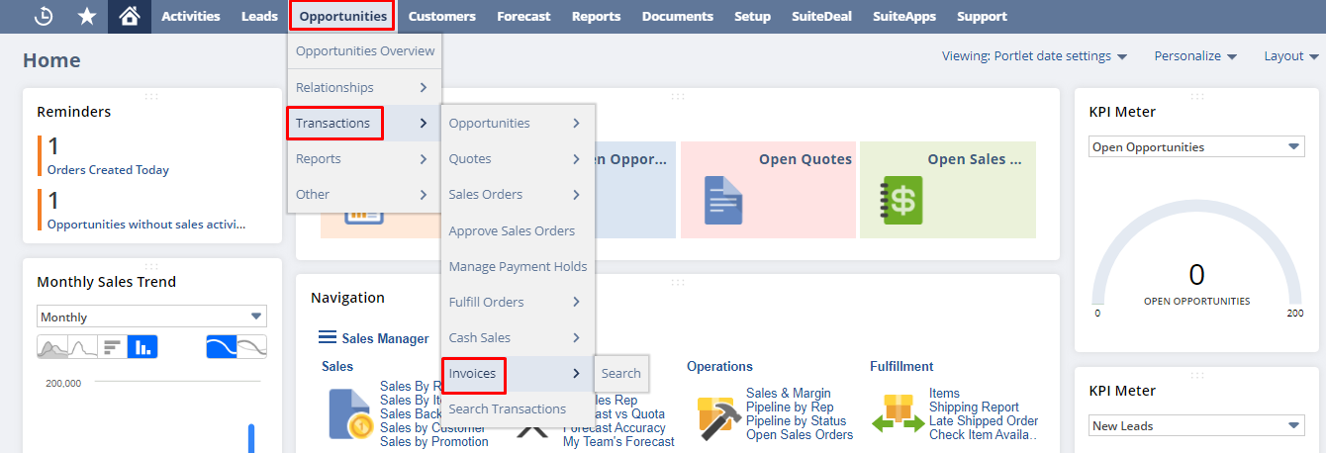
Click the date on the Invoice for which you want to create a return authorization.
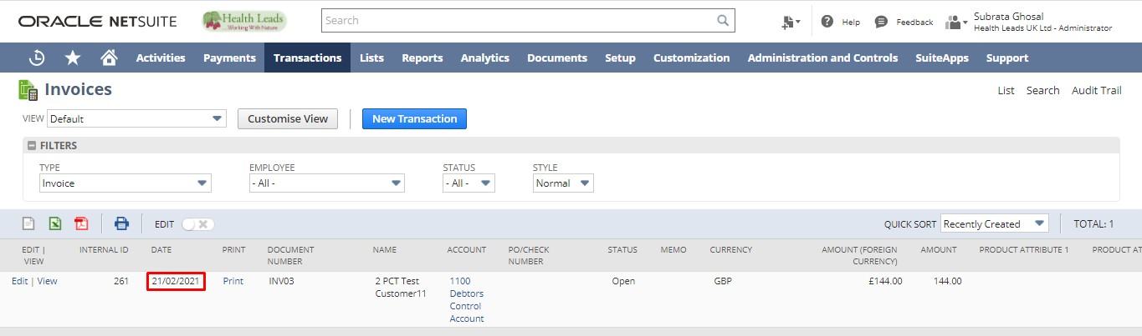
Click “Authorize Return”.
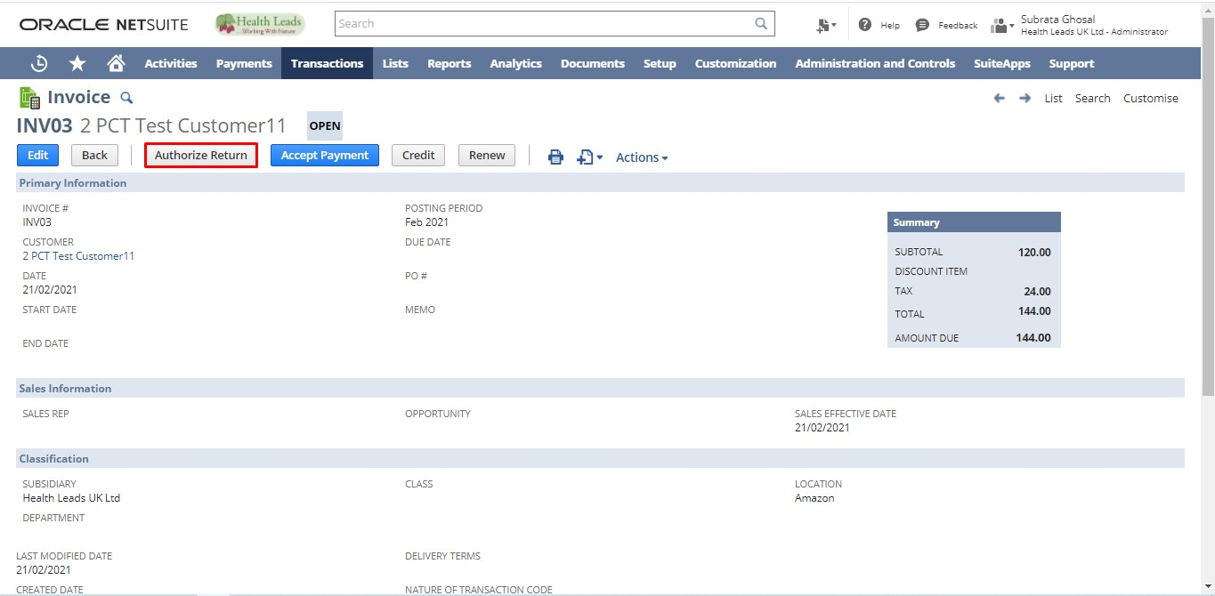
Add additional Information in the fields if any. Click the “Save” button.
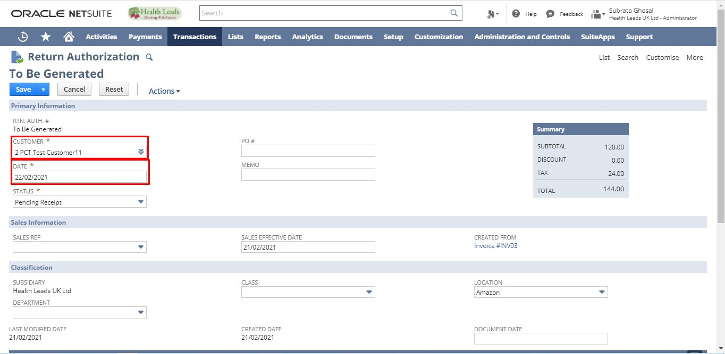
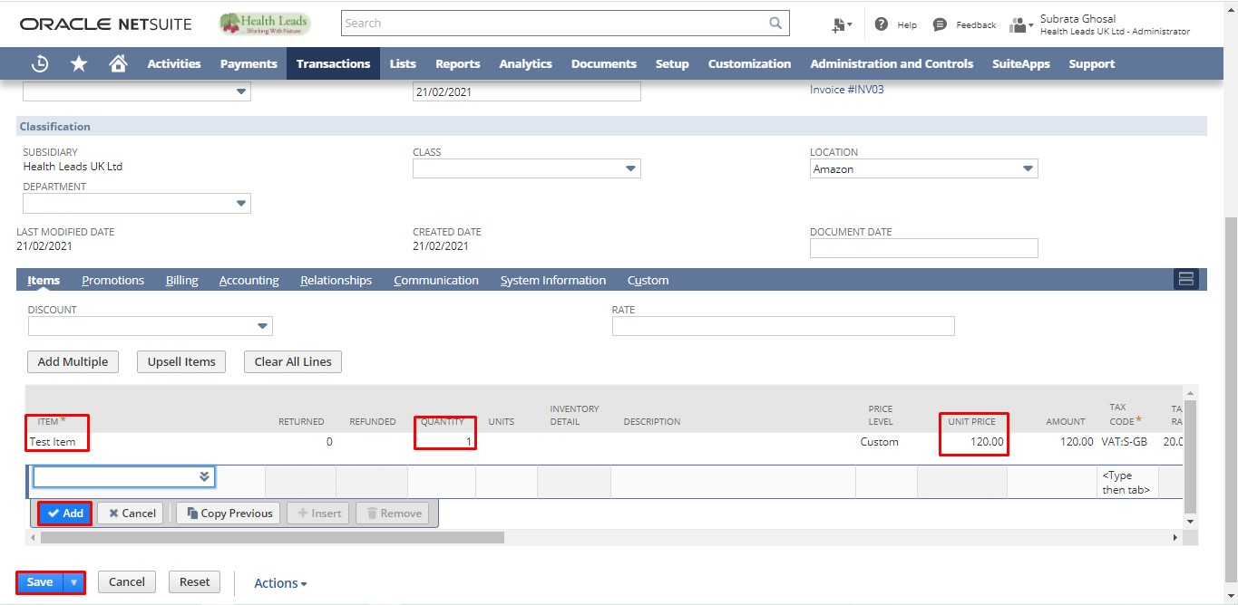

Receiving Return Authorization:
There are two ways to Fulfill Sales Order
- Bulk Receive Returned Orders
- From Return Authorization

Bulk Receiving Returned Orders
- From Administrator Role
- From Warehouse Manager Role

- Login to NetSuite with Administrator Role. Navigate: Transactions -> Customers -> Receive Returned Order.
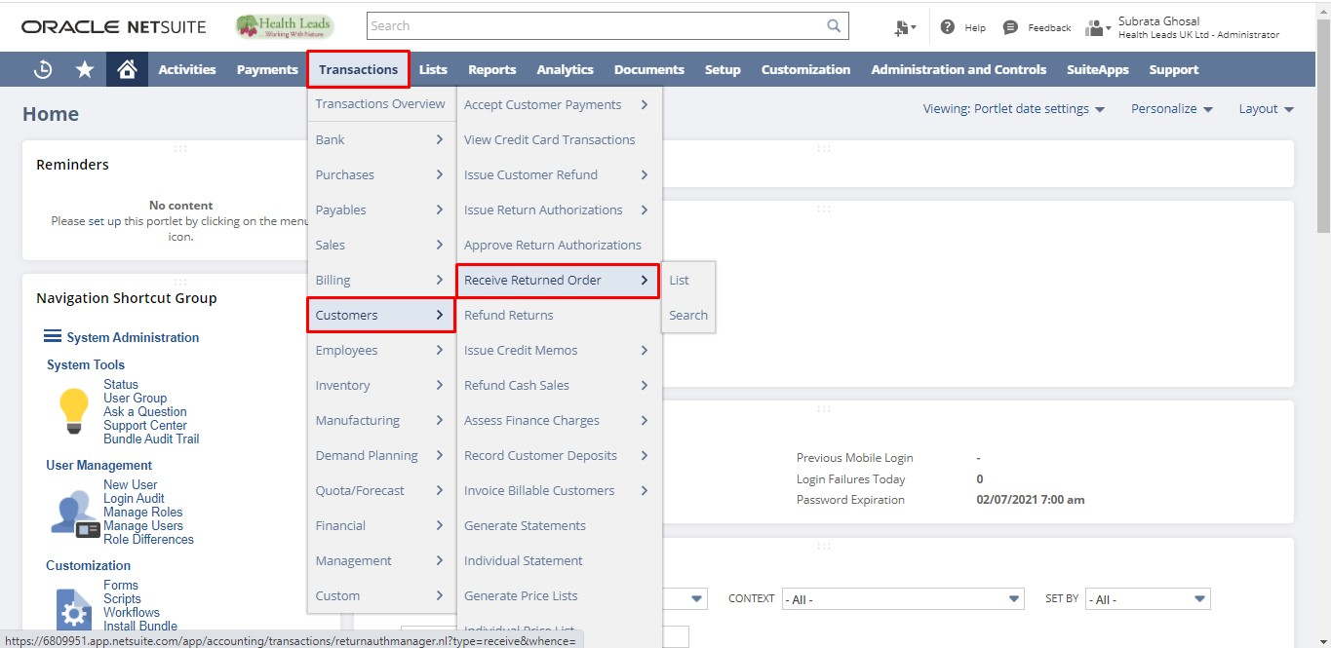
- Login to NetSuite with Warehouse Manager Role. Navigate: Receiving -> Receiving -> Receive Returned Order
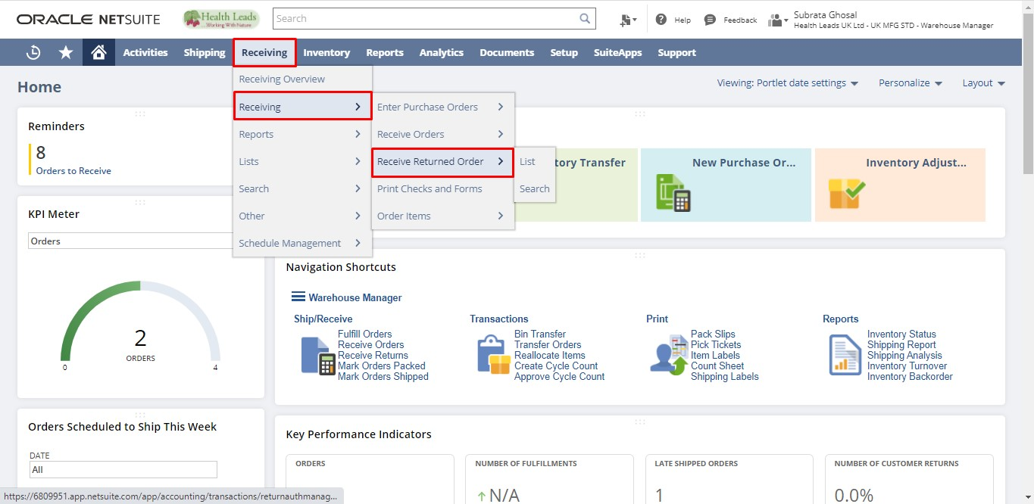
Select all the required details. Click on the “Submit” button.
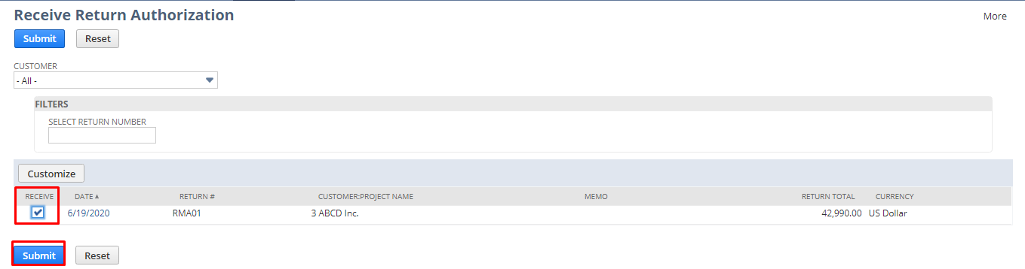
Click the “Save” button.
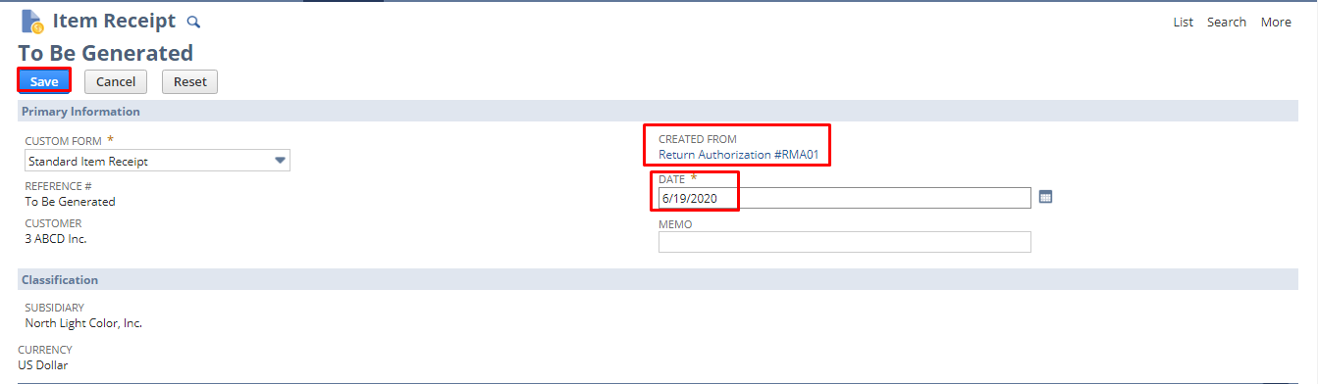
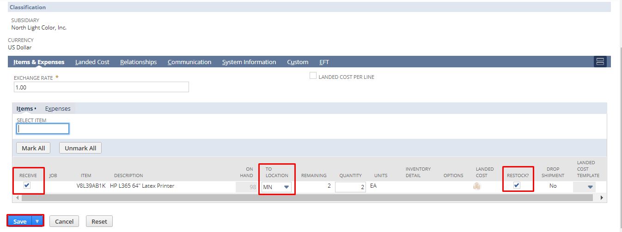

From Return Authorization
- From Administrator Role
- From Warehouse Manager Role

- Login to NetSuite with Administrator Role. Navigate: Transactions -> Customers -> Issue Return Authorizations -> List.
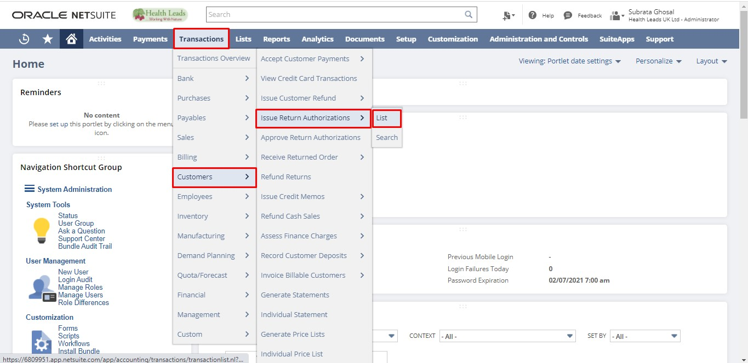
- Login to NetSuite with Warehouse Manager. Navigate: Customers -> Transactions -> Return Authorizations.
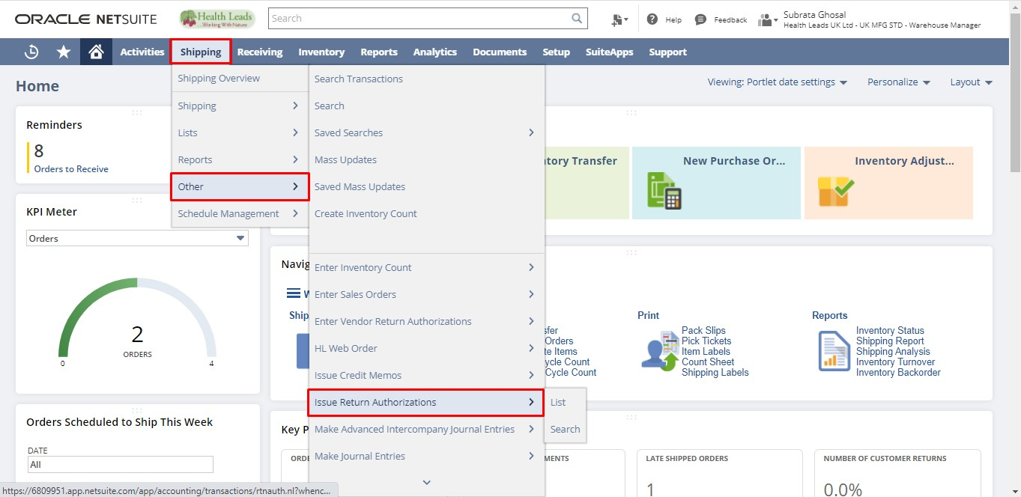
Click “View” on the Return Authorization for which you want to create an Item Receipt.
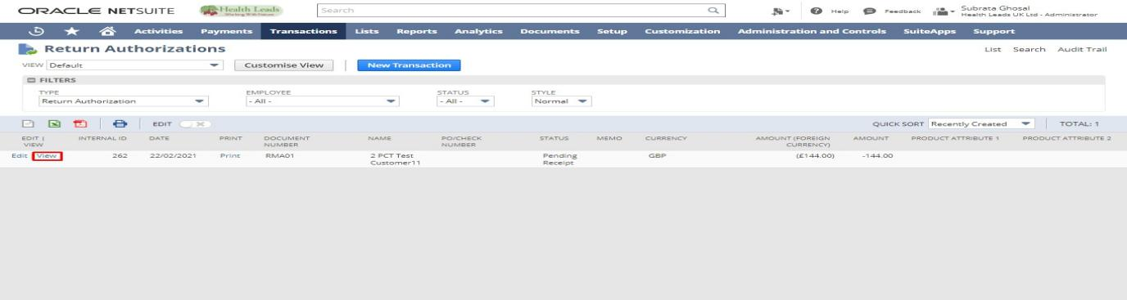

Click “Receive”.
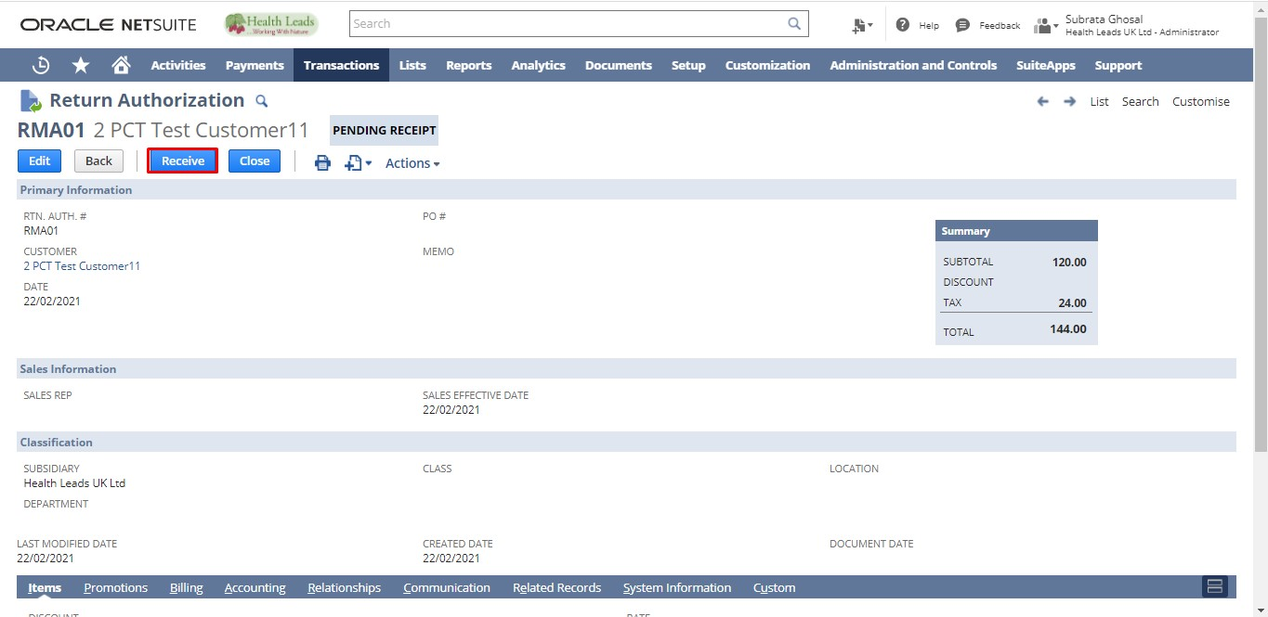
Check the checkbox for the Items you want to receive. Select the Location. Click the “Save” button.
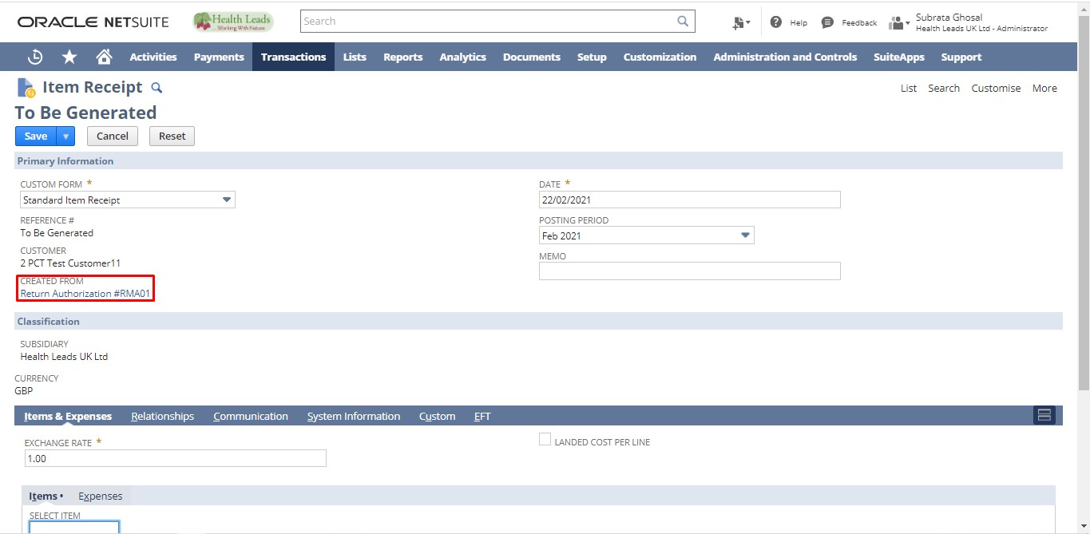
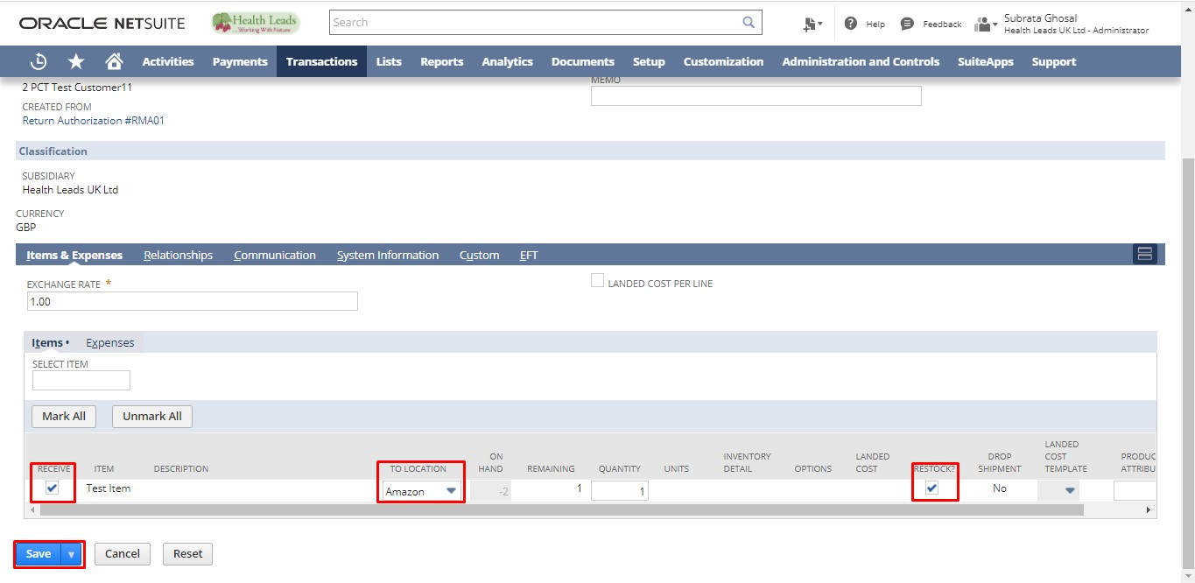

Create Credit Memo for Return Authorization:
- From Administrator Role
- From Cost Accountant Role

- Login to NetSuite with Administrator Role. Navigate: Transactions -> Customers -> Issue Return Authorizations -> List.
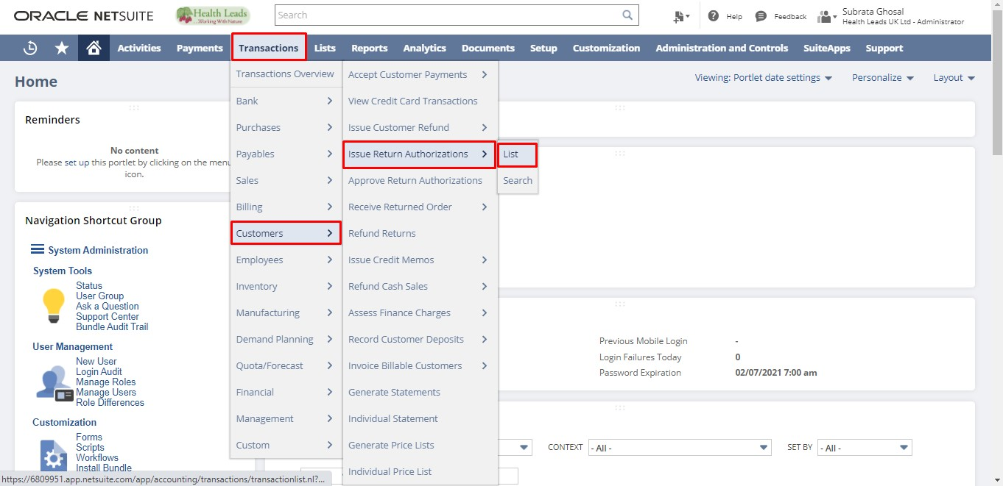
- Login to NetSuite with Cost Accountant Role. Navigate: Customer -> Credits and Returns -> Issue Return Authorizations -> List.
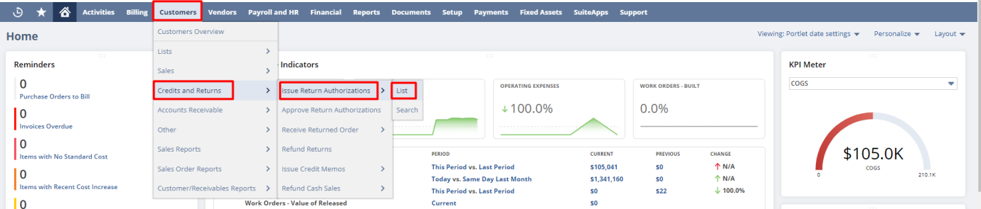
Click “View” on the Return Authorization for which you want to create a refund.
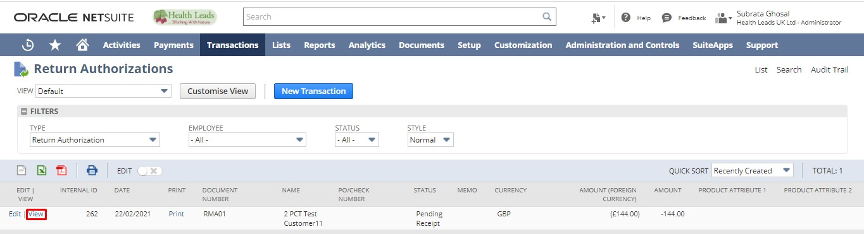
Click “Refund”.
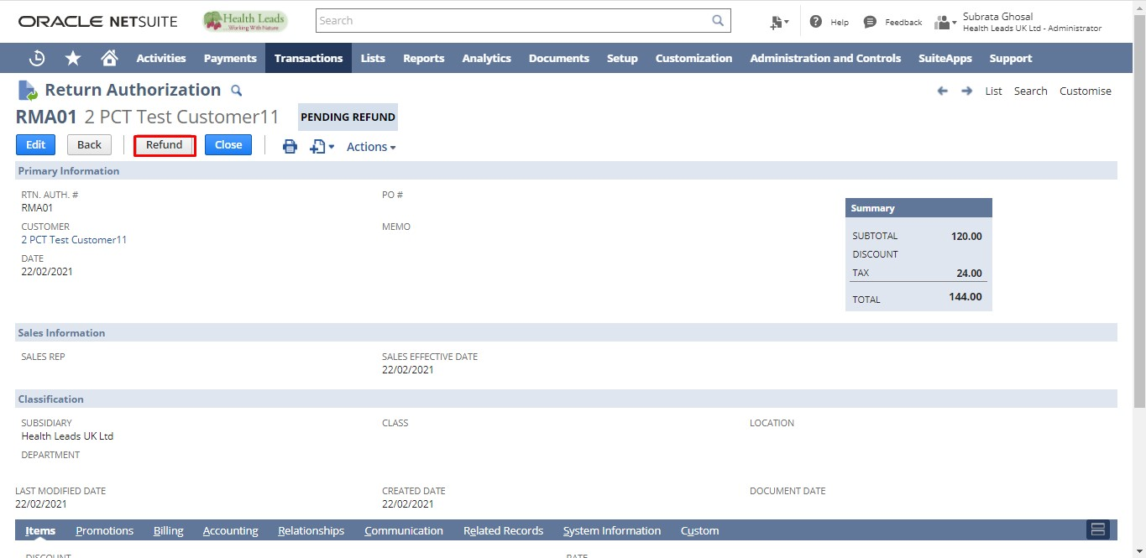
Enter Additional Information if any. Click the “Save” button.
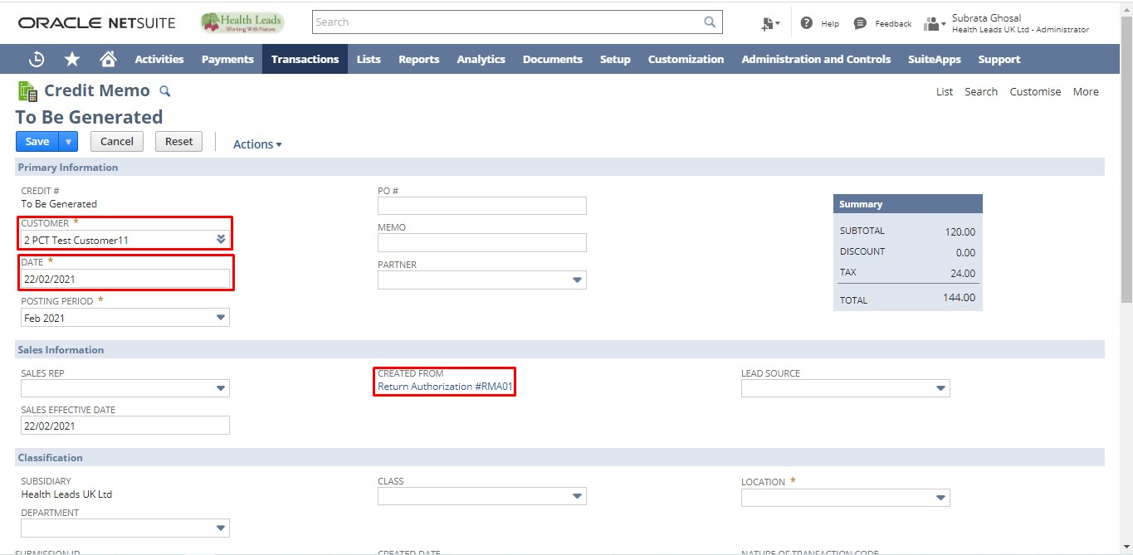
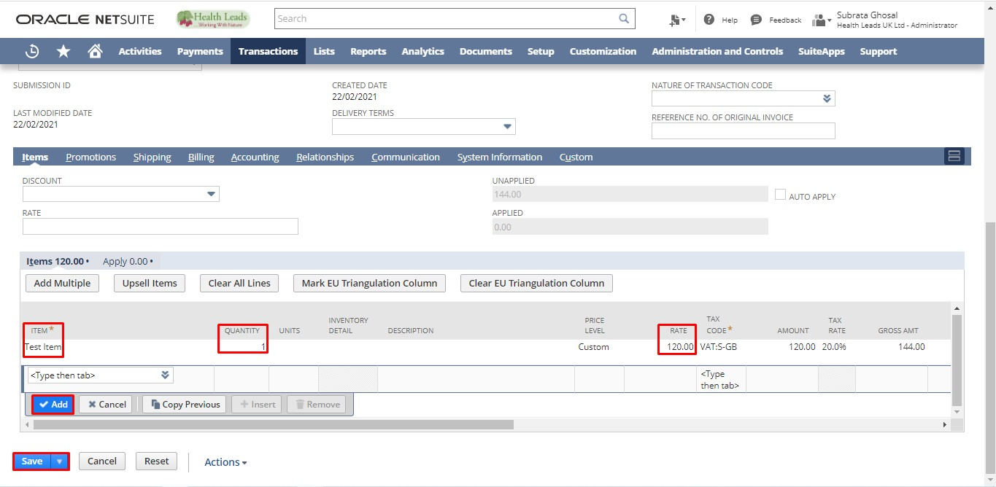

Click “Refund”.
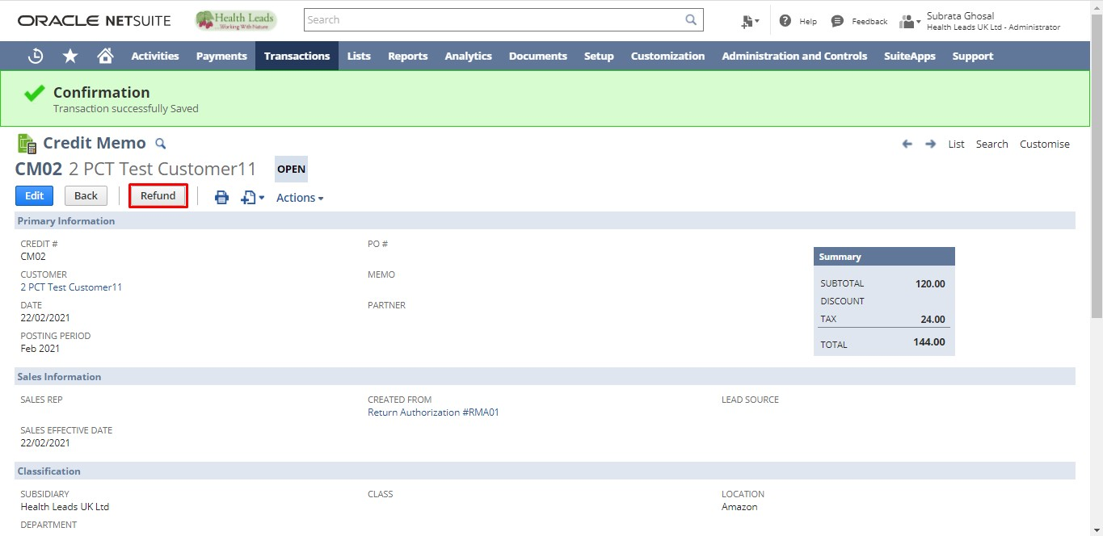
Enter Additional Information if any. Click the “Save” button.

